4 Oct: EU + RU experts to discuss Internet Regulations - Copyright. Privacy. Freedom. Digital & Social aspects
23 September 2013 at 12:59
Davos Forum’s regional session for PR and communications

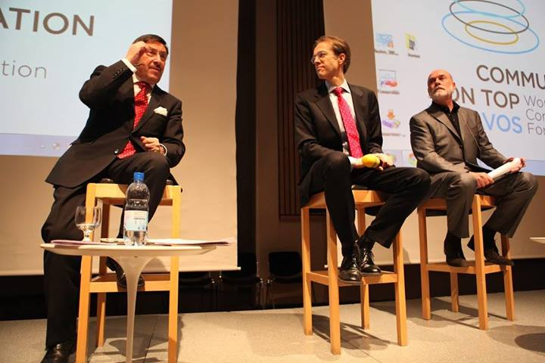
Prague welcomes top European experts for a talk on contemporary PR & Comms!

Dr. Daniel Holtgen, Communications Director at the Council of Europe, will lead a panel discussion focused on acute issues in Internet Regulations and their influence over the communications industry in Europe and Russia. The discussion will take place at the European Session of the Davos World Communication Forum held in Prague.

Other top speakers taking part will be Elvana Thaci, COE officer working on freedom of expression and Internet governance at the Internet Governance Unit (DGI) in the Council of Europe, Yanina Dubeykovskaya, co-Chair of the Committee and Content Director of WCFDavos, and several leading experts in online business, PR and communications.

The discussion will address the following key questions:
1. Should access to Internet be regarded as an inalienable right of all humans?
2. How to find the proper balance between copyright and freedom of content distribution in online networks?
3. Models of internet regulation, global initiatives, and due legislation activity on national level. Online sovereignty and is it possible in our days?
4. How is Trust – the key capital of communications, transformed into Social Media?
5. Is it possible to guarantee personal privacy online?
Internet and social media are today's main channels for communication, which naturally changes the very ‘rules of the game’ in media, PR, and marketing. However, those channels are unstable, as they develop way too quickly: there is still a lot to be improved as regards regulations and internet safety. In that respect, what could we possibly expect as benefits or as obstacles for the future of the communications industry?
Dr. Daniel Holtgen has stated that he is already “looking forward to the WCFDavos-CoT event in Prague to discuss this crucial question for citizens, businesses, media and governments all over Europe.”

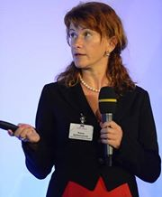
Yana Dubeykovskaya has also shared her viewpoint and expectations from the Prague session:“All we need to do in our job is to increase the trust of citizens, customers, employers, partners, and employees. One of the opportunities for success in our mission is to develop higher transparency in business and politics, to generate public involvement and most important - to maintain control over corporate and political decisions. Does it mean that the more transparency we secure, the more trust and ethics shall prevail? I certainly expect some useful answers and solutions from our discussion in Prague!”

WCFDavos summit aims to unite trend-makers and influencers from the communications elite and provide a platform for discussion focused on the future development of communications, their role in business, society, and politics. Its four main editions so far have summed over summoned top communicators from over 42 countries – chief managers and leading experts from more than 85 consultancies, 60 companies, 15 large international organizations, 12 media, 10 educational institutions and 6 government units. The Forum’s social media networks grow with each next event: its Facebook page unites 1310+ fans, its Twitter account registers 840+ followers, and its YouTube channel exceeds 120 videos.

WCFDavos|Prague’s European session is a great opportunity to foster collaboration between corporate PR directors and leading PR agencies, to exchange best practices in European PR and Communications, and to develop strong competitive advantages of the EU markets and PR communities globally.

Partners of the Prague event are: APRA and KoPR (Czech Republic), BAPRA (Bulgaria), DSOJ (Serbia), CPRA (Croatia), LRVS (Lithuania), PRSS (Slovenia), BPRCA (Belgium), MPRSZ (Hungary), ASSOREL (Italia), RPRA (Russia), IABC (Russia), AKOS (Russia), and Pravda Awards (Ukraine).

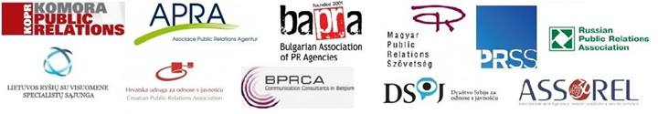

Register for Prague’s event now at http://wcf-davos-prague.evenium.net.
If you are a member of a partner organization, please provide the promo code for the special discount.

Visit: www.forumdavos.com or check the hashtag #WCFPrague!
Photos: https://picasaweb.google.com/107126070606639475341
Facebook: https://www.facebook.com/events/283041305169571/
Twitter: https://twitter.com/WorldCommForum
YouTube: http://www.youtube.com/user/forumdavoscom

For inquiries and information, please contact
Valentina Atanasova
Project Manager of WCFDavos
partners@forumdavos.com
+359 88 44 350 44

