PR Trends at WCF in Prgaue:

Less-is-More, Glocalization, Empathy, and Agility!
17 October 2013 at 19:18
Conclusions of the European Session of WCFDavos held in Prague, on 4 October

Top-rank communications professionals from 15 countries across Europe and senior Russian PR experts gathered together in Prague for the First European Session of the annual Davos World Communication Forum. On the previous day there was a Board meeting of the WCFDavos Committee to outline the future development of the Davos Summit's regional sessions and to consider the suggestions for its 5th main annual edition on 11-12 March, next year. Board decisions were taken regarding the due format and agenda content of WCFDavos'2014.

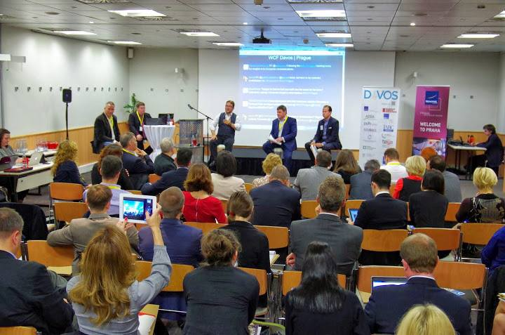
Prague session's key panel stating the very focus of the event: "The Future Communicator 3.0", was lead by Andre Manning, WCFDavos Committee Co-Chair and Global VP Corporate Communications at Philips. Here is what he shared:
"I agree that communications leaders should be highly engaged both with their internal and external stakeholders and they should be leading by example and speaking the truth to the company management power, which actually requires multiple skills and high emotional intelligence! We should not be so obsessed with the Board room, as more than two-thirds of the communications in organizations originates at other functions such as HR, businesses and marketing."

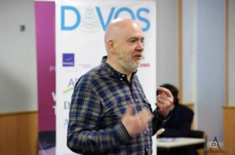
The opening keynote raised incredible interest and caused intensive interaction with the audience. It was rendered by Paul Holmes, the PR community guru worldwide, who marked several main trends of the industry: Courage, Savvy approach to data and Empathy as key features of the future Communicator 3.0, Social media and CSR for audience engagement, Brands being more dependent on employees, and the inevitable Evolving of marketing into a form of PR.

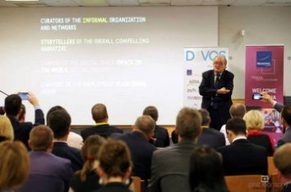
A great talk followed later on – Dr. Leandro Herrero's remarkable keynote on the Reinvention of CCO’s Role and Company Changes provoked by new behaviour models! Being the author of two bestsellers ("Viral Change", "Homo Imitans"), Dr. Herrero accentuated on some very interesting trends presented in a more analytical way: brand seen as a behavioural DNA pull, communications viewed from "outside the tribe", observation of the new urban social anthropology, focus on social movements for a better understanding on how to motivate people, communications focused on encouraging change (driven by behaviour management and good examples), and the "Less is More" approach: simple messages push actual behavioural changes (example: stating that 9 out of 10 people in your community do not litter has a far stronger effect than putting a sign that bans pollution).
Top level content came with every next agenda slot – now well reflected in the presentations' summary shared on the official WCFDavos website:http://www.forumdavos.com/regional_presentations/2.
The final TED-style real life-story-sharing talk by James Gillies, Head of Communications at CERN, cast a magic spell over the audience, rendering an excellent mixture of wit, wisdom and knowledge, the gripping clarity of which can only provoke and inspire!

Inspirational quotes and key insights shared in Prague:
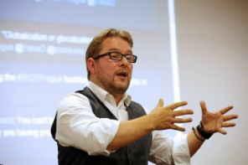
"Marketing mindset is still focused on how to fake data in the most authentic way possible, while public relations have already mastered the skill to be better storytellers." Paul Holmes
"It doesn't matter how much data you have at hand – it will not give you the right answer. It's the approach to it that matters." Nick Andrews
"Globalization or Glocalization? Key issue today is how to keep the consistency in the messages we need to deliver. We still have to find a solution for the smaller markets." Ladislav Cervenka
"Creativity is as a combination of art and design applied to culture. It is a must for the future communicator: rather than a strictly individuals’ capacity, creativity is a team platform, where ideas spark up and conversations are provoked!" Richard Chinn
"Communications should not (and do not) happen only in the Board room nowadays."Andre Manning
"Each leader has to face the regular work staff and communicate, in order to secure the long-term well-being of the organization." Terry O’Connor
"Less is More: the fewer people in a team, the easier we can manage them, the more we boss our employees, the less we are genuine leaders. While social media is about gaining vast audiences, true leadership is about achieving a grand goal with the help of your employees." Valery Levchenko
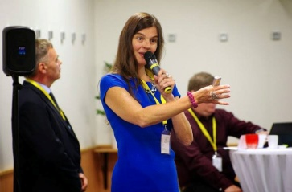
"Trust today is like a Playground – each player knows and follows the rules. Know your clients' touch-points, be agile, and lead." Senta Cermakova
"Senior PR is often stuck between external and internal stakeholders, as well as between the roles of adviser and business leader." Istvan Kutas
"Companies are truly global only if communicating in local terms." Gabor Hegyi
"Everything that happens online is knowledge." Maxim Behar
"For us, as professional communicators, the Web is a main channel! We now call for a self-regulated market, self-regulated users, and a sufficient number of Internet and Communications experts who should monitor these processes and influence their legislation. Access to Internet is as much a human right as the right to clean water or food supplies." Yanina Dubeykovskaya

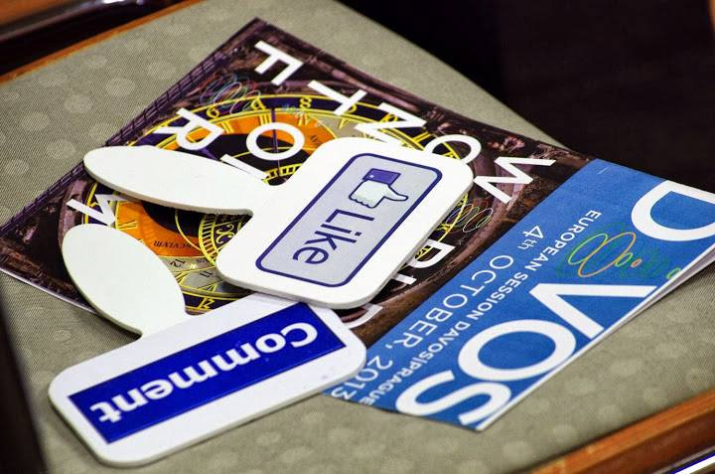
Visit: www.forumdavos.com or check the hashtag #WCFPrague!
Photos: https://picasaweb.google.com/107126070606639475341
Facebook: https://www.facebook.com/events/283041305169571/
Twitter: https://twitter.com/WorldCommForum
YouTube: http://www.youtube.com/user/forumdavoscom

For more details:
Valentina Atanasova, WCFDavos Project Manager
partners@forumdavs.com, +359884435044

