Top Speakers of Philips, Unilever, CERN, Telenor, EU Council, H+K, RIA Novosti gather in Prague to discuss future EU Communications
12 September, 2013
Davos Forum’s regional session for PR and communications
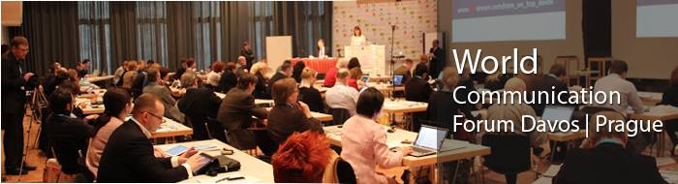
Top public speakers from across Europe will step out at the First European Session of the World Comm Forum:
4 October 2013,
Novotel Praha, Prague!

The overarching motto of the meeting: refuse to change, fail to understand new requirements, disregard the altered market demands, and lose competitiveness! WCFDavos|Prague focuses on Сhanges and Challenges in the PR and Communications in today’s rapidly developing digital world. Key topics of the agenda are: social and digital media impact on modern communications, privacy and publicity, global values and local trust, internet regulations, copyright, contemporary features of leadership. Yanina Dubeykovskaya, co-Chair of the Board and Content Director of WCFDavos, shares: “Today, each of us has to face some tough professional and personal choices. We choose the criteria of trust, transparency, digitalization, and we are still just learning to cope with the severe global competition.”

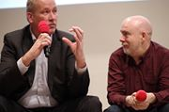
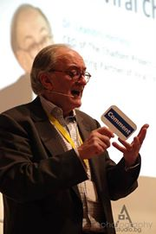
Paul Holmes, the PR and industry guru worldwide, will open the session with a talk on professional requirements and features of the Communicator 3.0, while Andre Manning, WCFDavos Board co-Chair and Global VP Corporate Comms at Philips, will continue with a key discussion on the Future of Communicators 3.0 - To be or Not to be?
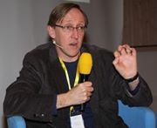
A keynote accentuating on Company Сhanges and the Role of Сorporate PR will be rendered by Dr. Leandro Herrero, author of the popular bestseller “Viral Change”, who says: “The answer to the new communications professional's role in the modern corporate organization is not simply a mere adaptation of the role, but its reinvention. There are no-man's lands and organizational areas where the PR and communications professional could thrive and take the lead. The opportunity for the reinvention of the New Comms Professional has never been greater!”
James Gillies, Head of Communications at CERN, Geneva, Switzerland, will lead a panel focused on Corporate Leadership - are senior managers more likely to be trusted as advisers, rather than followed as genuine leaders? He will also give a unique talk, sharing his own outstanding life-story: from Oxford research career into PR of Science - ideas, beliefs, values, crisis periods, insight, and solutions for success!

Among the remarkable European professionals who take part in the panel discussions are:
Maxim Behar, WCFDavos co-Chair, CEO of M3 Communications (Bulgaria), Chair of Hill+Knowlton Strategies (Czech Rep), Dr. Daniel Höltgen, Director Comms, Council of Europe (France), Terry O'Conner, Head of Comms, the Science & Technology Facilities Council (UK), Ladislav Cervenka, Director External Relations, UNILEVER (Czech Rep), Mark Mortell, Senior VP, Fleishman Hillard (Ireland), Richard Chinn, Senior strategist, Wolff Olins (UK), Istvan Kutas, Corporate Comms Director, Telenor Hungary Zrt., Valery Levchenko, Deputy Editor-in-Chief, RIA Novosti (Russia), Dr. Gábor Hegyi, Managing Director of Capital Communications (Hungary), Arturas Jonkus, Senior Strategy Consultant at Publicum agency (Lithuania).

Partners of the WCF Prague event are:
APRA and KoPR (Czech Republic), BAPRA (Bulgaria), DSOJ (Serbia), CPRA (Croatia), LRVS (Lithuania), PRSS (Slovenia), BPRCA (Belgium), MPRSZ (Hungary), ASSOREL (Italia), RPRA (Russia), and Pravda Awards (Ukraine).

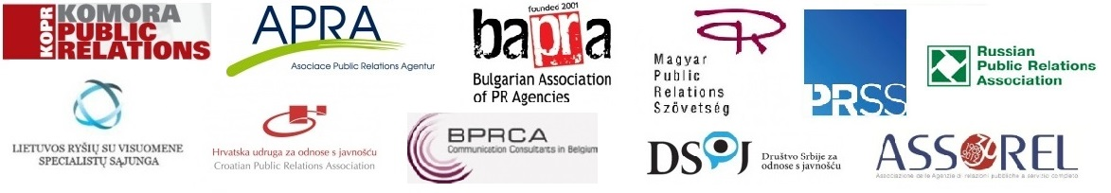
The main WCFDavos summit has been held in 4 consecutive annual editions in the past four years, summoning communicators from over 42 countries – chief managers and leading experts from nearly 85 consultancies, 60 companies, 15 international organizations, 12 media, 10 educational institutions and 6 government units. Davos Forum’s social network grows with each next event: a Facebook page uniting 1270+ fans, its Twitter account registers 815+ followers, and its YouTube channel exceeds 120 videos.

Registration terms can be found here: http://www.forumdavos.com/reg_registration/2
Members of partner organizations can use online registration with a special promo code – please, contact your local coordinator for details!
Online registration: http://wcf-davos-prague.evenium.net

For inquiries and information, please contact:
Valentina Atanasova
Project Manager of WCFDavos
partners@forumdavos.com
+359884435044

