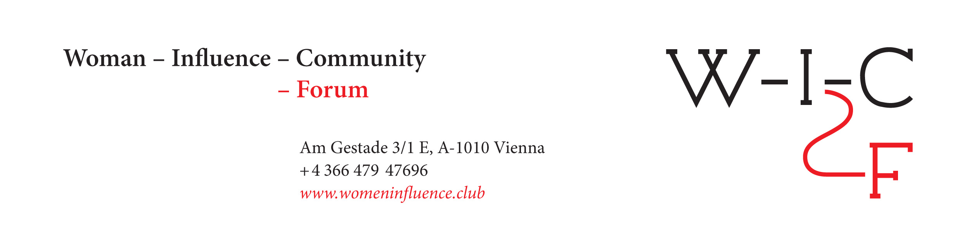
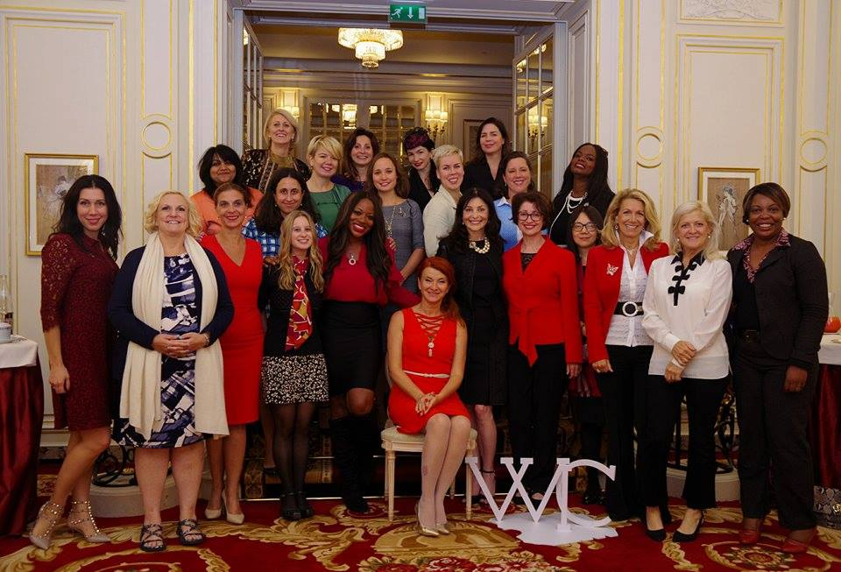

The first Women Influence Community Forum opened in Paris: successful women from 15 countries gathered at the Ritz to discuss six ways of women’s influence

On September 20, 2017, the first Women Influence Community Forum (WIС-F) took place at the legendary Ritz Hotel in Paris. Successful women from the USA, France, Russia, Germany, India, Switzerland, UK, Kenya, Turkey, Luxemburg, Belgium, Australia, China, Nigeria and Bulgaria gathered together to share their unique stories and powerful ways of influencing the world.

As a current key global project of the newly created and launched Women Influence Community (www.womeninfluence.club), the WIС-F Forum aims to unite proactive female business-managers, thought-leaders, philosophers, mothers, artists, muses, investors and entrepreneurs. The project and the community itself help those and other women all over the globe to continue to influence our world and enhance their role in the modern society.

The WIС-F Forum consisted of six equal panels devoted to six ways of women’s influence: Creator, Entrepreneur, Citizen, Professional, and even Mother and Muse. The WIС-F Forum attracted many French and international mass media and became a sensation on some internet platforms and social networks. The hashtag #womeninfluence reached an impressive rate of 2.3 million on Twitter and 20 000 on Facebook.

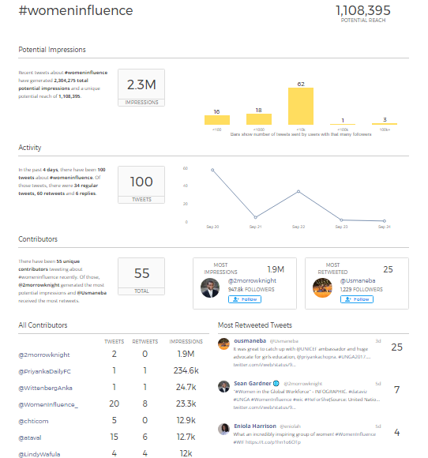

The next global session of the Women Influence Community Forum will be held on September 20, 2018, again at the renowned Ritz hotel, in Paris: register online.

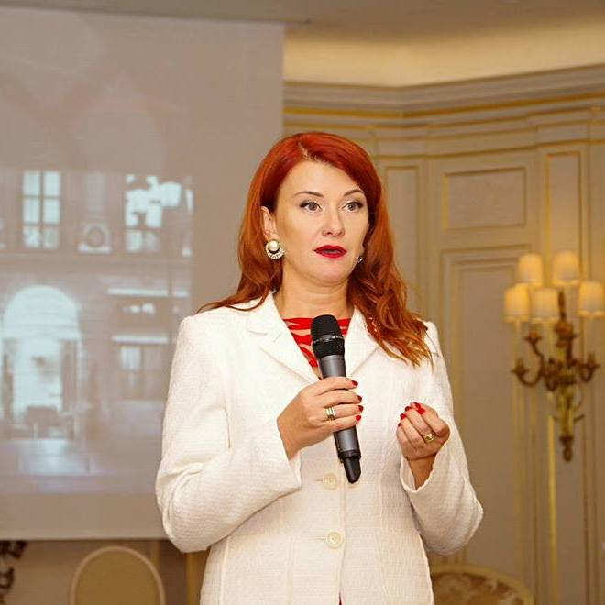
Yanina Dubeykovskaya, WIC-F's Founder & General Director and President of the WCFA Association in Switzerland, shared:
“Today, 50 extraordinary, talented, strong and successful women gathered to share their influence stories, so tomorrow at least 15 countries, 20 business companies, and women's communities around the world will gain further exposure to new ways of women's influence. This is the type of influence not based on a woman’s place in today’s social or business hierarchy, but rather on her mission to make herself, her environment, her country, and the world more perfect. For 2018, we have already scheduled additional WIC-F Forums in Russia, America, Switzerland, and Hungary.”

Watch the opening speech of Yanina Dubeykovskaya at the WIC-F Forum:
Huffington Post blog
Watch a short “teaser” video about the WIC/F Forum: here
Read more information about the Women Influence Community Forum: here
Follow the WIC-F Facebook Page: here

Please, address your questions and inquiries to:
MARINA MALAKHOVA, Tel: +336 32141373, Email: forum@forumdavos.com

