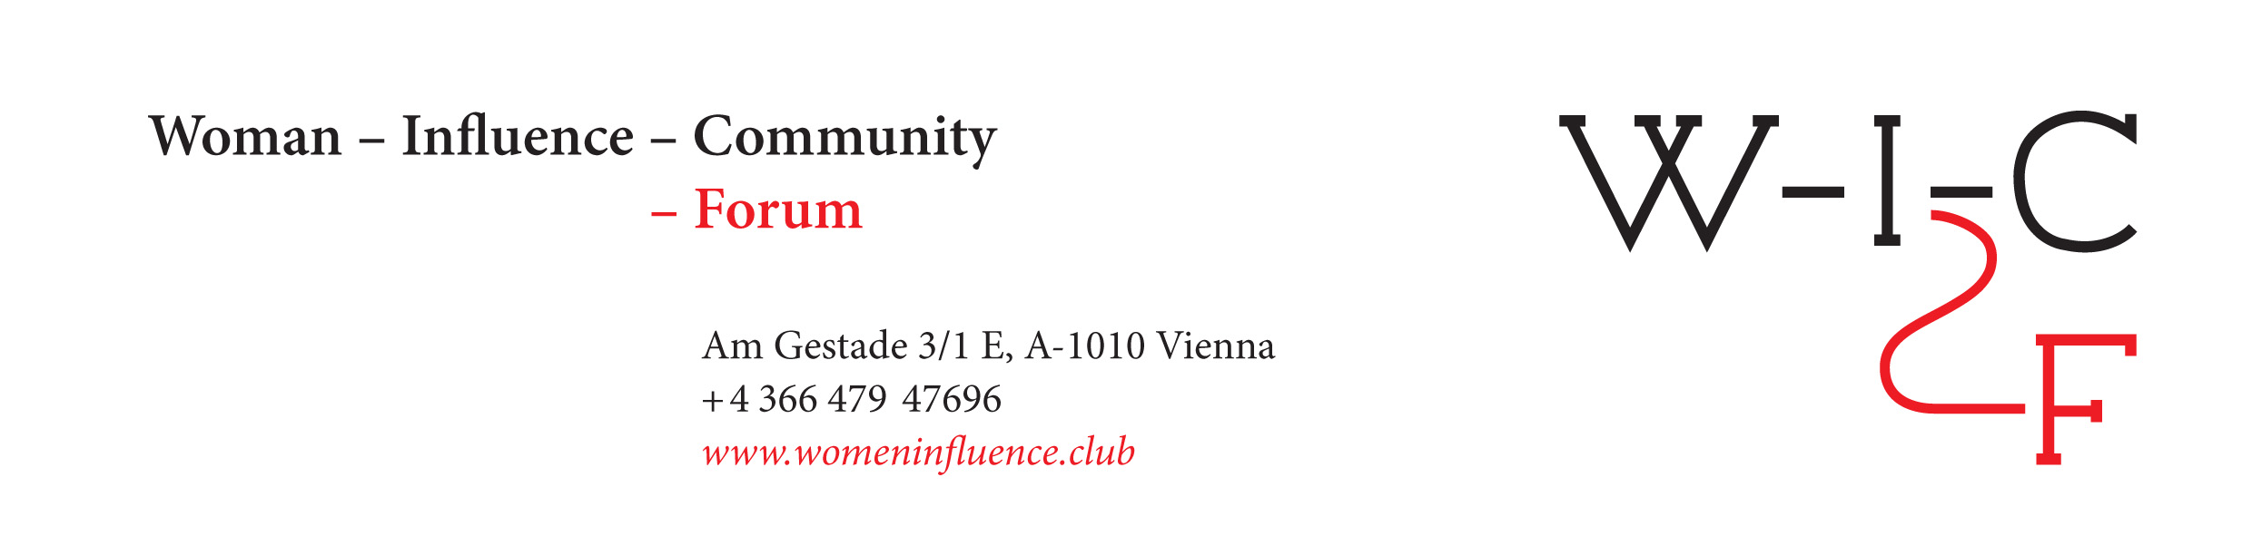

When Gabriel Chanel knocked at my door...

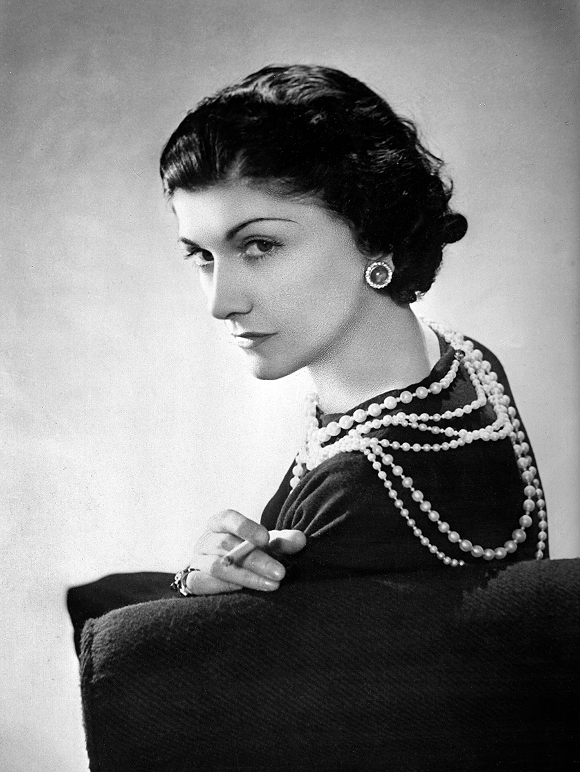
Can you imagine Gabrielle Chanel fighting for equal rights with men?
Not meaning social equality, since access to resources for education and medicine or participation in public decisions should be available for everyone – after all, they should be taken for granted.
We are rather talking here about the role of women in society, which, until today, is interpreted as if women are trying to run the same marathon of success and leadership that men are competing at, and complaining that men are faster.
Wait a minute, why should women need to run this marathon at all? Why not try to find our own ways of influencing the society? Let men run their marathon and take a stop, to think about it!
Looking for the right role of women’s influence requires, first of all, diving deep into the past and getting to know the biographies of influential women of previous times. And then one of them will suddenly knock onto your door and show you a way you couldn’t have noticed before, just because you were trying to run the marathon, seeing only men’s backs.
This is exactly what happened to Yanina Dubeykovskaya, WIC's Founder & General Director and President of the WCFA Association in Switzerland – Gabrielle (Coco) Chanel was the first who knocked at her door...
Reed the interview with Yanina Dubeykovskaya published in our Huffington Post blog and find out how Coco Channel has become a Muse for the upcoming Women Influence Forum, helping us to reconsider the traditional ways of women’s influence:
When Gabrielle Chanel knocked at my door...

