Women Influence Community Announced in Geneva

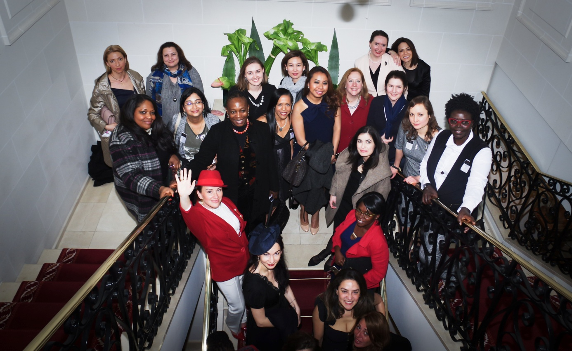

On 15th March, 2017, we gathered in Royal Manotel Geneva for a special occasion – Women Influence Community (WIC): project's inauguration & dinner. Initiated by the WCFDavos CEO Yanina Dubeykovskaya, the event gathered more than 30 successful women working mostly in the communication industry. All of them were dressed in Coco Chanel style.
Yanina Dubeykovskaya started the discussion with a speech on the six ways of women's influence. She named six basic spheres with the help of which women can have an impact on the world, explaining the qualities required and how the image of Coco Chanel has helped her formulate this theory.
Yanina's idea caused a vigorous debate: it turned out that every woman had her own story to tell about women's influence in today's world. The Co-Founder & CEO of World Woman Foundation Rupa Dash delivered a speech explaining how female protagonists in movies all over the world can impact the global economy.
After that, all dinner participants chose the roles they were successful in and marked them on personal sticker badges. To do it, they answered one simple question: what is your way to influence the world? Among possible answers there were: Entrepreneurship, Activism, Maternity, Creation, Professionalism and being a Muse.
Most of the dinner participants chose the roles of a professional, an interpreneur and a mother. The most 'unpopular' answer was the role of a muse. “This is because we still live in a men’s world: a lot of women struggle to be equal to men and to influence like men, which means that women do their best to get the traditionally male positions in politics and business. The comminity I'm trying to launch dares to change this situation: I'm sure we can make a difference! Be a woman, be yourself!” – said Ms. Dubeykovskaya.

Interview about WIF with Yanina Dubeykovskaya: Huffington Post blog
Video announce of the project: here

Background information:
Women Influence Forum is a new project of the World Communication Forum Davos team. The ambition of the project WIF is to fully engage its members in the development of powerful women's global influence.

More information about the Women Influence Forum: here
WIF’s Facebook Page: here

More information about the World Communication Forum: here

Please, address your questions and inquiries to:
Marina Malakhova, Tel:+336 32141373, Email: forum@forumdavos.com

