Women Influence Forum: successful women from 15 countries will discuss six ways of women’s influence and positive changes in the world, at the Ritz Hotel, Paris
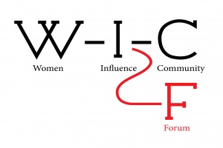
On Sept 20 the ambitious and innovative Women Influence Forum (WIF) will take place at the famous Ritz Hotel in Paris. Women from all around the globe will meet to discuss their ways of influence on the world.

WIF is a project of the Women Influence Community (www.womeninfluence.club), the main aim and ambition of which is to fully engage its members in the development of powerful women's global influence. It aims to unite proactive female business-managers, thought-leaders, philosophers, mothers, artists, muses, investors and entrepreneurs. The project and the community itself are created to help those and other women to continue influencing the world and strengthening their role in today's global business and society!

The Forum will consist of six panel sessions devoted to the six ways of women’s influence. Thus, the Women Influence Forum is the only platform where not only the classical “entrepreneur” and “professional” roles of women are discussed, but also such ways of influence as: being a mother, citizen, creator, and even a muse.

- Panel Session “Being a Creator” unites speakers such as:
- Alena Baeva, Violinist (Kazakhstan, Luxemburg)
- Olga Podoinitsyna, Member of the Board, VTB Capital (Russia)
- Camilla Webster, new acrylic series, female conscience, identity and desires – together with the world-renowned art consultant Tanya Brillembourg Capriles at IdeoBox Art Space, Wynwood, Miami (exhibition in October 2017), and also best-selling author of The Seven Pearls of Financial Wisdom: A Woman's Guide to Enjoying Wealth and Power (USA)
- Marie Beauchesne, Free-lanced consultant, entrepreneur, TEDx speaker (France)
- Loren Ferré, Chief Creative Officer of Grupo Ferre Rangel (USA)
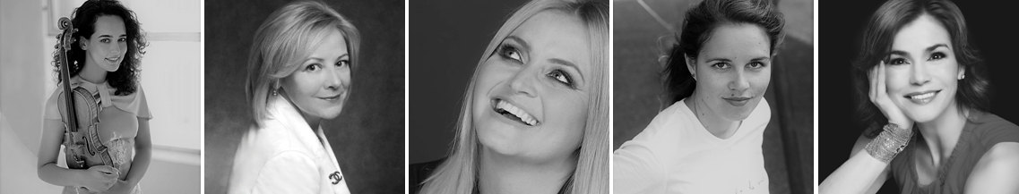

- Panel Session “Being an Entrepreneur” features the speakers:
- Dr. Anusha Ravi, CEO of Park Group of Institutions, Coimbatore/Chennai (India)
- Annie Mutamba, EU-Africa PR & Strategic Comms Consultant, co-founder of Meridia Partners (Belgium)
- Carol Pepper, Founder & CEO of Pepper International LLC, New York (USA)
- Ann Shriver Sargent, Co-founder & President of Porte-cochère (USA)
- Doris Hangartner, Founder & CEO of DORIS HANGARTNER AG (Switzerland)
- Natalia Smirnova, Owner & CEO at Personal Advisor Ltd., Moscow (Russia)
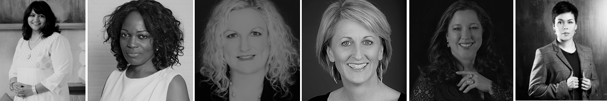

- Panel Session “Being a Citizen” gives the floor to:
- Lindy Wafula, CEO & Lead Consultant at Village Ventures International (Kenya)
- Dr. Jiahong Chen, Research Director S&C, Dialogue of Civilizations Research Institute (Germany)
- Catherine Hernandez-Blades, SVP, Corporate Communications, Aflac (USA)
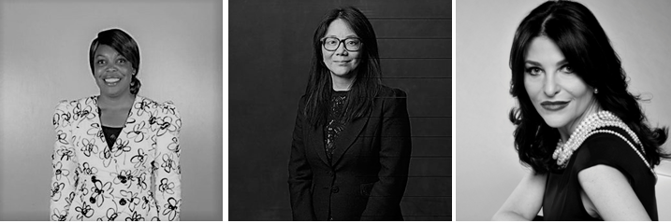

- Panel Session “Being a Mother” brings to the podium:
- Ilhame Boirie, President of MMM (France)
- Francesca Lana, NetworkHER President, Founder & CEO: ERA International (UK)
- Jan Cavelle, Entrepreneur, Writer, Coach to other women (UK)
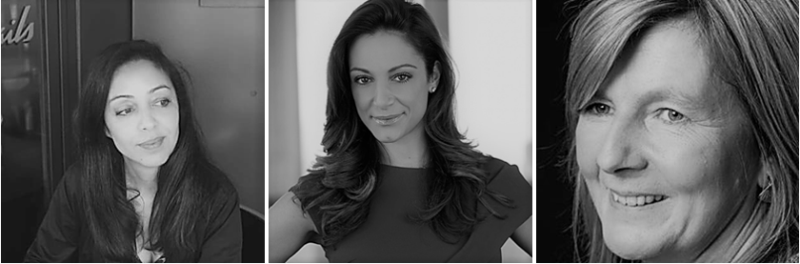

- Panel Session “Being a Professional” presents the following ladies:
- Prof. Patrizia Paterlini-Brechot, MD, Ph.D., Oncologist, Hematologist & Molecular Biologist at Faculty of Medicine, Paris Descartes (France)
- Kara Alaimo, PhD, Assistant Professor Public Relations, Hofstra University (USA)
- Kiki Keating, Founder & Head of Communications Strategy at KikiNetwork (USA)
- Ekaterina Kozinchenko, Partner, Head of A.T. Kearney, Russia & CIS (Russia)
- Maureen Murphy, Commercialization Advisor, Founder & MD of Clear Track Pty Ltd. (Australia)
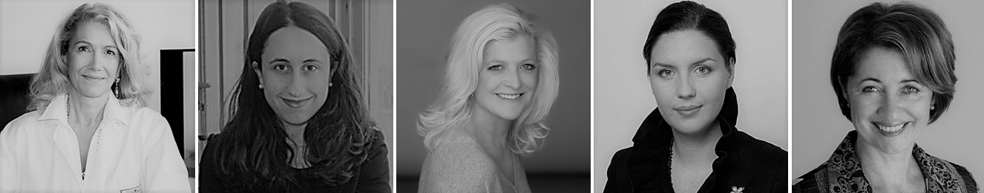

- Panel Session “Being a Muse” welcomes:
- H.E. Mrs Brigitte Touadera, the First Lady of the Central African Republic
- Galina Panina, Public Speaking Couch, Director PR&GR at Leroy Merlin (Russia)
- Chioma Isiadinso, Founder & CEO, EXPARTUS, New York (USA)
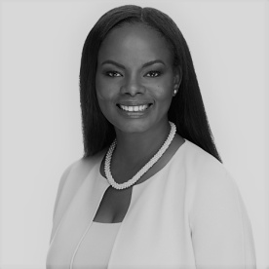

Yanina Dubeykovskaya, WIC's Founder & General Director and President of the WCFA Association in Switzerland, says:
“We have been preparing this forum for more than a year now, and I am glad that with our first steps we have managed to collect brilliant, talented and wise women from all over the world – women who comprehend their life and activities as influencing the future: truly influential women!
This year some regional WIF Forums have already been launched and will also be held in other countries. We believe that creating the Women Influence Forum is our first step towards the development of a global movement which will change the destinies of hundreds of women worldwide and make their life more meaningful and happier.”

Interview about WIF with Yanina Dubeykovskaya: Huffington Post blog
Video announce of the project: here

Background information:
Women Influence Forum is a new project of the World Communication Forum Davos team. The ambition of the project WIF is to fully engage its members in the development of powerful women's global influence.
More information about the Women Influence Forum: here
WIF’s Facebook Page: here
More information about the World Communication Forum: here

Please, address your questions and inquiries to:
Marina Malakhova
Contact:Tel:+336 32141373
Email: forum@forumdavos.com

