Innovators and designers met together in Łódź (Poland)
10 thematic blocks, 33 panelists, including special guests, such as the president of Łódź Hanna Zdanowska, Willy Lai Director of User Experience Design (Silicon Valley) and Jean Maer Design Director at IDEO, and an audience of experts and specialists in the field of user experience. All of these people took part in the first Polish edition of the World Communication Forum Davos in Łódź, dedicated to innovations and Human-Centered Design.
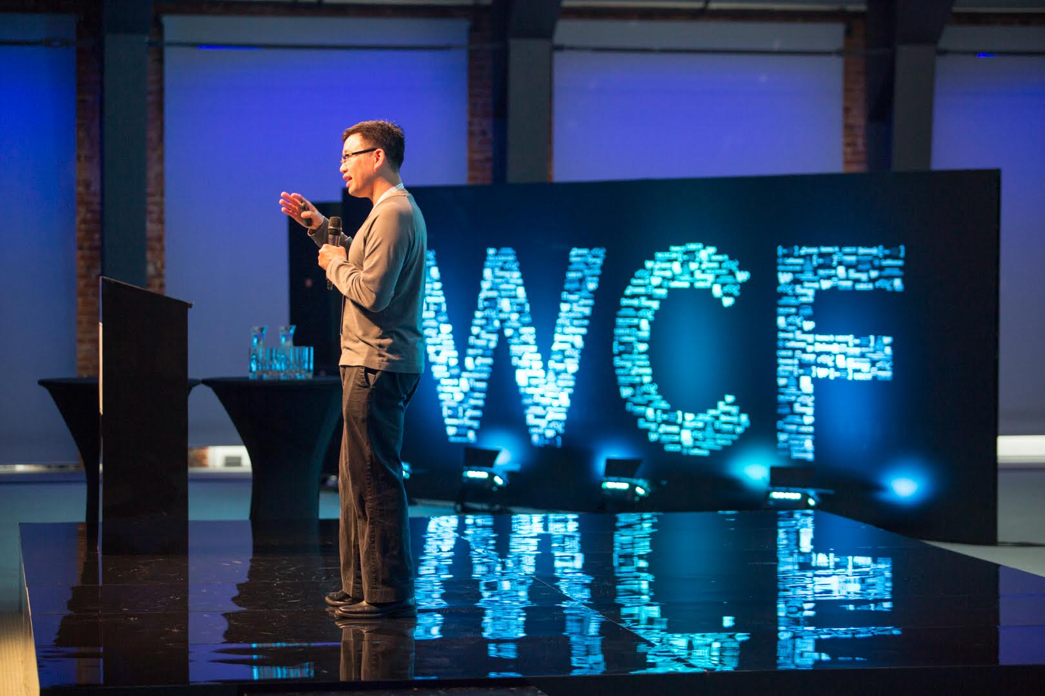
Willy Lai, Director of User Experience Design, Internet and Emerging Technologies, Silicon Valley (USA) / "The Business Value of User Experience Design"
For two days Łódź hosted the World Communication Forum Davos conference, dedicated to innovations and Human-Centered Design. The conference was opened by the organisers - the president of Łódź Hanna Zdanowska and the director of The Story Dymitr Romanowski. The conference was attended by experts and specialists from 18 countries, professionally involved in user experience and designing innovations. Among them were representatives of Polish and foreign companies, such as IDEO, UBER, Abbott, ABBYY, Starbucks, TripAdvisor, Unilever, MARS, Avon, Schneider Electric, Moleskine, as well as international organisations, such as NATO, and national ones, such as Engage Warsaw. Willy Lai was the special guest of the event.
The main topic of the conference was the concept of Human-Centered Design, which is currently the driving force in designing innovations. It is based on the assumption that innovation should cater to the needs of people. Being able to read people’s needs is key to creating innovations. There were 10 thematic blocks during the conference, related to those areas of human activity which innovators focus on.

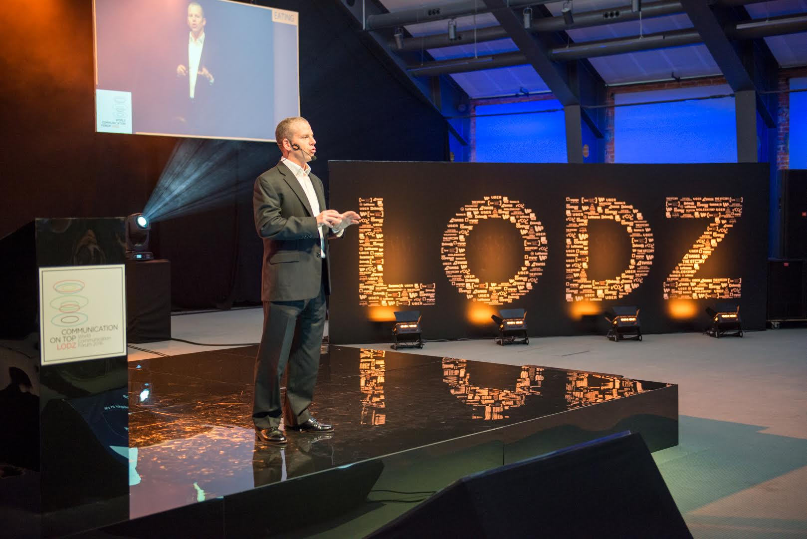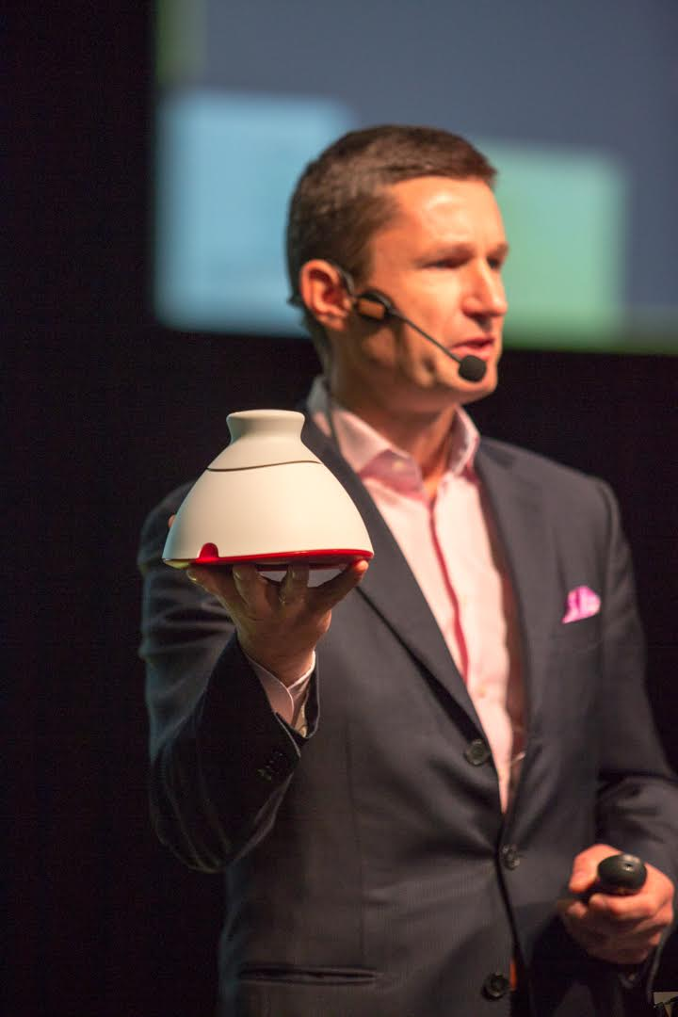
Drew O'Malley, Chief Digital Officer at AmRest (Poland) / "Restaurant innovations in Central Europe", and Marcin Halicki, Chairman at Braster (Poland) / "Revolution in breast cancer detection"
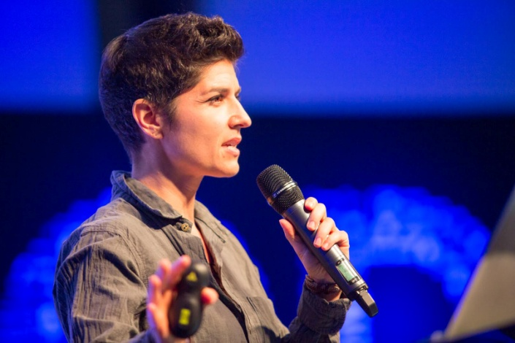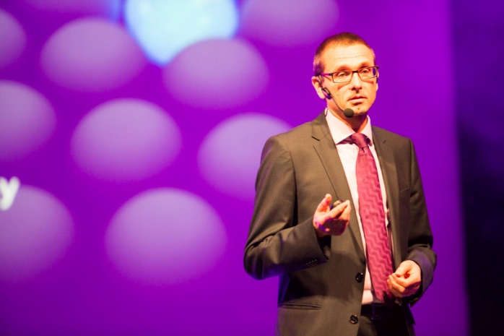
Jenn Maer, Design Director at IDEO - San Francisco (USA) / "Why Storytelling Matters in Healthcare", and Franky Saegerman, Head of Digital Insights at NATO (Belgium) / "NATO and Social Media - Measuring what matters"
The World Communication Forum Davos in Łódź conference was held in Poland for the first time. The conference was conceived and co-organised by The Story, a company focused on designing and implementing innovations in the IT field. The conference was co-organised by the city of Łódź. The conference took place on 10-11 October.
More information about the conference and the speakers you can find on www.davoslodz.com
Kacper Chudzikiewicz
media&content manager at The Story
Kacper.chudzikiewicz@thestory.pl, m. +48 572 940 901

