PRAGUE MEETS THE WORLD’S PR ELITE
15 August 2013 at 13:47
Davos World Communication Forum invites experts to discuss modern PR

First regional meeting in Europe organised by the World Communication Forum (Davos) – at Novotel Prague, on October 4, 2013.

The WCF Prague agenda will focus on "Communication Professionals 3.0 – Changes & Challenges: the PR expert in a rapidly altering digital world" as a main overarching theme, with the following expected key points: social media threats and advantages, new challenges of the business, and smoother ways of cooperation between agencies, their clients and local or international institutions.

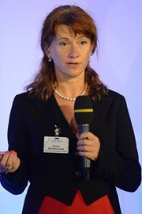
“With its new regional format, the global discussion on top communication trends initiated by us in the city of Davos will inevitably start uniting more and more professionals from around the world, bringing to the event unique expertise and shaping up tomorrow’s professional public relations and public affairs agenda”, says Yanina Dubeykovskaya, co-Chairwoman and Content Director of the Davos Forum and its regional sessions.

Among the key speakers will be leading representatives of the industry like Paul Holmes (CEO and founder of The Holmes Report), Andre Manning (Vice President at Philips Electronics), James Gillies (Head of Communications at CERN), Dr. Leandro Herrero (author of “Viral Change” bestseller), Maxim Behar (Hill+Knowlton Strategies), and others.

Key professional communities from Europe have already agreed to partner with the Prague Forum, among them: APRA and KoPR (Czech Republic), BAPRA (Bulgaria), DSOJ (Serbia), CPRA (Croatia), LRVS (Lithuania), PRSS (Slovenia), BPRCA (Belgium), MPRSZ (Hungary), ASSOREL (Italy), and RPRA (Russia).
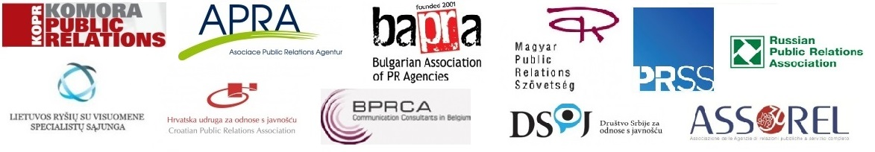

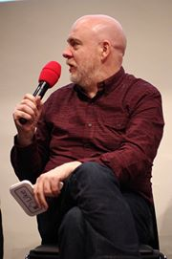
Paul Holmes (CEO and founder of the Holmes Report) has recently stated his about the Forum in Davos: "I have no idea how, but in the past several years the organisers have managed to create the liveliest engaging and influential event in our industry – this Davos meeting is an absolute phenomenon!"

For 4 years, the Davos Forum has summoned top communicators from over 42 countries, most of whom are chief managers and leading experts based in more than 85 consultancies, 60 companies, 15 large international organizations, 12 media, 10 educational institutions and 6 government units.

The WCF Davos Forum social media network grows with each next event: today its Facebook page unites 1170+ fans, its Twitter account registers 810+ followers, and the YouTube channel exceeds 120 videos.

Register for Prague’s event now: http://wcf-davos-prague.evenium.net
Members of partner organizations, please remember to provide your promo code for the special discount!
Agenda: http://www.forumdavos.com/regional

For more info, contact: Valentina Atanasova, Project Manager, partners@frumdavos.com, +359 88 44 350 44

