Discover the Undiscovered and turn it into a Business
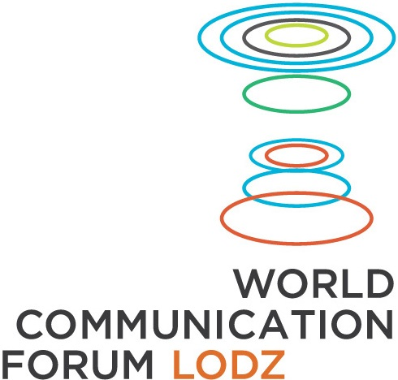
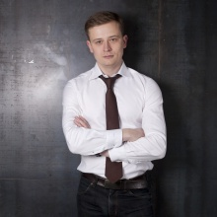
Dymitr Romanowski, CEO of The Story, talks about the first Special Edition of the World Communication Forum dedicated to Human Centered Design and held in Lodz, Poland

What is Human Centered Design?
Let me give an example. I’m sure you have used a smart phone before. Convenient, isn’t it? Human-Centered Design simply means designing simplicity, usefulness and aesthetics of a certain solution, such as a product or service. In other words, it’s about designing a solution so that it meets the expectations of the consumer when it comes to those three key factors. This is why new solutions are created based on research and observations of potential consumers, who are engaged in the production process. Some services and products are widely held to be convenient or just great to use and people feel the need to tell their friends about them. Others leave people indifferent or even unhappy. The former example is the one that has been created according to the Human-Centered Design principles.

Why have Tesla cars become so popular, setting aside the ecological advantages?
It’s the prime example that the most exciting products and services put the consumers’ and their needs first and become the starting point for further innovations. If this need is well identified and then provided with the right solution, we can be sure of commercial success.

Does that mean that to drive innovation all that’s needed is to change the approach during the production process?
Exactly! Let me use another example. Where did UBER come from? It’s a service that was created based on observation of the preferred methods of transportation. It was a matter of answering some basic questions. How important is using your own car? Is giving someone a lift a part of the culture of the target country? Are customers ready to forego taxis and get in a private car in exchange for a lower price? When they put all that together and added the popularity of mobile devices and the ubiquitous nature of the Internet, they came up with UBER. All that was needed was to create a service based on something that was always in high demand. I might add that we have invited Kacper Winiarczyk, the general director of Uber in Poland, to Łódź to talk about trends in transport of urban agglomeration residents. Let’s not forget about technological innovations, which are inextricably linked with service and product innovations. Technological products, which we can touch and use, are created through the use of Human-Centered Design.

Who else will we be able to see and listen to in Łódź?
There will be Jenn Maer from IDEO. This company is the icon of designing innovation, since they were the first to focus entirely on that idea as a business. And Human-Centered Design is a business and it is gaining more and more importance. IDEO designed the mouse for Macintosh on behalf of Apple in 1980. Since then, they have been designing products and services for many famous brands – LCD screens for Samsung, computer mice for Logitech, business class seating in Lufthansa planes and even the kitchen of the future, working with IKEA. No doubt the most important guest of the conference will be Willy Lai, the User Experience Director at the company for whom IDEO designed their mouse. I think they require no further introduction. This is an unprecedented event. Nobody else was able to invite a representative of this company to Poland. I’m happy to have a chance to meet him in Łódź, taking into account how much experience he accumulated over the years working for such companies as Samsung, AOL or eBay. The conference is a chance to meet experts on customer experience, service design and product design. There is a lot of special guests, since there is a lot to talk about. We divided the conference into 10 sections. Each is dedicated to a part of life that gets a lot of attention – from health to issues connected with living in an agglomeration.

This will be the first conference in Poland organised under the auspices of the World Communication Forum Davos. Could you tell us more about this organisation?
World Communication Forum Davos has been active for the past 8 years and it gathers communication and PR experts, such as Paul Holmes, the founder of The Holmes Report and the SABRE Awards, Faith Muthambi, the South African Minister for Communication, Sabitha Natraj, member of the board of Indian Oil Corporation in India, Scott Fahlman, the creator of emoticons and a Carnegie Mellon University professor from the USA, Jamie Vernon, the editor-in-chief of the American publication „American Scientist“, and Zhao Dali, the Secretary General of the China International Public Relations Association. The agency that I manage, The Story, is the Polish member of the organisation . We design and implement innovations according to the principles of Human-Centered Design.

Why is the conference held in Poland?
A lot of innovative projects are created in Poland, because the Polish are very entrepreneurial. I myself am one of those people. This is why, when the WFC board was deciding where to host the special edition dedicated to innovation and Human-Centered Design I proposed it should be held in Poland.

Łódź became the hosting city of the conference. Why?
Łódź has won the bid to host the conference. Warszawa, Poznań and Gdańsk received the same opportunity. Personally, I’m happy that Łódź became the co-organiser. It’s a special city with a rich history of entrepreneurship and creativity. I’m even happier that we will be graced with a visit from the president of Łódź, Mrs. Hanna Zdanowska.

How do you evaluate the Polish market absorption of products created by companies like yours?
We decided to help drive the Polish market for innovation. We are wondering if we’ll be able to create a new IDEO for the Central and Eastern Europe. We have already implemented a lot of projects. Currently, at the Story, we are working on a project called opoznionysamolot.pl. It’s a service that helps passengers receive compensation for a delayed or cancelled flight. Another example is the application ocozaklad.pl, which allows to place friendly bets among Facebook friends using a mobile app. We also worked on a much more serious project dedicated to local government funds. Thanks to nacoidamojepieniadze.pl we present how local governments spend their funds in a unique way. Together with PwC and the Polish Wind Energy Association we also created zieloneaukcje.pl, the first Polish platform that educates entrepreneurs how to sell surplus wind energy. We also have some successes on the foreign markets. For KCR, we’ve created a tool called Date Forecaster for the American market, which helps patients keep track of doctor’s appointments. The Story was also responsible for the UX Warsaw project on behalf of the capital’s tourist bureau. For this project, our company researched the experience of foreign tourists coming to Warsaw to visit the most famous landmarks. I am curious of how well we do in the future and whether the Polish market will be able to accept a service of designing and implementing innovations.

The World Communication Forum Davos conference will be held on 10 and 11 October in Łódź. Details and registration on www.davoslodz.com
For contact: hello@davoslodz.com

