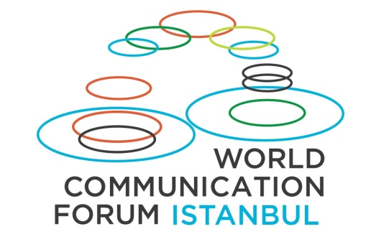
Davos World Communication Forum is to meet in Turkey
Held for the last five years in addition to Davos World Economic Forum, Davos World Communication Forum is now meeting in Istanbul to discuss “Crisis” and “Reputation”.
Gathering the world’s leading communication professionals, Davos World Communication Forum will be hosted by Istanbul University on the 3rd and 4th of November around the main theme “Crises and Chances: Country, Company and Personal Reputation”.
Expecting participants from many different countries, the opening speech of the Forum will be delivered by Allan Mayer, communication consultant of many Hollywood studios and stars. The Founder and General Director of WCFDavos, Yanina Dubeykovskaya, will start the sessions gathering esteemed communication professionals, including the following: the co-founder of Huffington Post and famous social media professional Sean Gardner from USA; also from USA, the journalist and Emmy nominated producer Rasha Goel, widely known for her interviews with Hollywood stars; the reputation, crisis and international communications specialist and Chief Academic Officer of Glion Institute of Higher Education Dr. Jon-Hans Coetzer from Switzerland; the international communications and crisis management expert, Founder and Managing Partner of The Stable House Richard Linning from United Kingdom; the Chief Executive Officer at Lubri Oil Corporation and communication strategy advisor for the Malaysian government Nurul Ashiqin Shamsuri; international digital and social communications consultant Gianni Catalfamo from Italy; Irina Bakhtina, Board Member and Communications Director of Unilever Group in North Africa, Middle East, Turkey, Israel, Russia, Ukraine and Belarus; the public diplomacy and communications specialist Ekaterina Lavrova, and the city branding specialist Vasily Dubeykovskiy from Moscow, Russia.
Many speakers from Turkey will also participate at the forum: Prof. Temel Kotil, General Director of Turkish Airlines and Academician (Professor, PhD), Korhan Kurdoğlu, Ata Holding Chairman of the Executive Board, İbrahim Eren, Deputy General Director of Turkish Radio and Television Corporation, Burak Karapınar, CEO of Invenura Holding, Defne Tozan, General Director of IBM Turk, Ziya Erdem, General Director of Ericsson Turkey, Fatoş Karahasan – Marketing, Advertising, Digital Communication Expert, Author and Academician (Asst. Prof.), Mehmet Gün, Gün + Partners Law Firm Co-Founder and Executive Lawyer, Bengi Vargül, President of Association for Corporate Communicators and TAV Airports Management Corporate Communications Director, and Arın Saydan, Vice President of Communication Consultancies Association of Turkey, Chairman of the Executive Board of Bersay Communication Consultancy.
The First Davos Organization in Turkey
Davos World Communication Forum has been held in Davos, Switzerland since 2010 as the extension of the World Economic Forum and is accepted to be one of the most important communication organizations in the world. The Davos World Communication Forum Director for Turkey and Istanbul – the University Faculty of Communication Professor Ali Murat Vural, explains that this organization carries a vital importance and significance as the first Davos organization to be held in Turkey.
Prof. Vural says “As if the bombs were not disruptive enough, the coup attempt of July 15 damaged our country’s reputation partially and unfairly. Thus, almost all scientific and social meetings, summits and concerts have been canceled. However, we achieved to keep the Davos World Communication Forum in Turkey from getting canceled, no matter what. This is Now an Organization That Carries Great Importance for the Country’s Reputation."
Prof. Vural expresses his joy that the Davos World Communication Forum will take place despite the consecutive crises recently experienced in Turkey and he mentions the gratitude of Istanbul University and the government to host the distinguished speakers and participants in Istanbul. Recalling the messages of support by the speakers, Prof. Vural adds:
“Surprisingly enough, Allan Mayer, who will deliver the opening speech, said that everyone around him tried to conceive him not to come to Turkey, but after the letter of the Grand National Assembly of Turkey that we sent to our speakers, he expressed that nothing would stop him from coming to Turkey. Other dear speakers and World Communication Forum’s General Director Yanina Dubeykovskaya supported us and stood by us, in spite of some initial hesitations. This organization is very important for gathering the best communication professionals from around the world. Beyond that, it now carries a great significance in a world full of crises, and an even greater importance for Turkey. With our distinguished speakers from Turkey and abroad, we will discuss crisis, the opportunities created by crises, and reputation in the contexts of person, company and country. As Istanbul University representatives, we are proud to hold such a grand organization at a critical time.”
General Partner of the WCF-Istanbul is the Turkish Ministry of Culture and Tourism. Key Sponsors of the event are the Turkish Airlines, ATA Holding, Arbeta Tourism, the Turkish Radio and Television Corporation - TNT World, and the company Invenura. The proud host of the event is Istanbul University.
Details and more information about Davos World Communication Forum Istanbul can be found at the web site of Istanbul University: http://davos.istanbul.edu.tr/ and the official web site of the Forum: http://www.forumdavos.com/regional/16

