Communication after the digital revolution: Yanina Dubeykovskaya about the global mission of WCFDavos

In the end of September, 2015, for the first time in Asia, the Davos Communication Forum shall be held as a high-level regional event (WCFDavos/Kuala Lumpur). Yanina Dubeykovskaya, the founder of WCFDavos, its very mastermind and head of the WCFDavos Committee, talks about the Forum’s true essence and mission.

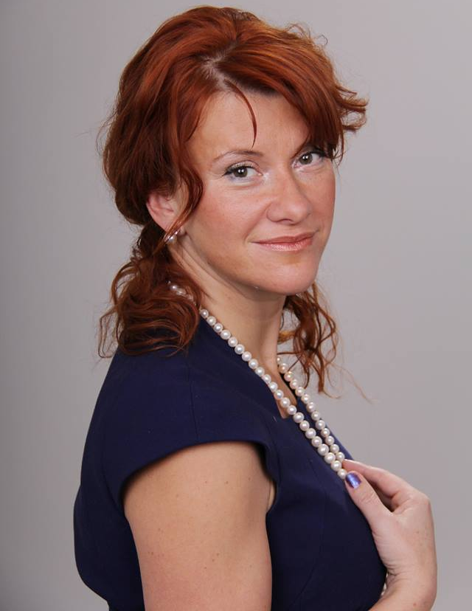
- Yanina, tell us about the Davos Communication Forum - the history of its creation, its mission, geographical scope, objectives and audiences.

The story of the Forum started 7 years ago and, respectively, equals around 60 000 hours of hard work, drive, dreams, despair, frustration and happiness. Talking about the establishment of the Forum can be done it two aspects. The first one covers the rational, corporate business. It is linked to the digital revolution that added weight to the profession and changed the role of communicators throughout the industry worldwide. We were among the first to realize that a new global professional community needs a new level of discussion. We took over the organization of the Forum as a platform for active people – drivers of the communication industry, in order to, firstly, find like-minded followers in the big world, globally, and, secondly, strengthen our own influence in shaping up the future of humanity. Therefore, we gather annually in Davos, which is traditionally known as the place for discussing the agenda of our future. Last year we had guests and participants from 34 countries, several ministers of communications and government spokespersons, some high-level deputies and very professional experts from the ministries of foreign affairs of 6 countries, representatives of some of the biggest agencies and reputable directors of corporate communications. This is precisely who we call influencers!
The Forum, as a global event, demonstrates that there are no teachers or students in our industry, that one local expertise always complements another, that communication challenges which the world is facing today require a drop-off of the restrictions on communication experts, which calls for a common awareness and understanding of our capabilities and true mission as professionals.
The second aspect of the Forum’s creation is more metaphysical. I guess to me and my closest associates it is crucial to understand our own social mission and, within our short lifespan, to try to do what we believe in. Such is only the sense of existential awareness, the sense of purpose. Another important point – you should never put any limits to your dreams, but afford yourself to jump twice your own height, go beyond, and erase them all.

- How did you come up with the idea of the Forum in Kuala Lumpur? What are the tasks and challenges the organizers get ready to face up?

Each regional forum occurs around a specific person who, having attended the main Davos event and having felt its unique format, audience, and atmosphere, finds the strength to bring it to the professional community of their own country. Nurul Ashiqin Shamsuri was the first participant and speaker from Malaysia who joined us a few years ago and then became a regular participant. She has recently become truly active in her own country and she felt the urge to combining our efforts, so that together we can hold a noticeable, meaningful and important regional event. In our turn, we gladly agreed, as we have always been interested in opportunities for closer contacts and analysis of Asian practices and those of the Malaysian professional community, in order to understand the needs for successful integration of the Asian professional community with the existing global expertise.
So, we are really grateful to Nurul and the influential people who have kindly accepted to join and make the Kuala Lumpur regional forum edition possible. Generally, this reflects a core trend: the world of communications has certainly strengthened the role of the individual as a key source of trust, competence, and uniqueness. It also reflects the peculiar shift of focus from the past decade’s blog-influence to the new evangelism of the Company Brand Leader.

- How are global communication threads woven into the fabric of the local forum?

Our Forum comes to each country with an agenda necessary for the development of this country or any of the segments of industry there. We do not adhere to the principle of replication or "top-down" imposing of the main forum theme or topics. Again, the semantics of hierarchy or the idea of the guru and his disciples is not close to us at all. We collect the highest professional expertise globally and believe that each regional or national market has unique features that will enrich the global communications industry.
Often, at regional forums where the level of local professional expertise is very high, some hot topics for discussion originate and get implemented in the Davos Forum content. However, one of the key tasks of the Forum in Davos is, of course, the formation of a global communications agenda, so the subject of global communications, the communications capacity for increasing the communication and reputational influence of a country, are very close and obviously relevant to Malaysia nowadays, when the country is opening to the world.

- Is the World Communication Forum Davos more likely to debate and discuss upcoming trends or provide the possibility of gaining practical knowledge and tools?

Any type of a tool-set follows the meaning and purpose of the respective campaign. The Forum, of course, offers some of the best examples and cases, but they all come to prove that tools are of secondary importance. What is more essential is to grasp the Big Idea.
The key effect of the Forum is the very broadening of the boundaries of understanding, uplifting the level of professional thinking, expansion of the global business contacts, and, of course, the inspiration that is given to each one of the participants.

- Who, in your opinion, should visiting the forum be recommended to and why?

Based on the above-stated and also considering the status of the project as perceived by me personally, I believe that the Forum will be useful for all who have an urging desire to go beyond the frame of industry services, who have the ambition to conquer new professional heights, and who are naturally interested in our huge global world.

Source: World Communication Forum – Administration

