Overzealous Citizen Journalism A Dangerous Trend
By Syamsiah Sahat
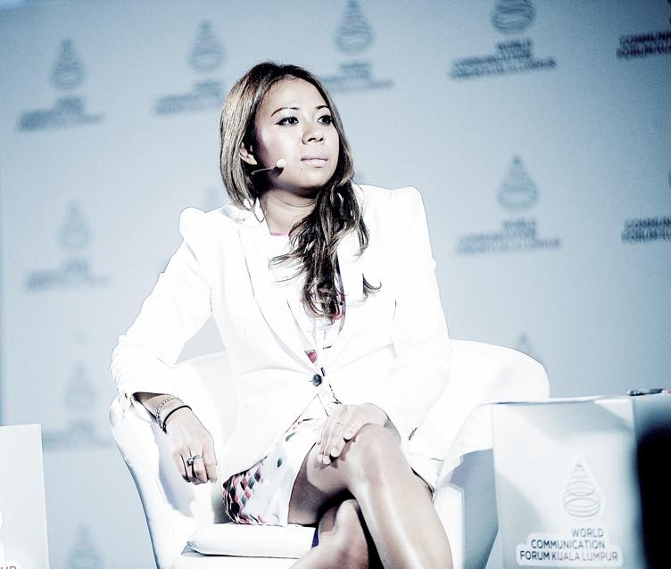

KUALA LUMPUR (Bernama) -- The race to become the first person to share a juicy piece of news is among the main reasons why many simply share information over the social media without verifying it authenticiy first.

This overzealousness has resulted in many a communication crisis, sometimes with dire consequences.

The director of the World Communication Forum Kuala Lumpur (WCFKL) 2015, Nurul Ashiqin Shamsuri said that human beings have a psychological and emotional need to come out first. This drives them to become online 'citizen journalists' by spreading whatever information they come across as quickly as possible without verifying the facts.

"Our country is going through a phase of information boom via increasingly sophisticated channels, with blogs and social media connecting people within seconds.

"Malaysia has only started its journey 10 years ago, and this makes it a newcomer to the experience. It's like a growing child, amazed by his new "power" to spread information across borders," she told Bernama in an interview during the ongoing WCFKL 2015 here.

DANGEROUS STAGE

Nurul Ashiqin, who is also a law and corporate communications lecturer at UCSI University, said that the netizens of Malaysia have forgotten the true function of technology in their fervour to spread news.

The Internet was originally meant as a platform to share positive information, boost the economy and disseminate government policies.

"Everyone wants to become an instant journalists. They eagerly share information to get thousands of 'likes' on Facebook and Twitter, without caring that it is false, all so they can enjoy their five minutes of fame," she said.

The communication crisis is not only prevalent in Malaysia, but in countries like Turkey and the United States as well.
"Citizen journalism is at a dangerous level in the country, and if unrestrained, social media sites could be made into a platform to destroy the reputation of a person, organisation and even country.

"It could reach a stage where people would rather believe unverified information than the truth disseminated through proper channels," she said.

EDUCATE, NOT CASTIGATE

However, Nurul Ashiqin was optimistic that educating people on the right usage of technology was more effective than punitive measures.

She believed that with guidance and time, netizens would come realise the consequences of sharing a piece of information without double-checking the facts first.

She is making it her mission to turn WCFKL into a platform to educate technology users and players in the country and hope that with the support of international technology enthusiasts, WCFKL would become an annual event for participants of all ages to share the ways in which information technology could be benefited positively.

JOURNALISTS MUST STEP UP

Meanwhile, crisis communication expert and Hollywood spin-master Allan Mayer agreed that the spreading of unverified information by citizen journalists has today reached a dangerous phase.

Mayer, who used to be an advisor to a wide range of corporate and institutional clients in the entertainment industry, said the way citizen journalists manipulate news could cause panic among the public.

He said journalists would get into trouble if they reported on something they were unsure of. On the other hand, citizen journalists seemed to be able to put out anything they hear without fear and understanding of the repercussions.
"That's a very dangerous thing and we're living with the consequences of that now. There are all kinds of terrible information going around and most people get it not from newspapers, radio or television broadcasters, but from somebody with a Facebook or Twitter account," said Mayer, who is a panelist at WCFKL 2015.

He suggested the problem be tackled by having 'real journalists' respond to any issues as soon as possible, in accordance with the speed of today's information technology.

"You have to give the people as much information as you can because at the end of the day, the individual citizen has to make up his or her own mind.

"I think it is the journalist's job to provide accurate information as much as they can so that citizens can make whatever decision they make. Understanding the motivation of why people are telling them certain things is very important."
Source: BERNAMA
http://www.bernama.com.my/bernama/v8/fe/newsfeatures.php?id=1175450

