Social media practitioners need to be more responsible
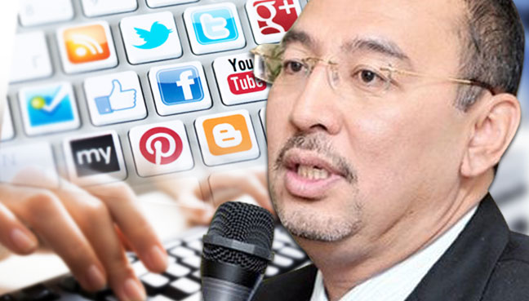
KUALA LUMPUR: Social media users and practitioners need to be more careful and responsible with any information that is shared and reported through the medium.
Communications and Multimedia Deputy Minister Jailani Johari said social media users should ensure that any matter reported and shared on social wesbites had a positive social impact, and would not affect the reputation of any party.
“It should not be because one wants to be an ‘instant news journalist’ and in pursuit of popularity, report on and disseminate false information, when by right, social media should be used as a platform for sharing positive information,” he said.
He was speaking to reporters after launching the 2015 World Communication Forum Kuala Lumpur (WCFKL) at the Putra World Trade Centre here, Monday.
Jailani hoped WCFKL could become a platform to create communication practitioners who were more ethical and responsible in disseminating information.
He said through WCFKL 2015, which was being held in Asia for the first time, Malaysia could share and gather information on how to create a solution to tackle the problem of baseless information.
“Through an experienced panel, we expect Malaysia to gain knowledge and new strategies, so as to cope with the new challenges of social media, positively,” he said.
WCF, which began in Davos, Switzeland, is now being held in Asia for the first time, and Malaysia was chosen to host it this year.
Source: BERNAMA
Published by The Today Post, Malaysia:
http://my.thetodaypost.com/dont-be-an-instant-news-journalist-seeking-fame-4753

