Malaysia hosts the World Communication Forum on 28 and 29 September
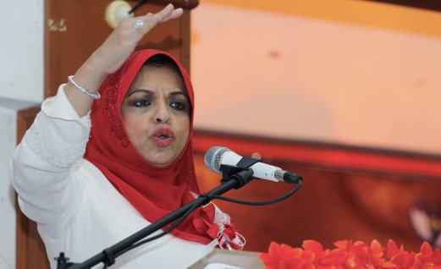
KUALA LUMPUR: Malaysia will host the World Communication Forum to be held at the Putra World Trade Centre on Sept 28 and 29.
The 2015 World Communication Forum Kuala Lumpur (WCFKL), will discuss, among others the future development of communications and their role in business, society and politics.
Patron of the WCFKL Secretariat, 2015, Datuk Seri Shahrizat Abdul Jalil said more than 500 participants from various sectors were expected to attend the forum, with the theme ‘World Communication: Changes, Challenges, Opportunities’.
“WCFKL is expected to attract communication experts and practitioners from the Asian region, as well as those in the public relations, marketing, strategic investor relations and media relations,” she told a media conference on the forum at PWTC here today.
She said Deputy Prime Minister Datuk Seri Dr Ahmad Zahid Hamidi was scheduled to open the forum, which would be held with the support of the Communications and Multimedia Ministry, the Federal Territories Ministry, Transport Ministry, the Deputy Prime Minister’s Office and Bank Rakyat.
Meanwhile, WCFKL director Nurul Ashikin Shamsuri said those keen to participate in the forum could register online at www.wcfkl.my before Aug 31 at a special price.
Source: BERNAMA
Published by News Straits Times Online:
http://www.nst.com.my/news/2015/09/malaysia-host-2015-world-communication-forum

