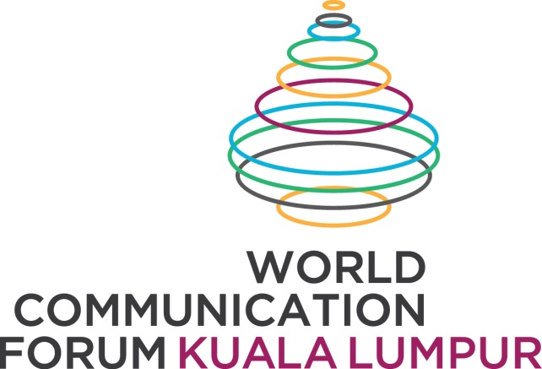
KUALA LUMPUR, Malaysia, Sept. 28, 2015
The inaugural World Communication Forum Kuala Lumpur 2015 with the theme: "COMMUNICATION WORLD: CHANGES, CHALLENGES, CHANCES," is being held for the first time ever outside of Europe in Kuala Lumpur today until 29th September 2015 at Dewan Merdeka, PWTC.
The two-day forum was officiated by YB Dato' Jailani Bin Johari, Deputy Minister of Communications & Multimedia Malaysia. He highlighted that the Ministry of Multimedia and Communication is proud to be part of such prestigious gathering of trend-makers and influencers from the global communications elite, where participants can look forward to learning the latest trends and take part in an intellectual discourse amongst the communication practitioners.
"The communication world has gone through so many changes, and with these changes comes various challenges. WCFKL 2015 provides a platform on how we can take these challenges in a positive way," said YB Dato' Jailani Johari.
Dato' Sri Shahrizat Abdul Jalil, Advisor of WCFKL 2015, added that the secretariat team, lead by Forum Director Nurul Ashiqin Shamsuri, have done justice to the inaugural event by showcasing an impressive line up of star speaker: from Allan Mayer - Hollywood Spin Master, Sean Gardner - Forbes #1 Social Media Power Influencer to Paul Homes - Public Relations guru who delivered a resounding Keynote Speech to some 500 forum participants.
WCFKL 2015 features a total of 26 speakers from United States, United Kingdom, Russia, India, Portugal, Singapore, Ukraine, Turkey, Malaysia and Singapore, is indeed a melting pot of the great minds of communicators.
Sessions are tailored to reflect the ongoing challenge that everyone faces today, such as crisis communication, reputation management, effective leadership communication, social media, retail communication and even include a special Townhall session where companies such as Bank Rakyat, Mercy Malaysia and Microsoft share their success stories and review additional communication strategies with WCFKL 2015 expert panelist.
For any media enquiries kindly contact:
Liz Jasri : +60 19 3177496
Email: secretariat@wcfkl.my
www.wcfkl.my
Source: World Communication Forum Kuala Lumpur Secretariat

