WCFA training course for young PR professionals in Davos
The World Communication Forum Association is launching its latest project this summer, the WCFDavos|CommCamp – a one-week intense course in strategic communications in the heart of the Swiss Alps, Davos. The camp will take place on Aug 16-22, 2016. It is intended for young, ambitious communication professionals and students from around the world.
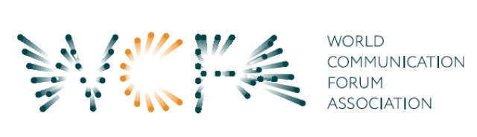
The main goal of the project is to arm young PR enthusiasts with practical knowledge and hands-on experience in the field of strategic communications, preparing them for the competitive environment of the modern market. The course shall include master classes, workshops, presentations and case studies. WCFDavos|ComCamp will cover key topics in dynamic discussions, among which:
• Rethinking strategic communications – new challenges and approaches.
• Strategic media relations in the era of social media.
• Crisis communications – how to handle a global crisis?
• Story telling – crafting strategic presentations.
Full program of the event, as well as information on terms and conditions, are available at WCF’s website: www.forumdavos.com/regional/13

To apply, participants have to send a curriculum vitae and a motivation letter till July 13, 2016: forum@forumdavos.com.
The WCFA Association invites all who wish to support the initiative to join as partners as well. Davos Communication Camp gives the opportunity for companies to advertise their brand, reach out to young specialists and scholars with innovative and creative knowledge, and network with the professional WCFDavos global community of communicators.
Entry terms: here, Online payment: here, Facebook event: here
__________________________________________
World Communication Forum Association is a non-profit organization under the Swiss Civil Code. It was officially registered in November, 2014 by a group of dedicated communicators from Europe, Asia and Latin America who, since 2010, have been successfully organizing the high-level global summit World Communication Forum in Davos (www.forumdavos.com) held annually at the Congress Centre in Davos, Switzerland. The main goal of the WCF Association is to contribute to the development of modern global communications.
Facebook: http://www.facebook.com/WorldCommForumDavos
Twitter: http://www.twitter.com/WorldCommForum
YouTube: http://www.youtube.com/forumdavoscom
Contact: PR Manager, WCFDavos, press@forumdavos.com

