WCFDavos Kyiv: effective solutions from the world's experts
September 8, 2014, World Communication Forum Davos (WCFDavos) was for the first time held in Kyiv. The forum united international and local professionals to discuss the latest trends and find new solutions. The Kyiv session of WCFDavos was organized by the “AGAMA communications” group of agencies.
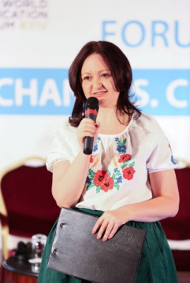
“WCFDavos Kyiv is the first international top-event in the sphere of communications in Ukraine. That’s why it was so important that the forum is held right now, when the country is being completely restarted,” comments Iryna Zolotarevych, Head of C4F Awards, member of the global WCFDavos Committee, CEO of Pleon Talan.
Forum Topics: communication efficiency, business during information wars, corporate transparency. During the WCFDavos, Ukrainian and international companies shared relevant cases dedicated to effective communication of the Ukrainian identity. Among them: “Made in Ukraine” by Ekonomika Communication Hub, “Vyshyvanka” by Kyivstar, and “New Country” by Valerii Pekar.
Three discussion panels were organized during tHE WCFDavos|Kyiv regional session:

● Information Warfare And Business: Learnings And Next Steps. Moderator: Yvetta Delikatnaya, Coordinator of national campaigns at Ukraine Crisis Media Center, a well-known media expert.
● Sufficient Level of Corporate Transparency in Ukrainian Realities (from now on). Moderator: Maryna Saprykina, CEO at Centre for CSR Development. The discussion was devoted to the new demands in the area of communications voiced on the part of society.
●From Communications Efficiency to Business Efficiency. New Opportunities. Moderator: Vlad Polonskiy, Business Development Director at AGAMA Communications. The participants talked about the current trends in measuring efficiency in traditional and digital communications.

The key conclusion after the discussions was that communications need to be responsive to the demands of society, quickly adapt to new challenges and use all possible channels. One of the WCFDavos speakers – Maxim Behar, VP of ICCO, CEO and Chairman of the Board of M3 Communications Group (Bulgaria), summed up the discussion: “Very soon, we will say SR: social relations, instead of PR.”

The WCFDavos finished with a gala ceremony of the international Communication for Future (C4F) Award. Prestigious trophies made of natural crystals were awarded for outstanding contribution to the future of communications, to: Roman Skrypin (co-founder of hromadske.tv), Irina Rubis (CEO at Ekonomika Communcation Hub) and Valerii Pekar (creator of the “New Country” project).
For more details, please contact: davoskyiv@pleon.ua

