Support despite obstacles: the prestigious C4F Award granted in Kyiv for the first time
Kyiv, September 8, 2014.
Three of six nominations of prestigious Communication for Future Davos Awards (C4F) were presented in Kyiv for the first time ever. The ceremony was held during Kyiv session of World Communication Forum Davos. For Ukrainian communication specialists C4F Award and the WCFDavos Forum itself have special meaning right now. The country passes through the difficult process of changes and the informational pressure is high, so the European support and recognition are very important.

Communication for Future marks outstanding achievements in the field of communications. Award is received by the professionals, whose projects set the standards for the future. The award itself is a crystal that symbolizes transparency and efficiency of communications. It is remarkable that Kyiv is the first city where the whole nomination process was fulfilled for the regional WFCDavos event.
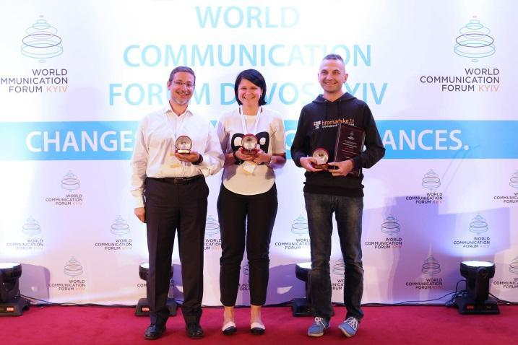
“C4F is a professional award. Only professional organizations and representatives of the WFCDavos board can nominate the candidates”, says Iryna Zolotarevych, Head of C4F Awards, member of the global WCFDavos Committee, CEO of Pleon Talan, “For Ukrainian specialists, C4F Awards is an opportunity to gain international recognition of the highest level. All winners of Ukrainian awards will be automatically included in the shortlist of C4F Awards 2015 in Davos.”

C4F-2014 Award winners:
Media of the Future – Roman Skrypin (co-founder of hromadske.tv)
Idea of the Future – Irina Rubis (CEO Ekonomika Communcation Hub)
Relations of the Future – Valerii Pekar (creator of the “New Country” project)
World Communication Forum Davos is an annual event held in Davos Congress Centre, Switzerland. Initiated by an International Coordinating Committee in 2010, it has united acknowledged professionals from 44 countries worldwide. The forum has been supported by 33 key associations within the industry in 21 countries from 5 continents in Great Britain, Belgium, Italy, Switzerland, Bulgaria, Lithuania, Ukraine, Croatia, Serbia, China, India, Brazil Ghana, Russia, etc. Since its first edition in 2010, WCF in Davos has held various regional sessions in some of the largest cultural and financial capitals across Europe.
C4F Davos Awards are the first of their kind. They are rendered to challenging visionaries and communication professionals with key achievements in the development of the communications industry. The award is presented in 7 categories: Titan of the Future, Image of the Future, Media of the Future, Relations of the Future, Idea of the Future, Grand Davos Award and Tolerance for the sake of the Future initiated by the International Oleksandr Feldman Foundation in 2014. The C4F Davos Awards Ceremony was held for the first time in 2011, during the annual edition of the World Communication Forum in Davos.
To see the C4F Davos Awards Winners from previous years, please visit: http://www.forumdavos.com/awards

