World Communication Forum – in Davos for the fourth time

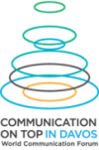
On 7-8 February, 2013, communications trend-makers from all over the world will gather again at the fourth edition of the World Communication Forum (WCF) “Communication on Top” in Davos, Switzerland, to discuss today’s key challenges to the communications industry and set the global strategies for the year.

Program 2013 offers many provokative presentations, a lot of discussions and hot debates on diverse topics, such as “Global vs. Local Communications”, “Regulations & limits of freedom on the Internet and Copyright”, “Today's world-change-driver: Human Creativity or Technology?”, “Text vs. Image”, “Social PR vs. Traditional PR”, and more.
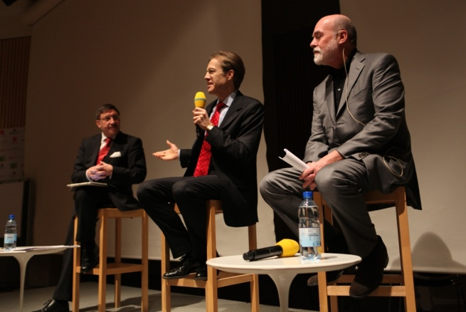
For the first time the WCF includes industrial discussions on issues concerning energetics, crisis communications, transport, reputation management, banking, pharmacy, and telecom. It will summon communications directors from geographical areas where these industries mark a rapid growth.

WCF is steered by an international coordination committee. Its members, also speakers at the event, are thought-provoking chief communication experts and with multi-cultural background:

- Paul Holmes, Founder and CEO of The Holmes Report and the SABRE awards, UK;
- Dr. Daniel Hӧltgen, Director of Communications at the Council of Europe, France;
- Allan Mayer, Principal Partner and Head of Strategic Communications at 42West, USA;
- James Guillies, Head of Communications at CERN – the LHC developers, Switzerland;
- Roma Balwani, SVP and Head of Corporate Communications, Mahindra Group Ltd., India;
- Lorena Carreño, President of the Association of Public Relations Professionals in Mexico;
- Hiromi Yokoyama, Associate Professor at Tokyo University, School of science, Japan;
- Mohamed Al Ayed, Founder/CEO of Trans-Arabian Creative Comms Services, UAE;
- Yanina Dubeykovskaya, WCF Content Director, GM of Seamediagroup Ltd, Russia.
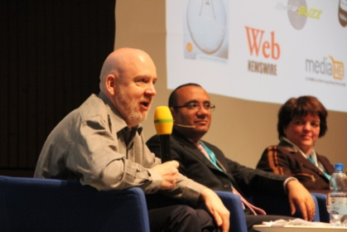
One of them, Paul Holmes, world-famous PR industry guru, shared his impressions with enthusiasm: “No idea how they did it, but in just 3 years the organizers have created the most lively, engaging and influential event in the industry – this forum is an absolute phenomenon!”

The World Communication Forum was created in 2009 by the international coordination committee. Its fundamental idea is to summon the new communications elite to an annual global conference for an open discussion of the contemporary communications professional agenda and also for sharing best practices, strategies and creative ideas. In 3 years only the forum has registered a huge number of international partner associations and organizations from 35 countries across 5 continents: IAB Europe, The Holmes Report, The London School of Public Relations and Branding (LSPR), Trans-Arabian Creative Communications (TRACCS), PRORP – The Mexican Association of Public Relations, Russian Public Relations Association (RPRA), Armenian Public Relations Association (APRA), Association of Business Communicators of India (ABCI) and more.

For more information, check the WCF’s official website – www.forumdavos.com, or its YouTube Channel – www.youtube.com/user/forumdavoscom, where you can find the records of all the debates, discussions and interviews held at the event so far.

Contacts:
Kalina Toncheva
PR Manager
at Top Communication Gmbh
е-mail: press@forumdavos.com

Official WCF Profiles:
Facebook: www.facebook.com/WorldCommForumDavos
Twitter: www.twitter.com/WorldCommForum
YouTube: www.youtube.com/forumdavoscom

