14 Top Pro-s “on board” of the World Communication Forum in Davos!
21.03.2012
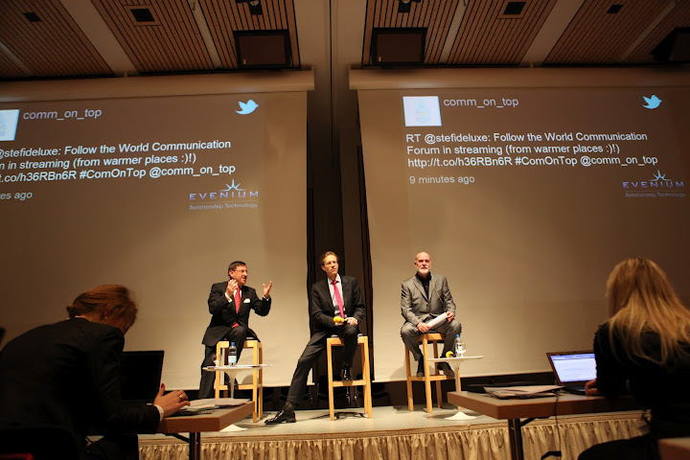
WCF “Communication on Top” has welcomed 11 new members in its ranks – practitioners, marketers, scientists, and entrepreneurs from 6 countries (Spain, India, Malaysia, South Korea, and Japan) joined to contribute to the international and professional diversity of the Forum Committee:
Abdul Jalil Maraicar, Client Director at Cisco Systems in Malaysia, Board Member of the Advisory Panel at the “Universiti Teknologi Petronas”, Adjunct lecturer at the Multimedia University, Malaysia;
Allan Mayer, Principal Partner and Head of Strategic Communications at the New York agency 42west, the PR advisors of movie or music stars and celebrities from the entertainment industry;
David Lee, Founder and CEO of Shakr Media tool, a web-based personalizing instrument that uses online content and automatically translates it into video, South Korea;
Gianni Catalfamo, European Digital Director at Ketchum Pleon, a top Social Media expert from Italy;
Hiromi Yokoyama, Associate Professor at the University of Tokyo, School of Science, Japan;
Juan Carlos Belloso, a seasoned place-branding expert, Director of Future Places Ltd. and Advisor to the Barcelona Brand Project & Strategic Metropolitan Plan and Catalonia Brand Committee, Spain;
Mirko Pallera, Founder and CEO of Ninja Marketing, a rapidly-growing online media company in Italy;
Paul Holmes, Founder and CEO of the Holmes Report and the SABRE awards, the PR guru worldwide;
Roma Balwani, SVP & Head of Corporate Communications at Mahindra & Mahindra Ltd., one of India’s top-rated companies, active in the aviation and car manufacture industries;
Sergey Zverev, Founder and CEO of the CROS PR&PA, a popular consultancy in Russia;
Valery Levchenko, Deputy Editor-in-Chief at RIA Novosti, a leading Russian media and news agency.
The Forum Committee comprises of 30 communication professionals altogether, from 20 countries across 5 continents: www.forumdavos.com/committee
3 top communication experts became Forum regional representatives:
Annie Gravier, Public Affairs and Communications at “Technoparc Montréal”;
Yogesh Joshi, President of the Association of Business Communicators in India (ABCI);
Arturas Jonkus, Director of the Publicum Relations Company, Lithuania.
The summit is actively promoted via a network of 23 regional representatives (4 are also committee members) covering a range of 40 countries: www.forumdavos.com/representatives
A major task of the coordinating committee and the regional representatives’ network is the further intensive development of WCF as a global summit of the communication industry aiming at an annual Davos union of the new digital elite worldwide.
The 3rd edition of World Communication Forum “Communication on Top” held on 9-10 February, 2012, in Davos Congress Centre, Switzerland, brought much more than the expected geographical or cultural diversity of any diplomatic conversation typical of a global summit: uniting 100 practitioners from 28 countries, it penetrated beyond the scheduled agenda, going past artificial solemnity, in order to provoke heated discussions and amazing networking activity, delivering a sense of unique experience, with memories that warm the hearts of all its attendees!
The key impression from WCF 2012 was well voiced by two remarkable communication experts who attended the 3rd summit and contributed largely to its tremendous effect:
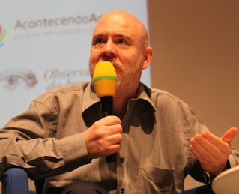
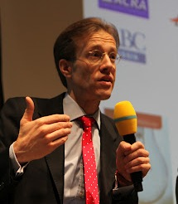
“WCF’2012 was so diverse and you could actually see people get inspired by that! It is precisely what you should take from Davos – inspiration from a different field which helps you to reflect on your own work and make improvements!"
~ Daniel Holtgen, Director of Communications at the EU Council

“No idea how they did it, but in just 3 years the organizers have created the most lively, engaging and influential event in the industry – this forum is an absolute phenomenon!”
~Paul Holmes
In its 3 editions so far WCF has registered over 60 partners and 240 participants (190 unique) from around 35 countries, representing in total: 61 agencies (8 of them global), 43 companies from various business sectors (aviation, energy, banking, engineering, manufacture, technology, etc.), 12 large international associations, 8 influential media units, 7 universities, and 5 government bodies.
Get a glimpse of the WCF 2012 atmosphere and enjoy the collaborative spirit radiating from its video-&-photo records posted on:
YouTube: www.youtube.com/user/forumdavoscom
Picasa: picasaweb.google.com/CommunicationOnTop/ComOnTop2012
A full overview of the 3rd Forum you can check at www.forumdavos.com/events/2012 and all WCF-2012 presentations are available for viewing at www.forumdavos.com/presentations/2012 .
For additional information, contact:
partners@forumdavos.com, tel.: + 359 884 435044
Valentina Atanasova
project manager

