Maxim Behar: Social Media Make the World a Better Place
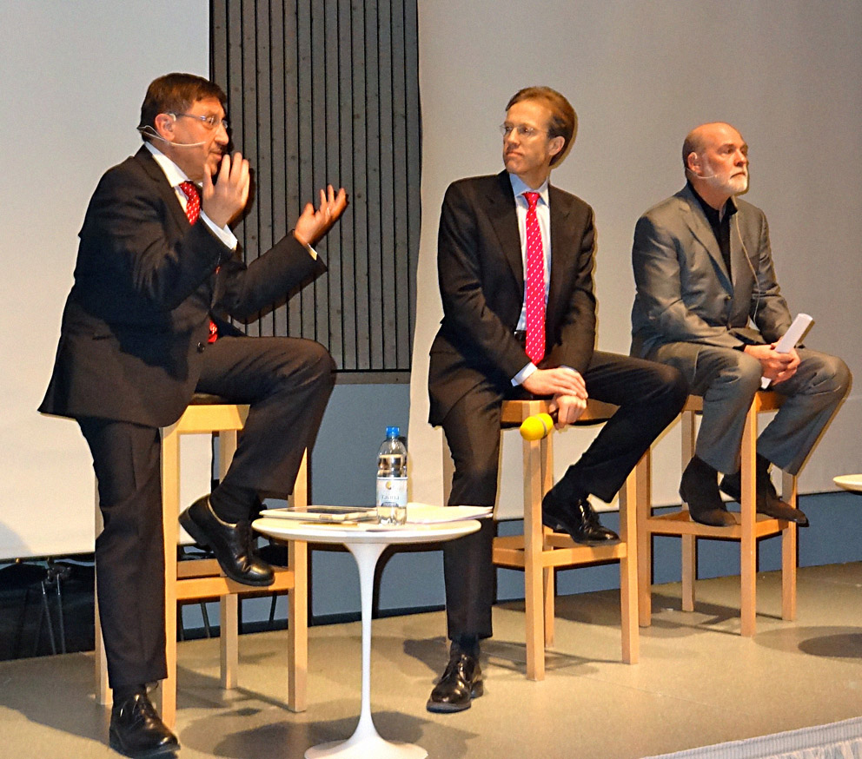
February 9, 2012, Davos.
“Тhe world is transparent. There can’t be any limits to transparency, as it leads to higher ethical standards,” said Maxim Behar today at the World Communication Forum in Davos. He participated in the “Privacy vs. Publicity in the era of transparency” debate along with Allan Mayer, Principal Partner at the biggest show business PR agency in New York, 42West. Moderator of the debate was Daniel Höltgen, Director of Communications at the Council of Europe.

“No one can stop transparency anymore. From now on transparency will constantly evolve thanks to social media, which make the world better, more honest, and moral, and provide something very important and needed these days – knowledge,” said Behar.

This is Maxim Behar’s third participation in a row in the prestigious forum in Davos. Two years ago he presented on the topic of social media, and last year he was the moderator of the opening debate between Paul Holmes and Marshall Sponder, as this year Mr. Behar took part in the debate himself.

Maixm Behar is the CEO of the leading PR agency in Bulgaria, M3 Communications Group, Inc., a Hill+Knowlton Strategies affiliate. In January 2012 he was also appointed a Chairman of Hill+Knowlton Strategies office in Prague.

The forum Communication on Top summons professionals and innovators in the field of communications, and lets the trend-makers share creative ideas, and discuss best practices and new strategies. This year more than 35 speakers from 25 different countries around the globe participate in the forum. Four case studies are presented along with seven panel discussions, 5 keynotes, and two debates, aimed at exploring the future of communications.

The third edition of World Communication forum opened on February 8th. In addition to the “Privacy vs. Publicity” topic, this year the forum program features such topics as “New challenges to the PR consultancies – global vs. local”, “Interactions in virtual economics”, and “Virtual vs. face-to-face communication in PR and marketing”.
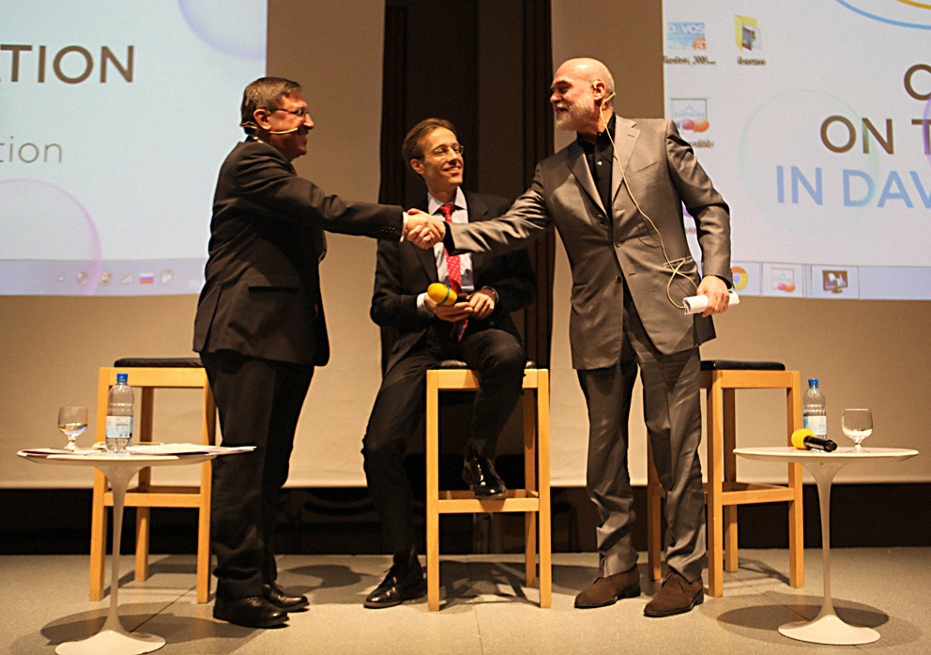
In addition to participating in the “Privacy vs. Publicity” debate, Maxim Behar moderated the C4F (Communication for Future) Awards closing ceremony. This is the second edition of the awards, given to individuals with major influence on the improvement of communications and contribution to the new trends in the industry.

For additional information, visit:
http://www.forumdavos.com/
or contact M3 Communications Group, Inc.: +359 2/818 70 10.

