Private or public? - This time you’ll have to choose!

Over 30 top speakers from 20 countries worldwide, 7 topics for panel discussion, 2 case studies and 3 debates at the 3rd World Communication Forum in Davos in 2012.
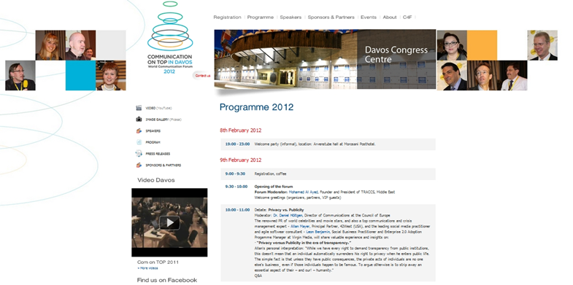



World Communication Forum program is finalized for 2012. The forum agenda is designed to traditionally gather the new digital elite in Davos and let the trend-makers exchange their ideas and views on privacy / publicity in the upcoming transparent future, communicating scientific breakthroughs, machine-generated content as the possible prospect of communications and the ways to sustain territorial reputation.


Allan Mayer, Principal Partner with 42West and a top reputation expert, will rival Leon Benjamin, Social Business Practitioner and Program Manager with Virgin Media, in a debate Privacy versus Publicity in the era of transparency on the first day of the Forum.

The heated discussions will run on with Paul Holmes, founder and CEO of The Holmes Report and the SABRE awards, taking a word on Running internal communications, trying to find out who is in charge of corporate PR within a company. The third problem to be debated is Virtual or face-to-face communications as a better tool in marketing, and it is headed by Abdul Jalil Maraicar, Client Director for Cisco, Malaysia.

7 panel discussions spread over the two days of the Forum concern some major trends and challenges within the branch, including the latest problems for consultancies, the associations’ missions, today’s role of a CCO, virtual economics and more.

Communication professionals from Canada, Sweden, Netherlands, France, Russia, Switzerland and Japan will discuss whether contemporary science can be transparent if urged to keep the technological secrets under the constant brain drain pressure (Michel Claessens, France, Nettie Buitelaar, Netherlands), how the natural disasters have affected the Japanese academic studies (Hiromi Yokoyama) and what exactly the innovative communication is (Maria Satherstrom, Sweden). This and more will be considered within the Communicating scientific breakthroughs panel.

The Media Communications panel will explore the variety of ways technology is expected to influence communications in the future, presenting David Lee, Korea, with his case of transforming text into video content, and Nikos Sarris, Greece, analyzing whether or not machines can already make sense of what is going on in the world.
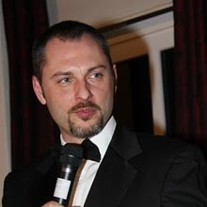




A round table discussion on Reputation management is to consider the territorial reputation and elaborate ideas on promoting country, region or city image, while the two case studies will tell a cute story of Challenging national ego and using it as a marketing tool (Ruxandra Vasilescu, Romania) and present the new Emergency 2.0 Wiki project as a means to handle global crises (Philippe Borremans, Belgium).

World Communication Forum in Davos has been gathering communication influencers since 2010, providing them with a platform for discussion on the future development of communications and their role in media, technology and business. Participants from over 20 countries across five continents have joined the Forum in the previous years.

For the full program please visit:
http://www.forumdavos.com/programme
Or check the speakers’ profiles at:
http://www.forumdavos.com/speakers/2012

For more information, visit www.forumdavos.com or the Forum’s social media profiles:
FB - http://www.facebook.com/ForumDavos
Li - http://www.linkedin.com/groups?gid=2252687&trk=myg_ugrp_ovr
Tw - http://twitter.com/#!/comm_on_top

