At the Cross-point between Technology and Media

Technology has changed dramatically the way we communicate and do business - it would be naïve to think the change would not affect our future... How do media and mass media fit and evolve in this new environment? The answer will be provided by the Media Communications panel at the 3rd edition of the World Forum in Davos “Communication on Top”. Each of the 3 speakers participating in the panel discussion is a top expert in his own area:

Tom Foremski is a former Financial Times journalist who has been covering Silicon Valley for over 27 years. He has also covered US technology markets for leading computer journals around the world and was the first journalist to leave the Financial Times to make a living as a full-time blogger. His popular news blog is The Silicon Valley Watcher - at the intersection of technology and media, reporting on the business and culture of innovation.

David Lee is an entrepreneur based in South Korea. He is the founder and CEO of Shakr Media - an innovative technology which algorithmically converts web text news into videos. It is meant to be used on the web, via mobile and connected TV. There are different applications of the technology which is still to be improved by receiving feed-back from user experiences. Shakr Media launched Space Magazine for iPad as a visual show which can be watched instead of read - it is among Korea's most successful international magazine iPad apps.
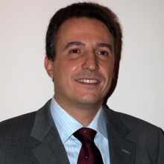
Nikos Sarris, Senior Manager in charge of Media Research and Development projects at Athens Technology Center. Lately he has been involved mainly in media related projects focusing in the semantic analysis and “understanding” multimedia news content. Nikos will share his ideas on whether machines could “make sense of what is happening in the world”. Today, millions of people are publishing, blogging, posting and tweeting, adding up to a conventional Tower-of-Babel of amazing dimensions.
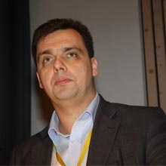
The panel will be moderated by Valery Levchenko, the Deputy Editor in Chief for RIA Novosti - the largest Russian aggregator for news and information and resource partner for the Media Communications panel, focused on the crossing point between new technologies and new media.
The 3rd World Communication Forum will again gather trend-makers and influencers from the communications elite and provide a platform for discussion on the future development of communications and their role in media, technology, and business. Participants from more than 20 countries across five continents have joined the Forum in previous years.
Join the forum to learn if the existing and emerging technologies of semantic analysis could help us organize the nowadays chaos of information!
You can view the full program at: http://www.forumdavos.com/programme
Or check the speakers’ profiles at: http://www.forumdavos.com/speakers/2012
For more information, go to www.forumdavos.com or visit the forum’s social media profiles:
FB - http://www.facebook.com/ForumDavos
Li - http://www.linkedin.com/groups?gid=2252687&trk=myg_ugrp_ovr
Tw - http://twitter.com/#!/comm_on_top
Contact us: Boris Matev, PR Manager, b_matev@forumdavos.com, +359 2 427 8510

