Believe in what’s not there yet - World Communication Forum, Davos’12
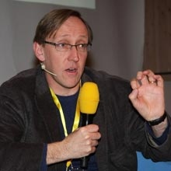
The 3rd edition of “Communication on Top” (www.forumdavos.com) will try to find the answers to several major questions of the new digital reality (Privacy vs. Publicity, Professional Ethics in the era of transparency and authenticity, Is corporate confidentiality still kept today, Communications’ mission – form a professional community or engage socially, Building territorial reputation – a synergy between brand, producer, and area image... and more) by presenting a diversity of topics and comprising various aspects of the modern communication industry. Among its key panels will be Communicating Scientific Breakthrough. Moderator of the panel is James Gullies, Head of Communications at CERN, who will lead the discussion with several panel speakers – experts in science communication:
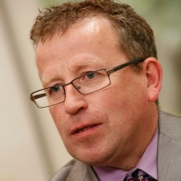
Michael Claessens, who holds a PHD in science and possesses a long career in both scientific research and journalism, will share his professional views on transparency in avant-garde technologies and research in his presentation on “Technological Secrets. Can Science be transparent?” With complex scientific and technological projects addressing key challenges for humanity (and attracting huge amounts of funding), there is an increasing and legitimate demand from the public for better information and dialogue. M. Claessens will give examples from his current position as Head of Communication of the ITER Foundation, an international nuclear fusion research project.

Hiromi Yokoyama, Associate Professor at Tokyo University, School of Science, will present “Science communications in Japan - an academic approach, before and after the 3.11 crisis”. The formal introduction of science communication took place in Japan after universities became independent administrative institutions, which led to a new setup of the university PR staff. The conditions of science communication were further changed after the extreme disaster of Tohoku earthquake, the subsequent tsunami, and the Fukushima Nuclear Accident - since the 3.11 crisis universities in Japan have been pressured to increase the public visibility of their research outcome.

Annie Gravier, Director Public Affairs and Communications at Technoparc Montréal, will share insight as a seasoned expert dealing with over 35 of the most innovative scientific companies in her region. Her topic “Technological breakthrough – the dream is (already) alive” will help the forum participants to take a peek at what awaits the green scientific community: the future Éco-campus Hubert Reeves, which will be an open, high knowledge site in a wooded setting conducive to the emergence of new technologies in the fields of clean technologies, climate change and renewable energy.

The Marketing manager of Ideon Science Park, Maria Sätherström, will accentuate on the latest innovative communication strategies and techniques in promoting scientific and technological breakthrough in a speech called “How innovative is innovation communication?” Maria runs the unit with utmost professionalism, by nurturing and developing Ideon's strong brand, communications and public relations. She also holds management seminars and is in charge of the networking at Ideon.


The answer to the question “Talent-hunting or head-stealing?” will be provided by the experienced director Nettie Buitelaar, CEO at Leiden Bio Science Park and a seasoned expert in company management, with vast knowledge on the best strategies for running successful business units and conducting research analysis. Nettie is also the owner of the Buitelaar Biotech Business - founded in 2006, the company provides independent high-quality advice and services in biotech business, focusing on the transfer from science to market.

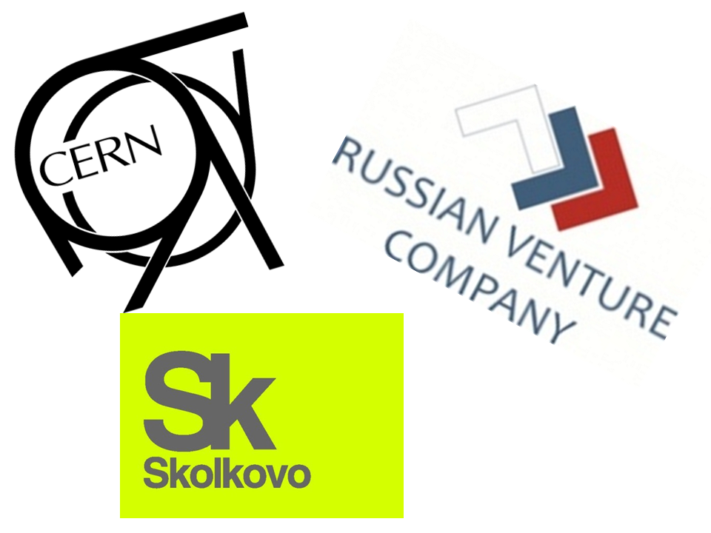
Forum resource partners supporting the organization and holding of the Communicating Science Breakthrough panel are: The Russian Venture Company (RVC-OJSC), a government fund of funds and a development institute of the Russian Federation and one of Russia's key tools in building its own national innovation system, The European Organization for Nuclear Research (CERN), and SKOLKOVO Foundation, a principal agency responsible for Skolkovo Innovation Center for developing and commercializing advanced technologies.

All of the above and other influential professionals, skilled trend-makers, and communication practitioners will again gather to share best practices and creative ideas – at the third edition of Communication on Top, held on 9-10 February, 2012 in Davos, Switzerland.

You can view the full program at: http://www.forumdavos.com/programme
Speakers’ profiles are available at: http://www.forumdavos.com/speakers/2012
For more information, go to www.forumdavos.com.

Visit the forum’s social media profiles here:
FB - http://www.facebook.com/ForumDavos
Li - http://www.linkedin.com/groups?gid=2252687&trk=myg_ugrp_ovr
Tw - http://twitter.com/#!/comm_on_top

Contact: Boris Matev, PR Manager, b_matev@forumdavos.com, +359 2 427 8510

