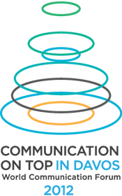
20 partners – and more to join the “Com on Top” World Forum for the new digital elite in Davos!

Creative agencies and organizations from Western Europe, Latin America, Russia, Middle East and North Africa unite their efforts in providing invaluable support as official partners of the Third Edition of the World Communication Forum – Communication on Top, held on 9-10 February, 2012, in Davos Congress Centre, Switzerland. “Com on Top” will again gather influential professionals and trend-makers in the modern communication industry to share best practices, new strategies, insights and creative ideas for the development of communications.

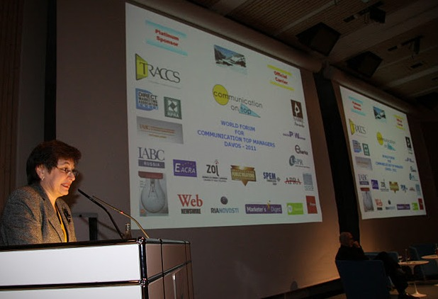

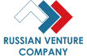
Recently, “Com on Top” has established a partnership of crucial importance with the Russian Venture Company (OSCJ), which provides support and resources for holding two interesting forum 2012 panels focusing on Communicating Scientific Breakthrough and Communication Signals for Investors.
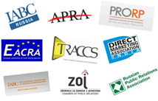
Large organizations acting regionally as partners of the forum are: IABC - Russia, IABC - Netherlands, the Russian Public Relations Association, the Direct Marketing Association - India, the European Association of Credit Rating Agencies (EACRA), the ZOJ Chamber of Public Relations, the Armenian Public Relations Association, Trans Arabian Creative Communications – the largest public relations networks in the Middle East & North Africa, and PRORP – the umbrella organization for Public Relations professionals in Mexico.

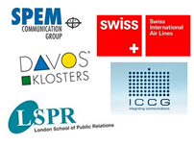
Several innovative agencies and institutions use their best efforts to collaborate in the further development and promotion of the event within their sectors and regions: the long term host of the event Davos Klosters, the official carrier Swiss International Air Lines, SPEM Communication Group, a leading agency specialized in counseling & implementing strategic communications, the London School of Public Relations – one of the leading educational bodies offering PR training, branding and reputation management, and Integrating Communication (ICCG), which is Russia's largest company specializing in strategic communications and legal consultancy.
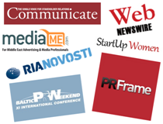
Influential media organizations are also contributing to the popularization of the Forum’s message worldwide: RIA Novosti – Russia’s largest news and information aggregator, also provide the resources and expertise for the Media Communication Panel in the forum edition for 2012, the Communicate Magazine, a corporate communication magazine based in the UK, MediaME, a major portal for marketing and advertising professionals in the Middle East, and the largest Asian news portal – WebNewsWire.
Event Partners promoting the goal of the forum are “Baltic PR Weekend” and “Startup Women”.

The brand partner of the forum is Depot WPF, a major branding company based in Russia, which created the new forum visibility, logo and corporate style identity.

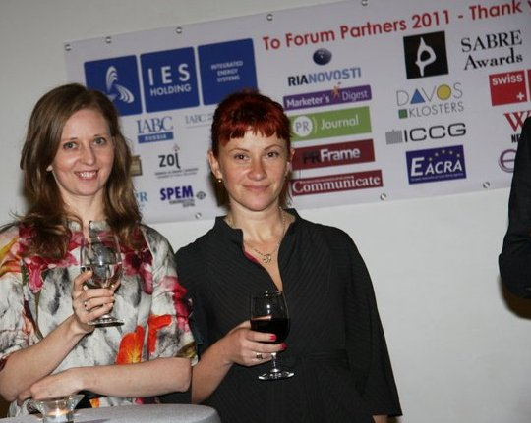

For more information, please visit www.forumdavos.com or join our social networks on:
FB - http://www.facebook.com/ForumDavos
Li - http://www.linkedin.com/groups?gid=2252687&trk=myg_ugrp_ovr
Tw - http://twitter.com/#!/comm_on_top

Contact: Boris Matev, PR Manager b_matev@forumdavos.com

