Communication 4 Future Award

You see the future – the world sees you!

Top Communication GmbH announces the launching of an Annual Award for Communication Professionals who share most innovative and creative visions for the future development of communications – Communication 4 Future (C4F). The award is to be given to individuals with major influence on the improvement of communications and contribution for the newest trends in the development of the communication industry for the respective year.

The annual award is positioned within 4 nomination categories:

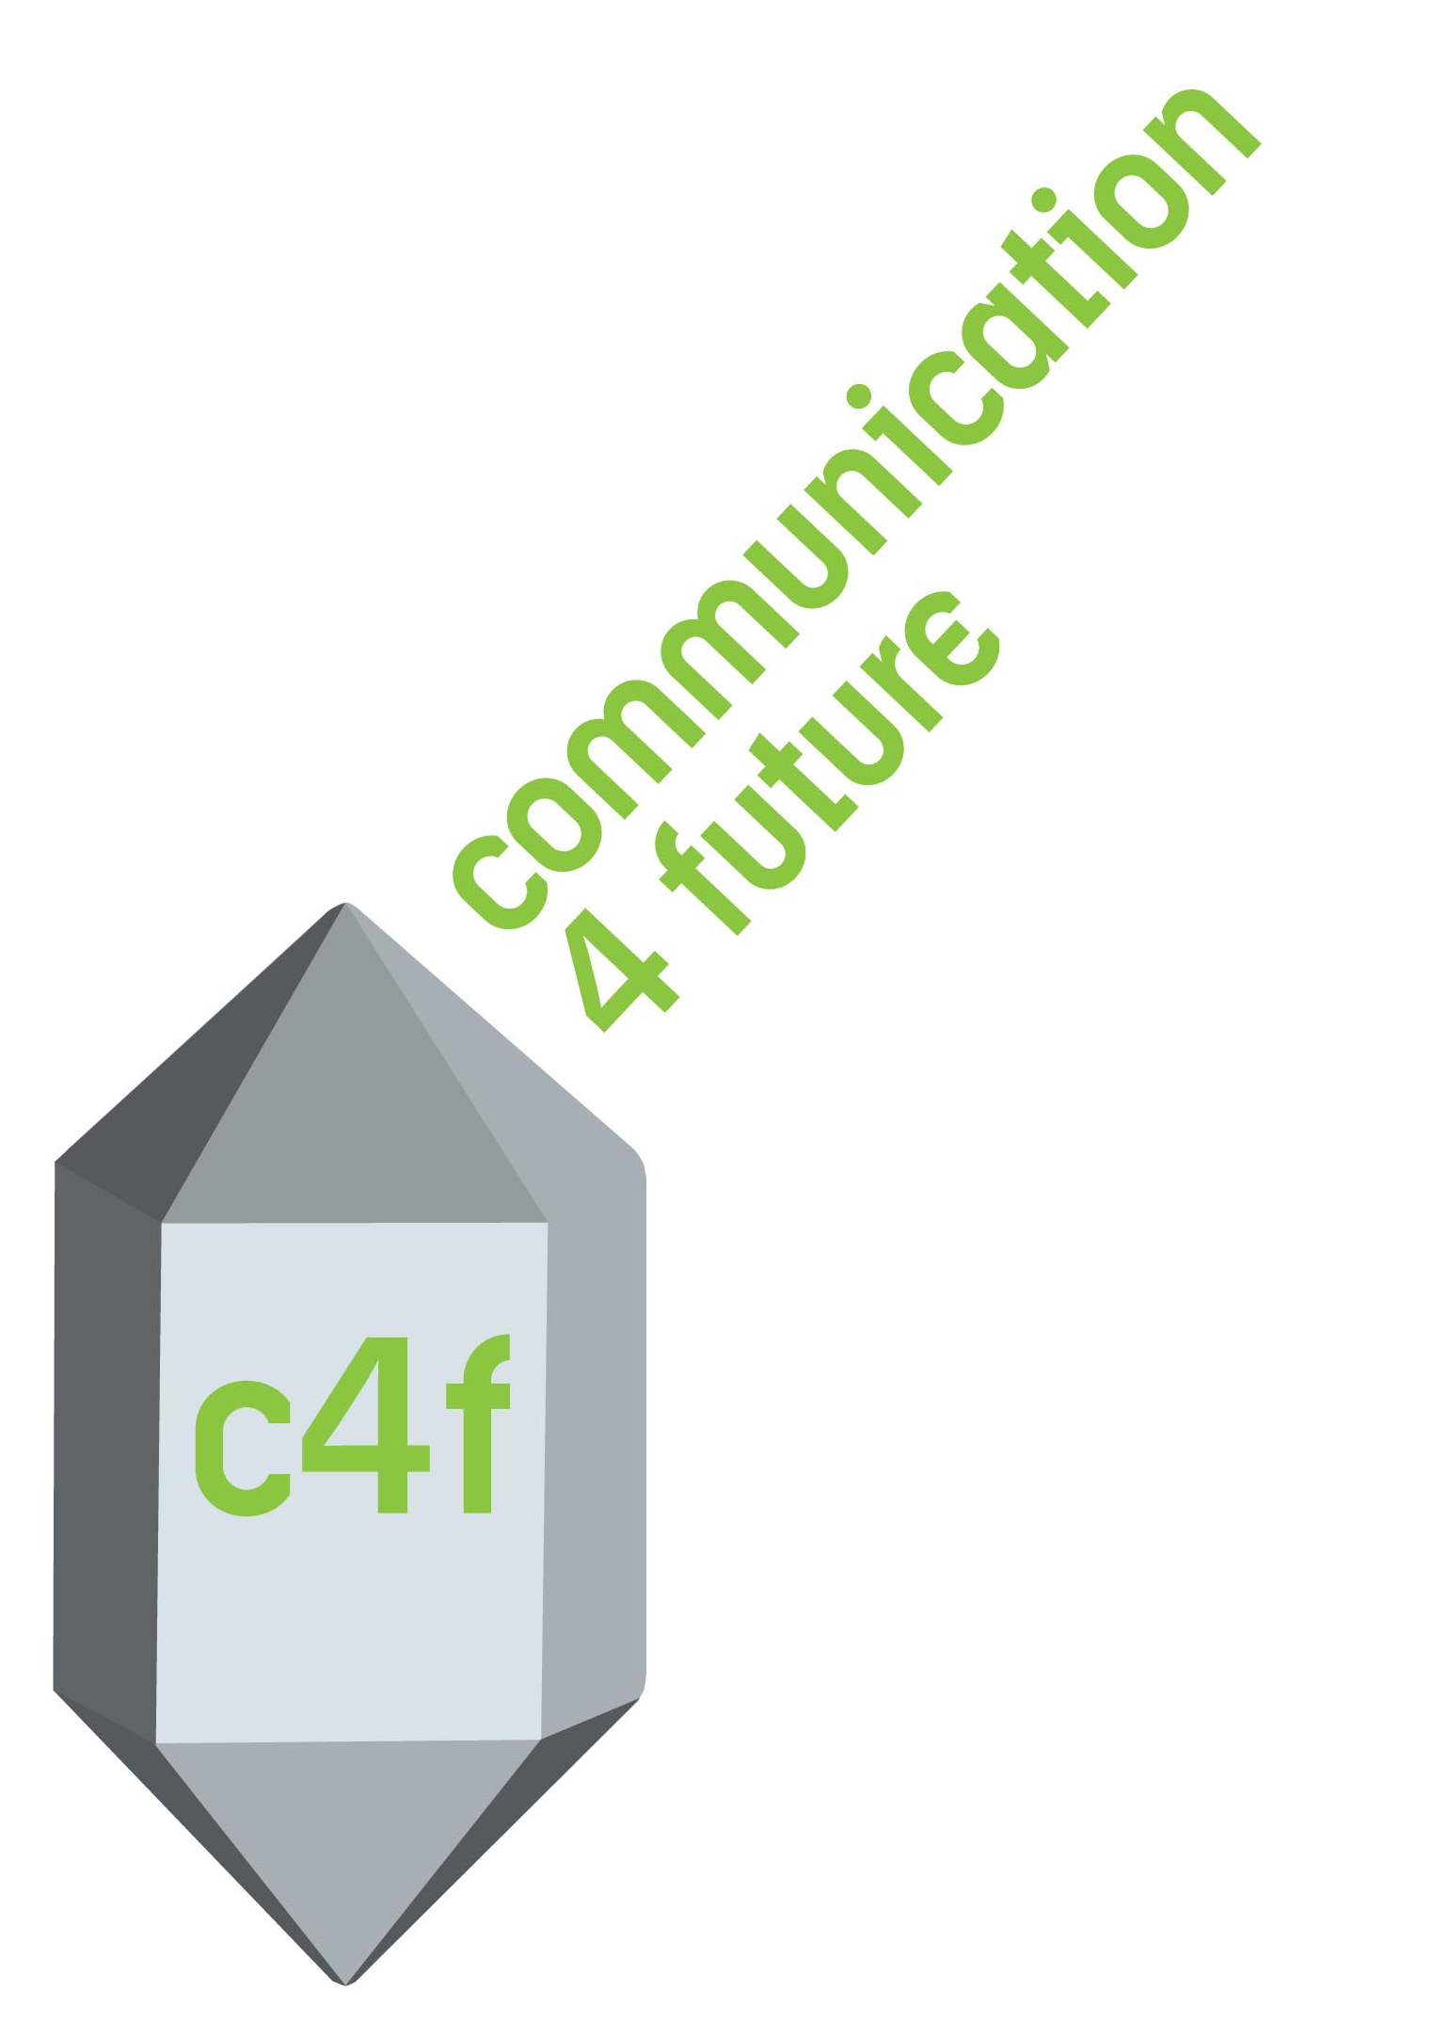
- “Titan web 2.0” - due to be given to the blogger who uses best efforts in promoting transparency, authenticity, and humanitarian values, while tackling the future of communications;

- “Image of the Future” - due to be given to the manager or designer who creates the best innovative brand and/or image;

- “Media of the Future” - due to be given to the most efficient media manager working in the area of new media, internet, and TV;

- “Relations of the Future” - due to be given to the corporate manager who strives to develop corporate communications trends aiming at partnerships, transparency, openness, and/or an ecologically-friendly environment;

There are two stages of nominees' selection:

- Long-listed candidates can apply via the Forum website, or they can be filed upon recommendation and discussions with partners, regional representatives, and social networks of World Forum “Communication on Top”.

- Short-listed candidates are selected via monitoring of the received applications, as well as further research regarding the adjacent documentation. The final stage is a voting procedure within the Forum Committee.

The winners receive a trophy of excellence and the right to a permanent free participation and a Special Guest status in each of the annual editions of World Forum “Communication on Top”.

The trophy and the certificate of the award are to be given to the winners during the gala dinner of the main World Forum “Communication on Top” held each year in Davos.

Web-page of the C4F award: http://forumdavos.com/awards
Forum program: http://forumdavos.com/program

For more details contact: press@forumdavos.com

