**Winners of the C4F Davos Award 2018 were announced   
during the WCF-Global 2018 in Geneva**

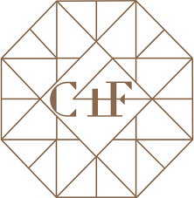The winners of the prestigious Communication For Future Davos Award 2018 were announced on 22 March during the Forum WCF-Global 2018: "Communication Power" in Geneva. The international jury board of C4F Davos Award 2018 consisting of communication leaders from 14 different countries chose the best cases for 19 categories in three divisions: personal, corporate, and start-up. The winners and short list nominees of the Award became also the unique possibility to represent their showcases during the WCF-Global 2018: "Communication Power" after the C4F Davos Award Ceremony on 22 March.

The aim of the C4F Davos Award is to recognize highly professional and globally remarkable individual communicators and/or organizations worldwide with a creative approach and unique vision of the future of communications.

**WINNERS OF THE C4F DAVOS AWARD 2018**

**CORPORATE CATEGORIES**

1. **Communications of the Future**

“1st World Internet PH” - Globe Telecom, The Philippines

1. **New Generation Communications**

“KFC: The Size Doesn’t Matter” - RODNYA agency, Russia

1. **Reputation of the Future**

“Barrier Free” (Teva, New Corporate Brand) - SPN Communications agency, Russia

1. **Value of the Future**

“Somos Livres” - Ideal H+K agency, Brazil

1. **Education of the Future**

“Financial Literacy Begins in the Family”- SPN Communications agency, Russia

1. **Community of the Future**

“Tech-in-Media: an easy way to explain science” - SPN Communications agency, Russia

1. **Pro Bono of the Future**

“Somos Livres” - Ideal H+K agency, Brazil

1. **Media of the Future**

“7 ways we create wonderful experiences” - Globe Telecom, The Philippines

1. **Trust of the Future**

“Insights Program” - T.Rowe Price + Imprint, USA

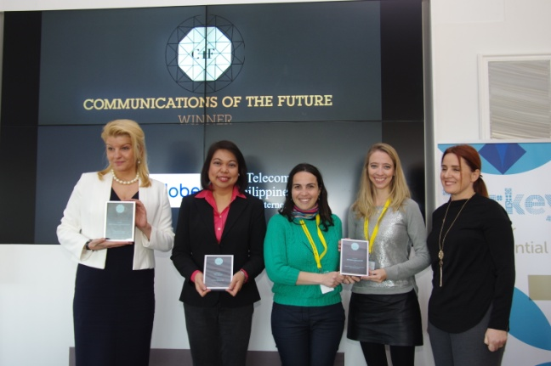 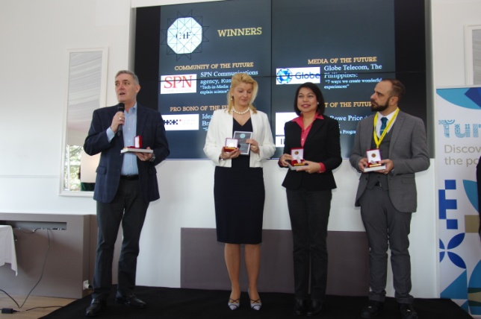

**PERSONAL CATEGORIES**

1. **Grand Davos Award**

Yogesh Joshi, President of the ABCI association, India

1. **Idea of the Future**

Dr. Jon-Hans Coetzer, Chief Academic Officer, EU Business School Group (Switzerland)

1. **Leader of the Future**

Nurul Shamsuri, Program Director of Yayasan JUWITA, Founder of ‘Fearless’, Malaysia

1. **Relations of the Future**

Lena Bӓcker, Co-Founder and President at Good Government Affairs, Committee Member at UNEDUCH/United Nation, International top-relations, Global Goodwill Ambassador, UNEDUCH - Universal Education Charter, Central government administration, Stockholm, Sweden

1. **Talent of the Future**

Ashay Sahasrabuddhe, Ph.D. research scholar at the University of Mumbai and Founder & CEO of Kintel Incomm Pvt Ltd., India

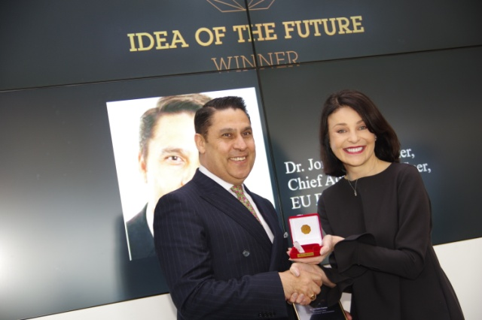 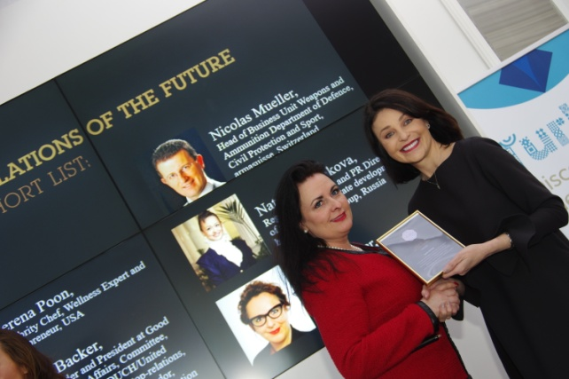

**STARTUP AND TECHNOLOGY CATEGORIES**

1. **Idea of the Future (personal)**

Ma. Yolanda C. Crisanto, SVP, Corporate Communications of Globe Telecom, Philippines

1. **Idea of the future (corporate)**

“Our future in the face of 4 students” - EU Business School Geneva, Switzerland

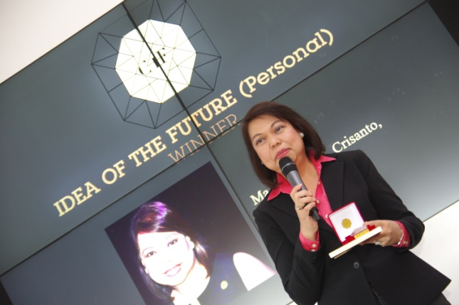 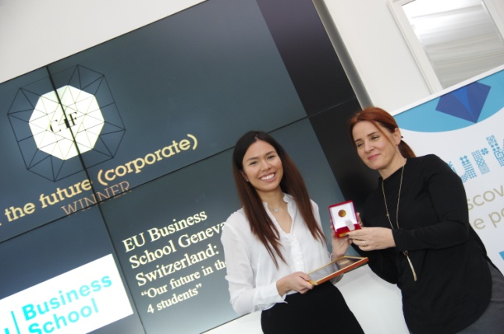

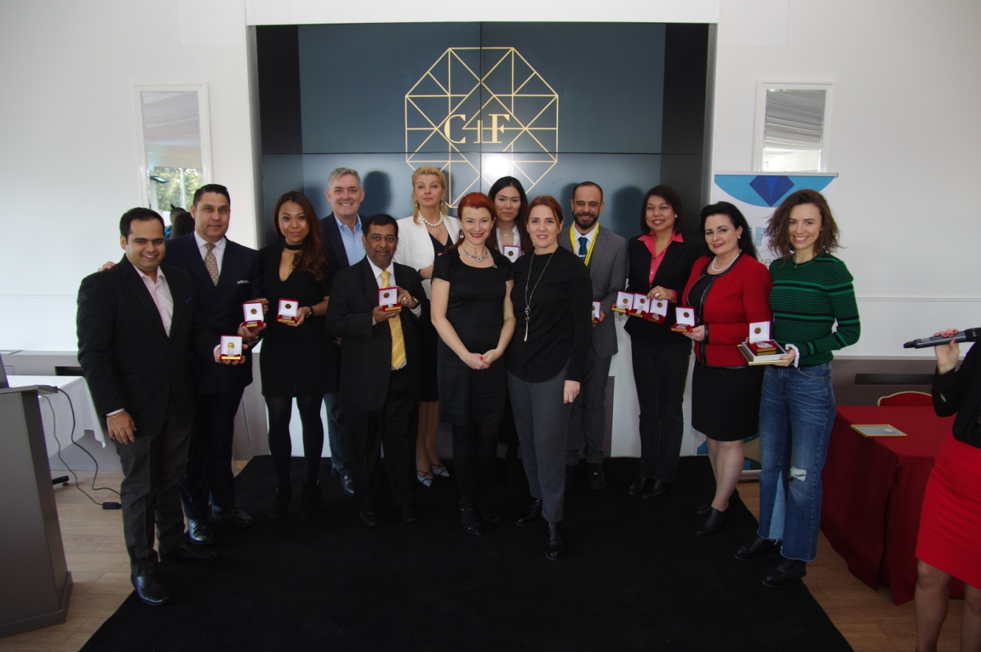

If you have any questions, please contact:

Yanina Dubeykovskaya, Director of the C4F Davos Award +41 762 413 224; [yana@forumdavos.com](mailto:yana@forumdavos.com)

Valentina Atanasova, Project Manager: +359 884 435 044; [partners@forumdavos.com](mailto:partners@forumdavos.com).

***------------------------------------------***

*C4F Davos Awards were inaugurated back in 2011, as a special recognition of remarkable professionals with an outstanding contribution to the development of communications. Today, the awards are positioned in 23 categories altogether, in praise of individual achievement and also the best corporate showcases for the year: 8 Personal C4F Awards and 15 Corporate C4F Awards.*

***In facts:***

*8 years of existence*

*23 categories under 3 divisions*

*Currently 17 jury members from 14 countries*

*Since 2011 winners from 22 countries worldwide*

<http://www.c4fdavosaward.com/>

<https://www.facebook.com/C4FDavosAwards/>