On March 21-22, in Geneva:
Global Communication Influencers Will Discuss the Power of Communications
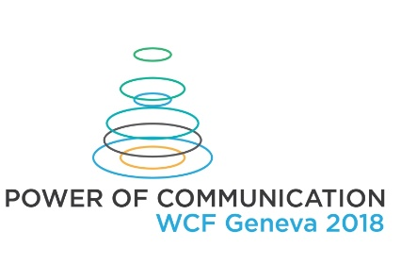
On March 21-22, the communications elite worldwide – top managers, communications experts, local market leaders, will gather in Geneva to discuss the power of communication and its influence on the modern world: power that goes hand by hand with the future development of our society in many ways – from technical improvements to advocacy of human rights.

The first day of plenary sessions of the World Communication Association Forum 2018 includes hot discussions about the power and future of communications. Main topics:
- Power of communication and Young Leadership Power.
- Country Branding - Stakeholders, Drivers, Benefits. Power of Country Communications.
- Agenda 2049: AI as a reality. Global Health Promotion. Gaming for social change,
- Media for All: Exploring Audiovisual Accessibility for deaf & blind people from Indian Communication perspective.
- PR is dead – long live… Re-/Impact Branding, Reputation Management, Virtual Reality?
- The Future of Learning – Education in Communication in the 21st Century.
- Power of Ethics in Public Relations: why is it of crucial importance today?
- Social Media Influencers - Who? Why? How? Power in Direct Contact.
- Real-life storytelling by a top communication expert, and so on:
www.forumdavos.com/programme

Among the speakers and guests of the WCFA meeting in Geneva you will see: Paul Holmes – Founder and CEO of The Holmes Report and the SABRE awards, Dr. Jon-Hans Coetzer – Chief Academic Officer at EU Business School Group, Sean Gardner –Co-Founder of the pioneering Huffington Post "Twitter Powerhouses Series", Deborah Grayson Riegel – Director of Learning at Boda Group and author of the book "Tips of the Tongue", and many other leading experts: www.forumdavos.com/speakers/2018

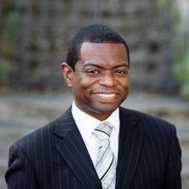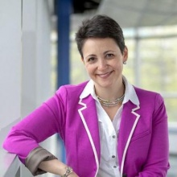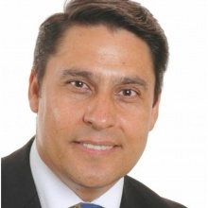

Learn more about the event: www.forumdavos.com
How to register for participation: www.forumdavos.com/registration
About the WCFA Association and its Executive Board: http://www.wcfaglobal.com/

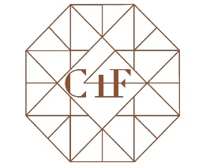
The second day of the forum will be devoted to the C4F Awards, introducing the best communication stories and cases of 2017. C4F Awards, launched seven years ago, aim to recognize remarkable individual communicators and/or companies with a creative professional approach and unique vision of the future of the World Development. Last year the Awards went to professionals from 12 countries: USA, UK, Brazil, Nigeria, Kazakhstan, India, Italy, Russia, Austria, Ukraine, Armenia, and Germany.
This year the short-listed nominees and winners will get the opportunity to present their showcases during the second day of the upcoming event. Winners of the following categories will get the trophy during the Forum in Geneva:
Individual: Grand Davos Award, Titan of the Future, Image of the Future, Talent of the Future, Relations of the Future.
Corporate: Education of the Future, City of the Future, Media of the Future, Pro Bono of the Future, Community of the Future, Reputation of the Future, Branding of the Future, Anti-Crisis of the Future.
Learn more about the C4F Award: www.c4fdavosaward.com
How to apply for the C4F Award: www.c4fdavosaward.com/Apply

Partners of the forthcoming forum:
EU Business School (Switzerland) www.geneva.euruni.edu
JSP Communications (Nigeria) www.jspcommunications.com
DonValley (South Africa) www.donvalley.co.za
Kaiser Communication (Germany) www.kaisercommunication.net/en
RADA Research & PR (Egypt) www.rada.com.eg
Ideal H+K Strategies (Brazil) http://www.idealhks.com/
Communications Korea (South Korea) www.commkorea.com
Africa Communications Week http://www.africacommunicationsweek.com/
C. Moore Media (USA) http://cmooremedia.com/about/
Village Ventures International (Kenya) http://www.villageventuresinternational.org/

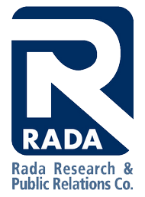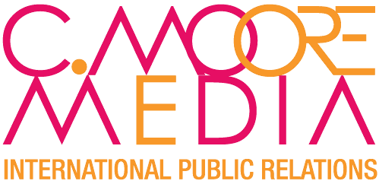
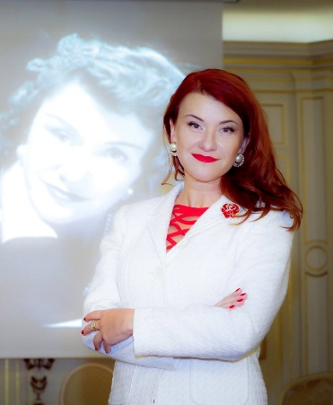
Yanina Dubeykovskaya, Founder and Content Director of the World Communication Association Forum and President of the WCFA association, shared:
“In 2017 it became obvious that the communication industry has finally changed. There no longer exists any traditional corporate PR. New industries such as social media management and virtual reality finally shaped into separate markets. However, talent, creativity and relationships – in their traditional sense – have acquired a complementary value. Forum’2018 will discuss exactly this new structure of markets and the required new profile of the communicator as a professional.”
The WCFA association’s annual event – 8 editions (2010-2017) – in figures: • 42% agency managers • 32% CorpComm Heads • 11% university reps • 10% Gov reps
• 5% media • 8 years #WCFDavos • 63 countries • 343 speakers • 248 presentations
• 190+ consultancies • 128+ companies • 138+ partners • 19 Gov units • 28 international orgs
• 29 educational institutions •51 media partners • 79 panel discussions • 37 keynotes
• 140 videos • 37 personal + 19 corporate C4F awards • 30 case studies • 9 training classes
• 14 regional forums • 5 projects of the WCFA association
Follow us:
Facebook: https://www.facebook.com/WorldCommForumDavos
Twitter: https://twitter.com/WorldCommForum
YouTube: https://www.youtube.com/user/forumdavoscom
Linkedin: https://www.linkedin.com/groups/2252687

For more details, please contact:
Valentina Atanasova, Project Manager: partners@forumdavos.com, +359 884435044
Aleksandra Antokhina, PR Manager: office@forumdavos.com, +49 176 20081914

