The New Program Board for WCF 2018 Has Been Announced
The World Communication Forum’s Program Board for 2018 has been formed. For the next calendar year, the WCF will be led by 27 communication professionals representing 20 countries all over the world: Russia, India, South Africa, Germany, Hungary, Italy, Bulgaria, China, Egypt, Turkey, the USA, Brazil, Armenia, Poland, Ukraine, Kazakhstan, Switzerland, Canada, UK, and Holland. In the nearest future, several significant for the communication industry events have already been scheduled by the Board, among others – the WCFA USA Trip, in cooperation with the PR Museum in New York, some regional communication forums, webinars, and the next annual WCF “Communication on Top”.
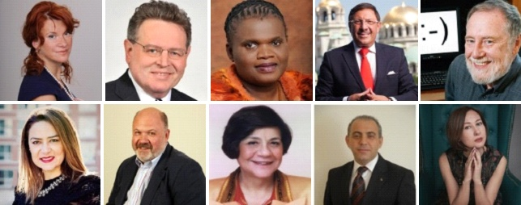
Members of the new WCF Committee are:
- Yanina Dubeykovskaya, WCFDavos Founder and Content Director, WCFA association's President (Russia),
- Prof. Dr. Ali Murat Vural, Executive Board Member and Coordinator at Bersay Communications (Turkey),
- Assel Kozhakova, DIPM MCIM, Founder & CEO of Red Point Kazakhstan (Kazakhstan),
- Catherine Hernandez-Blades, Senior Vice President, Corporate Communications, Aflac (USA)
- Dymitr Romanowski, Co-founder of The Story, Design & Innovation (Poland),
- Evgeniya Bliznyuk, Director and co-founder of Corestone, advisor at the Presidential Administration (Ukraine),
- Faith Muthambi, former Minister of Communications of the Republic of South Africa,
- Flavio Oliveira, Global PR Manager at UBM,
- Gabor Hegyi, Founding Managing Director of Capital Communications (Hungary),
- Guntram Kaiser, Chief Executive Officer of KaiserCommunication GmbH (Germany),
- Jennifer Stapper, Chief of the Communications Section at UN Volunteers (Germany),
- Gianni Catalfamo, CEO at One Wedge, Web 3.0 evangelist, Founder of cc:catalfamo (Italy),
- Dr. Jon-Hans Coetzer, former Chief Academic Officer (CAO), Glion Institute of Higher Education (Switzerland),
- Kara Alaimo, PhD, Assistant Professor of Public Relations, Hofstra University (USA),
- Lina Duque, MBA, Social Media Strategist, Executive Branding Coach and University Lecturer (Canada),
- Loula Zaklama, President and Managing Director of RADA Research & PR Co. (Egypt),
- Maxim Behar, ICCO President, CEO of M3 Communications Group, Inc. (Bulgaria),
- Olga Bereslavskaya, PhD, Founder of "Amazing Hong Kong" ("Amazing City Award"), Senior Investment Advisor at Qianhai Pacific World Assets Management Co., Co-founder of the World Communication Forum,
- Olga Podoinitsyna, Member of the Board, VTB Capital (Russia),
- Sandeep Malavi, Deputy Municipal Commissioner, PRO, Thane Municipal Corporation (India),
- Saurabh Kumar Uboweja, Founder, CEO & Director Brand Strategy at Brands of Desire (India),
- Sean Gardner, Co-Founder of the pioneering Huffington Post "Twitter Powerhouses Series" (USA),
- Sergey Zverev, President of CROS PR & Public Affairs (Russia),
- Scott Fahlman, Research Professor, Carnegie Mellon University (USA),
- Solly Moeng, Managing Director of DonValley Brand, Marketing & Communications (South Africa),
- Tatevik Pirumyan, Executive Director of APRA - the Armenian Public Relations Association,
- Yuxing Han, Professor - School of Engineering, South China Agriculture University, Founder of Nanjing Yunyan Technology Ltd. (China).

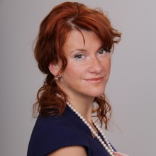
Yanina Dubeykovskaya, Founder and Content Director of the World Communication Forum and President of the WCFA association, shared:
“There are plenty of interesting ideas and important events on our agenda for 2018. We continue to build the global communication community and the new WCF Committee of 27 communicators active in 20 countries is the confirmation of the fact that we are on the right way! I believe with such an international composition of experts we will be able to form, on the one hand, a highly involving and diversified agenda which will prove attractive and interesting to all players in the communication industry. On the other hand, the program will genuinely focus on global communications as a driver of human development, since all members of the committee are trusted leaders of local regional or national professional communities within the communication industry.”
More information about the WCF Committee members for 2018: www.forumdavos.com/committee
Follow us on Facebook: www.facebook.com/theWCFA/
www.wcfa.ch
www.forumdavos.com
www.c4fdavosaward.com

For more details, please contact:
Valentina Atanasova, Project Manager: partners@forumdavos.com, +359 884435044
Aleksandra Antokhina, PR Manager: office@forumdavos.com, +49 176 4183 6565

