#WCFGenevaWeek 2017 summoned participants from 30 countries who discussed: Fake News, Reputation, Diplomacy, South Sudan, Global Communities, CSR, VR and AI, Startups, and Education in Communications
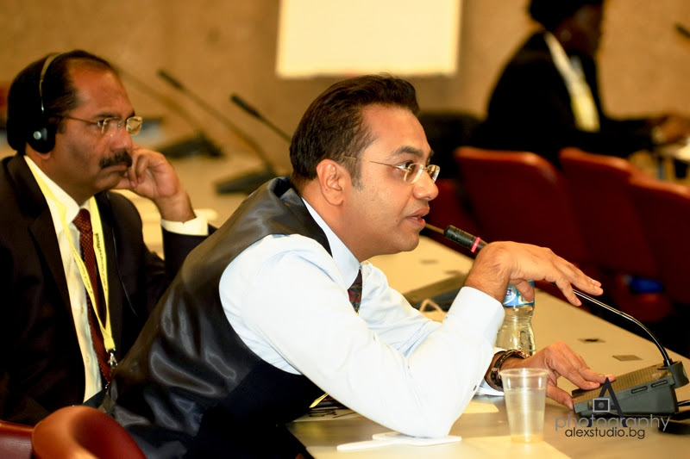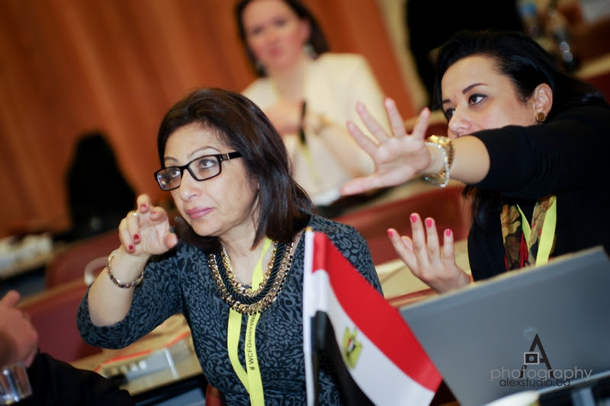
The annual event of the World Communication Forum Association “Communication on Top” which took place from the 13th till the 17th of March, 2017, summoned into the world’s global capital – Geneva – a diverse community of professionals from all over the world, in order to discuss the global agenda of the communication industry. More than 145 participants, 80 of which stepped out as speakers, attended the #WCFGneevaWeek to share key insights and learn from the experience of leading global experts.
This year, the WCFA welcomed a larger number of communication specialists from India, the USA, Turkey, Egypt, South Africa, Germany and Italy. On the whole, representatives from around 30 countries attended the event, among which, for the first time: Israel, Kenya, South Sudan, Barbados Islands, and Australia.
#WCFGneevaWeek offered a perfect platform for discussing both local and global topics from the communication field. Some of the most interesting insights shared and conclusions made were:
- Creating stories that provoke the recipients‘ empathy – a key factor in Country Branding.
- We consume 87% more information than 30 years ago – "It is the new fast food!"
- Europe is no more the shining example of integration. Populism, isolationism: on the rise.
- Mainstream media has a crucial role in contextualizing impactful stories from a crisis.
- Fake news is a danger to democracy and can become hate speech. FB fails to combat.
- Communication wags the tail of diplomacy. Word-wars. EU’s basic advantages – integration and equal human rights, are at stake. Global communicators need Digital Diplomacy and a common ground to fight terrorism and fake news. Europe's problems are not caused by Trump, they are home-grown. We must overcome divisiveness.
- Organizational culture VS Individual culture. Corporate identity VS Personal identity. What is the Global identity today? > Impact of tribal, ethnic, and religious identity...
- A heartbreaking story: debilitating, ongoing conflict in Sudan. Huge human costs – 5.5 million south Sudanese will die of famine by mid-2017. Where is the African and the world‘s leadership?
- Misplaced focus of Clinton’s campaign – stress on policy, rather than intensifying the emotional value and tweeting more intensively or aggressively. The @realDonaldTrump won the Election in 2016 because he outsmarted his rivals on social media.
- Fake News on the rise, as people trade trust in established news for what family+friends share on social media! This is not someting new, but now it is being industrialized.
- Unbelievably strong impact of the Social Media – today, more than ever, a cause can make a difference! Each and everyone of us has influence and can be a media – this should be used to attract attention of governments or to involve the Silicon Valley in due action regarding the world's problems!
- Voice of your company’s staff is more influential than ever! Set the example from the top to encourage Employee Advocacy.
- Wanna know how to engage the globe? Just see how @realDonaldTrump changed the game. Once it has touched the emotions of the electorate, a campaign’s success is guaranteed. Elections will never be the same again: forget about pragmatic or rational political leaders, reach out to gain the hearts of the people.
- 3.9 billion people unconnected to the internet are disproportionately female, rural, poor, illiterate, or elderly.
- Today's brands need to humanize themselves. Social media numbers are fine but engagement is more important. CSR is an essential part of an organisation's culture, not just linked to profitability. Think of it as a core function, not as a subsidiary one.
- Digital CSR is the corporate wonder weapon to inform, inspire and impact the world.
- You or your company's reputation is EVERYTHING! 24/7 social media monitoring is absolutely required. Clients expect their consultants to be decision-makers and react on the spot.
- The rationale behind non-cash/digital money currencies (Bitcoin, Blockchain, Cryptocurrencies, etc.) and how this can change the world we live in.
- Science plays an increasingly big role in communications. What are the implications for practitioners?
- Communication has been redefined and given new meaning, referring increasingly to the technological revolution of the late twentieth century. By renegotiating the meaning of communication, we have also successfully renamed our own identity as a society – a global culture – managed by these technological innovations.
- VR has huge potential markets - $ 80 billion by 2025. Yet, many tech limitations to adoption still remain.
- Culture + Environment + Opportunity. That's how you support entrepreneurship in emerging markets.
- VR and AI will continue to grow their market share, yet are still expensive for NGOs.
- 3 threats of AI: be used by terrorists; violate privacy; have HUGE impact on employment.
Full summary of the event: http://www.forumdavos.com/events/2017.
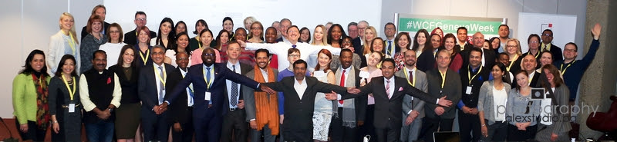
A brilliant summary by Michael Bociurkiw: https://www.linkedin.com/pulse/main-takeaways-from-world-communications-forum-davos-2017-bociurkiw
Ggreat coverage by Pranbihanga Borpuzari: http://economictimes.indiatimes.com/small-biz/marketing-branding/branding/two-indian-startups-bag-the-communication-for-future-awards-2017/articleshow/57871824.cms
Impressions by Louise Nealon: https://www.linkedin.com/pulse/power-personal-louise-nealon
During the #WCFGenevaWeek, the traditional annual “Communication for Future” Award ceremony was held at the luxurious Geneva hotel Beau-Rivage. No less than 19 awards reached their winners from all around the world: http://www.c4fdavosaward.com/C4F-Winners.
The co-authored book "WCF: Existential Business Case" was also presented during the Gala Dinner. It describes the experience of a group of global experts, who took part in the launching and development of the global annual WCFA event “Communication on Top”. The book is still available to order online: http://wcf-book-2017.evenium.net.
The WCFA association is grateful to all partners who turned the event into a valuable experience for all attendees: TRT World (Turkey), Corestone Corporation (Uraine), BSA Crescent Unversity (India), RVC and ComLab (Russia), ZEE School (India), The Story (Poland), Don Valley (South Africa), Kaiser Communication (Germany), RADA Research & PR (Egypt), JSP Communications (Nigeria), CROS Public Relations & Public Affairs (Russia), M3 Communications Group, Inc. (Bulgaria), Capital Communications (Hungary), Competence Communication (Italy), Project Z (USA), Evenium (France), Depot WPF (Russia), Ochsner Consulting (Switzerland), ASC (Russia), ABCI (India), APRA (Armenia), RPRA (Russia), CIPRA (China), ABRACOM (Brazil), ABRADI (Brazil), Geneva Comms Network (Switzerland), ICCO (England).
Yanina Dubeykovskaya, Founder and Content Director of the World Communication Forum and President of the WCFA association, shared: “The Forum in Geneva collected many communication specialists from all around the world. The event has developed with the time into a platform to go beyond local borders and talk about global communication with the participation of a diversity of the related counteracting parties. This has not happened accidently, but because the WCFA association is the only organization of communication professionals in the world that fights to increase the influence of communication on the development of the world and goes beyond the classical service model of interaction with business, public institutions or politics”.
The WCFA association’s annual event – 8 editions (2010-2017) – in figures:
• 42% agency managers • 32% CorpComm Heads • 11% university reps • 10% Gov reps • 5%
media • 8 years WCF • 63 countries • 343 speakers • 248 presentations • 190+
consultancies • 128+ companies • 138+ partners • 19 Gov units • 28 international orgs • 29
educational institutions • 51 media partners • 79 panel discussions • 37 keynotes • 140 videos
• 37 personal + 19 corporate C4F awards • 30 case studies • 9 training classes • 14 regional
forums • 5 projects of the WCFA association
Follow us on:
Facebook: https://www.facebook.com/WorldCommForumDavos
Twitter: https://twitter.com/WorldCommForum
YouTube: https://www.youtube.com/user/forumdavoscom
Linkedin: https://www.linkedin.com/groups/2252687
www.forumdavos.com
www.c4fdavosaward.com

For more details, please contact:
Valentina Atanasova, Project Manager: partners@forumdavos.com, +359 884435044
Aleksandra Antokhina, PR Manager: office@forumdavos.com, +49 176 4183 6565

