World Communication Forum Association: Actions instead of words!
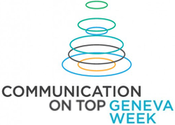
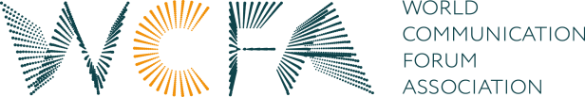

The Global Annual “Communication on Top” Forum organized under the auspices of the World Communication Forum Association (WCFA) will take place for the 8th time this year – for a whole week! It will be held from the 13th till the 17th of March 2017, and it is also moving from Davos to Geneva, one of the most important European cities, where the global agenda of today’s society and economy is not only discussed, but also actively implemented by global organizations and worldwide communities.

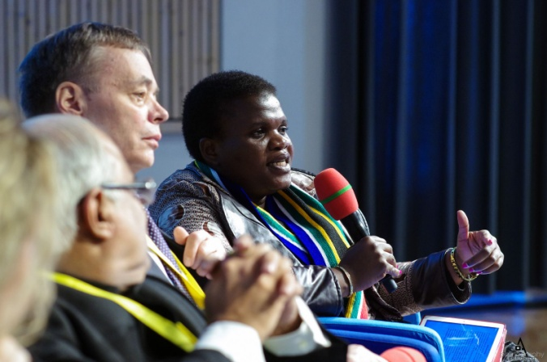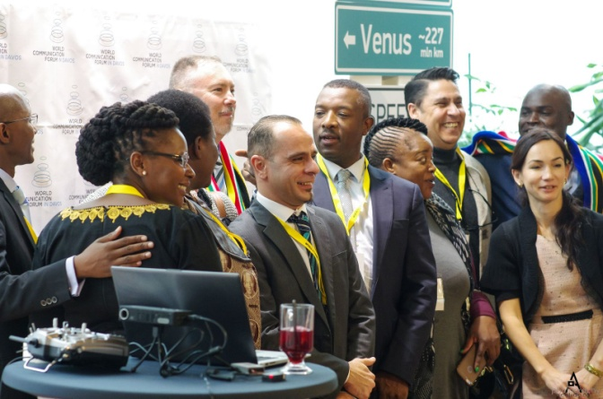

For the first time, the Forum will be shaped in the format of a “Geneva Communication Week”. Five days devoted to a variety of hot topics will be hosted by different locations.
The key themes for discussion are focused on:
- Country branding.
- Communication & Public Diplomacy.
- Can communication save lives?
- Social media in political campaigns and business.
- How can communication help to make the world a better place?
- Who shapes and verifies the global agenda and how to deal with fake news?
- Modern CSR tendencies.
- New money and new currency of social evaluation.
- Scientific communication.
- Communication for StartUps.
- Global education for global citizens… And more!

As one of the very few independent communication associations in the world, WCFA attracts attention of both global communities and mass media. However, the upcoming event has already exceeded its greatest expectations! Among the Guests of the Forum in Geneva are: Faith Muthambi, Minister of Communications of the Republic of South Africa, Daniel Holtgen, Director of Communications and Spokesperson of the Secretary General and Deputy Secretary General at the Council of Europe, Roman Vassilenko, Deputy Minister of Foreign Affairs Republic of Kazakhstan, Alexandra Cousteau, the granddaughter of the world famous ocean explorer Jacques-Yves Cousteau, oceanographer, filmmaker and globally recognized advocate on water issues, and many more – you can see the lineup of great speakers here: http://www.forumdavos.com/programme.

Traditionally, the prestigious annual “Communication for future” – C4F Awards will be handed during a ceremony at the “Geneva Communication Week”. The gala dinner and the official announcement of the winners are scheduled for the 14th of March, at the exquisite Beau-Rivage hotel with a view to Lake Geneva.
Also, the inauguration of the Women Influence Community (WIC) will be held on the next evening (15 March), at the Royal Manotel hotel. Key purpose of the WIC community is to show powerful women’s influence on the global development of society and humanity.

Partners of the Geneva Week are: TRTWorldChannel (Turkey), The Story (Poland), Don Valley (South Africa), GROU (Ukraine), Kaiser Communication (Germany), RADA Research & PR (Egypt), JSP Communications (Nigeria), CROS (Russia), M3 Communications Group, Inc. (Bulgaria), Capital Communications (Hungary), Competence Communication (Italy), Evenium (France), Depot WPF (Russia), Ochsner Consulting (Switzerland), ASC (Russia), ABCI (India), APRA (Armenia), RPRA (Russia), CIPRA (China), ABRACOM (Brazil), ABRADI (Brazil), Geneva Comms Network (Switzerland), ICCO (England).

Yanina Dubeykovskaya, Founder and Content Director of the World Communication Forum and President of the WCFA association, shared: “The meeting in Geneva will again unite all the World Communication Forum Association members together. The WCFA is the only association of communication professionals striving for a higher level of communication influence on today’s global development and going beyond the classical stereotype of a ‘service model’ of communications in business or politics”.
WCFA Meeting – 7 editions (2010-2016) – in figures:
• 42% agency managers • 32% CorpComm Heads • 11% university reps • 10% Gov reps • 5%
media • 7 years WCFDavos • 58 countries • 263 speakers • 202 presentations • 165+
consultancies • 115+ companies • 125+ partners • 19 Gov units • 20 international orgs • 22
educational institutions • 45 media partners • 65 panel discussions • 32 keynotes • 140 videos
• 28 personal + 7 corporate C4F awards • 13 case studies • 5 training classes • 12 regional
forums • 5 projects of the WCFA association
Follow us on:
Facebook: https://www.facebook.com/WorldCommForumDavos
Twitter: https://twitter.com/WorldCommForum
YouTube: https://www.youtube.com/user/forumdavoscom
Linkedin: https://www.linkedin.com/groups/2252687
www.forumdavos.com
www.c4fdavosaward.com

For more details, please contact:
Valentina Atanasova, Project Manager: partners@forumdavos.com, +359 884435044
Aleksandra Antokhina, PR Manager: office@forumdavos.com, +49 176 4183 6565

