C4F Award Jury Board 2017 Unites 19 Global Experts
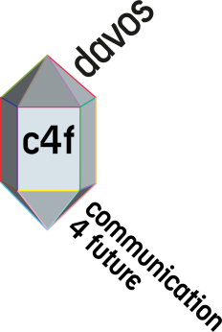
Starting preparations of edition 2017, Communication for Future (C4F) Davos Award will again function as a prestigious and influential platform for recognition of the most avant-garde communicators across the globe! The gala ceremony is held during the annual World Communication Forum in Davos (#WCFDavos) which takes place at the Congress Centre in Davos, Switzerland, in the beginning of March next year. Recently, the C4F nominations have been divided into personal and corporate. Three of the categories are established and held by the WCFA association and the income is to be fully used for the association’s initiatives. On 15 May, the secretariat of the C4F Award has announced the members of the two Jury panels for the Award’s edition in 2017 (listed below).
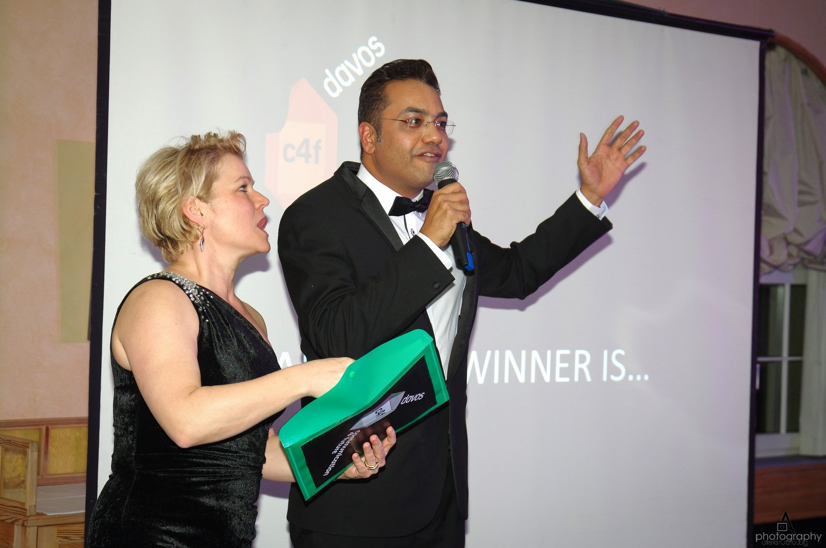
Personal C4F Awards Jury – 8 global experts representing 7 countries:
- Alfred Koblinger, Chairman, CEO of BBDO Holding (Austria)
- Galina Panina, PR Director & Manager External Communications, Leroy Merlin (Russia)
- Iryna Zolotarevych, Director of WCFDavos|Kyiv, WCFDavos Committee member, PR&GR Services Director, AGAMA Communications (Ukraine)
- Lorenzo Brufani, Owner and General Manager of Competence Communication (Italy)
- Maxim Yakover, Founder of Chasopys, co-founder of DreamKyiv, co-owner of Interesting Kyiv, Board member of VDNH
- Natalia Gromadskikh, CEO of IPR Belarus, MSSc, Lecturer of Public Relations at the Belarusian State University (Belarus)
- Olga Kudinenko, Tabletochki (Ukraine)
- Scott Fahlman, WCF-Davos Committee member, Research Professor at Carnegie Mellon University, 'Father' of the smiley emoticon (USA)
- Sumita Singh, Manager Corporate Communications, IndianOil (India)
- Danijel Kletić, CEO at Apriori World (Croatia)
Corporate C4F Awards Jury – 11 global experts, representing 9 countries:
- Rana Nejem, Chairman, Founding Director of YARNU (Jordan)
- Andrea Cornelli, Vice President and CEO of Ketchum-Italy and PR HUB coordinator (Italy)
- Bayan Tal, Senior Advisor at the Jordan Media Institute, former DG of National Radio & TV (Jordan)
- Dymitr Romanowski, Co-founder and CEO of The Story digital branding agency
- Fabienne Rollandin, Executive Director External Relations, Glion Institute of Higher Education (Switzerland)
- Frédéric Massé, Vice President, Head of Government Relations for SAP EMEA, Deputy Head of Global Government Relations (France)
- Philip Osagie, Global Strategist of JSP Communications & African PR expert (Nigeria)
- Philippe Borremans, Director Strategy at PR Media - Morocco (Belgium)
- Tanuja Kehar, Vice President Corporate Communications, Unitech (India)
- Tatevik Pirumyan, Executive Director of APRA - the Armenian Public Relations Association (Armenia)
- Vanduta Khurana, Co Founder of n2-X and Managing Partner of Daks-India (India)
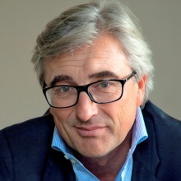
The Personal C4F Awards (8 categories) are to be given to individuals with a strong professional influence on the global improvement of communication in its broad sense and a truly effective contribution in fostering new trends for the development of the communications industry worldwide. Alfred Koblinger, President of the Personal C4F Awards Jury and CEO of BBDO Holding (Austria), shared: "There are a lot of outstanding people who act as real ‘game changers’ in their relevant environment. Most of them never get rewarded for their amazing work. C4F wants to lift the curtain and recognize them – with a personal award. This is a difficult and responsible task for the jury, as the global relevance of an achievement is often gained via a national prism or local viewpoint. Only via a clear description of their achievement and an objective proof we shall be able to chose those who are dignified to receive this prestigious award.“
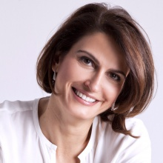
The Corporate C4F Awards (15 categories) are to be given to companies which set the standards for effectiveness and professionalism within the global communication industry and demonstrate innovation and creativity in the realization of their communication strategies and campaigns. Rana Nejem, President of the Corporate C4F Awards Jury and Founding Director of YARNU (Jordan), stated: "There is so much incredible cutting-edge work that is being done, and higher standards are being set every day by corporations working in this field. We have decided to position the Corporate Award into 2 sub-groups: The Who and the How, with several categories under each of these divisions. This is the chance for the truly outstanding to shine!"

Nominations are now open: http://c4fdavosaward.com/Apply. The next step will be to announce the option for online application and payment.

Launched in 2011, the award has gained a vast global prestige and professional weight as a sought-after prize recognizing top performers across a wide range of communication disciplines: visual communications, media relations, reputation management, CSR, branding, education, and more. Renovated in 2016, the gala ceremony had an outstanding resonance, presenting some of the best cases of effective and creative methods for global communication. All guests enjoyed a spirit of unity and cooperation – dancing, karaoke singing, and congratulations. More than 20 cases worthy of recognition were submitted and evaluation was held in two stages: first, the jury determined the candidates for each nomination, and then the voters evaluated each case as per five criteria - effectiveness, influence, trend, integration of solutions, and social convenience. Nominees with the highest number of points were announced as Winners in 3 Personal and 7 Corporate C4F Award categories, 2016: http://c4fdavosaward.com/C4F-Winners/2016.

Yanina Dubeykovskaya, General Director of WCFDavos and President of the WCFA, said: “WCFDavos has always sought for the ways to promote individual effort within the communications industry, supporting professionals who spearhead innovation and whose vision defines industry’s future and drives global change. C4F is definitely a grand step in that direction, helping us single out and recognize opinion leaders who can build the global communications agenda as part of the World Communication Forum.”

Official website: http://c4fdavosaward.com/

C4F Davos Awards were inaugurated back in 2011, as a special recognition of remarkable professionals with an outstanding contribution to the development of communications.
Today, the awards are positioned in 23 categories altogether, in praise of individual achievement and also the best corporate showcases for the year: 8 Personal C4F Awards and 15 Corporate C4F Awards (7 “Who” + 8 “How” categories).
Follow us on Facebook: https://www.facebook.com/C4FDavosAwards/
For contact: c4f@forumdavos.com

