WCFA Global Survey Results:
Long-term Reputation is the Key Challenge for Communication Professionals

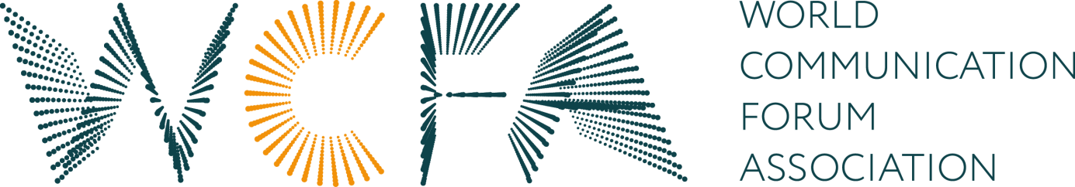

In November, 2016, the World Communication Forum Association (WCFA) held a global survey focused on the main tasks, challenges and trends of the communication industry. 187 communication professionals from five continents answered 10 questions about the communication industry, as per their personal experience.

Every third participant of the WCFA survey sees the key task of professional communicators in promoting global values and solving global needs. Other 33% of the respondents concentrate on facilitating international communications and supporting the activities of global companies. Therefore, the survey results show a clear tendency of the communication industry towards international cooperation and constructing a global communication society.

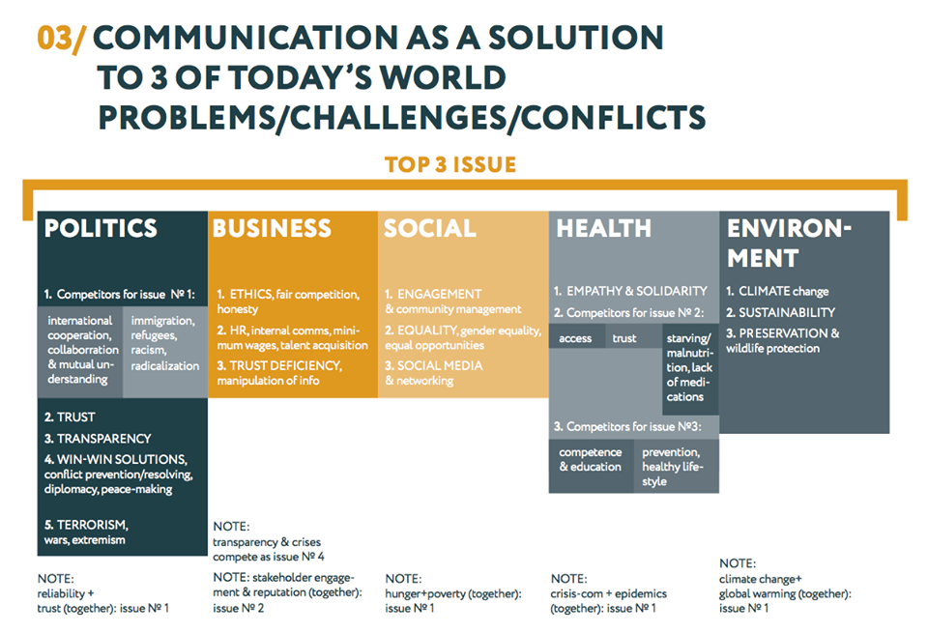

The key challenge that 45% of the communication professionals declare to be faced with today is the formation of a long-term reputation in a fast-changing world. The modern world is changing rapidly, so today’s communications need to be even more flexible in order to keep up with the times and reach the target audiences. Besides, permanent reputation does not exist anymore. Now, reputation needs to be kept up-to-date every day.

Apart from their key tasks, the questioned communication specialists believe they should also contribute to overcoming political challenges, such as refugee crises, reliability, building transparency and trust, countering terrorism, etc. In business communications they could certainly help with ethics, HR & talent acquisition, and trust deficiency. Moreover, communicators are ready to take part in solving problems with social engagement, equality, hunger, and eager to help with environmental issues like climate change, sustainability, wildlife preservation, or ready to foster solidarity, empathy and free access to the health system. So, communicators see a big part of their role not just in the professional area, but in contributing to society and facilitating solutions to the most urgent problems of our times.

37% of the respondents view social media support or developing SM communications as the most perspective market niche for today’s communication agencies. Community management takes the second place with ¼ of the votes, followed by crisis communications which were selected by 20% of the participants. It seems the importance of media relations and media management is no longer brought into question.

The three main skills of today’s CCO or communication director in a global company are: leadership, vision, adaptive to change, as per the results of the WCFA survey. The ability to react quickly to rapidly changing circumstances is viewed as one of crucial importance. Obviously, the modern communication professional needs to be not only a good manager and organiser, but again – to be able to race with the time. When asked to name three additional valuable skills, the respondents chose experience, stamina/resilience and discipline.

Yanina Dubeykovskaya, Founder and President of the World Communication Forum Association, shared: “The WCFA association holds such surveys annually in order to inform its members about new trends and important calls within the industry. The results of the poll aim to help specialists foresee the main challenges they will face in the nearest future and develop the right communication strategy”.

This year, 187 communication specialists participated in the survey. More than a half of them currently act as company presidents or managers, and almost 40% represent communication agencies. The average age of the majority of respondents (59%) is between 30 and 50 years.

The World Communication Forum Association (WCFA) is a non-profit organisation whose goal is to create a global cross-border and cross-cultural professional community in the field of communications. The focus of the WCFA lays on communications, media, PR, branding and leadership. Strongly believing that communication as a key factor in the development of humanity, the WCFA initiates researches and surveys about the specifics and future of communications: new behaviour models, educational models, recognition and influence etc. For more information visit our home page: http://www.wcfa.ch/en/about-us.

Follow us in the social media:
Facebook page: https://www.facebook.com/theWCFA
Internal Facebook Group: https://www.facebook.com/groups/wcfadavos/
YouTube Live-Streamed Webinar: https://www.youtube.com/watch?v=efcLR_F5XnI
WCFA survey: http://www.forumdavos.com/uploads/files/filepath_31.pdf

Join as a WCFA member: http://www.wcfa.ch/en/join-us

