World Communication Forum 2017 is Moving:
From the Global village of Davos to the Global Capital of Geneva
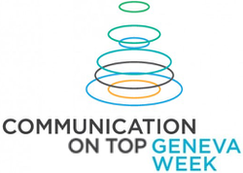
During the week of 13-17 March 2017, the World Communication Forum will be held again in Switzerland, for the 8th time. However, this time the Forum is planned to be very different. Compared to its previous 7 editions that took place in Davos, the upcoming WCF will offer a larger scale of content, hosted by the global capital of the world – Geneva.
The main aim of the World Communication Forum and the WCFA association is to increase all communicators’ influence on the future of humanity, on the development of the business in different countries, on their nations, and on each person in particular. Therefore, Geneva, the ‘global capital’ that hosts the highest number of important international organizations within the world, is the perfect location. Starting from 2017, the C4F Awards ceremony will also take place in Geneva. The motto of the Awards is ‘Communication for future’, and Geneva is the cradle of the world’s future.
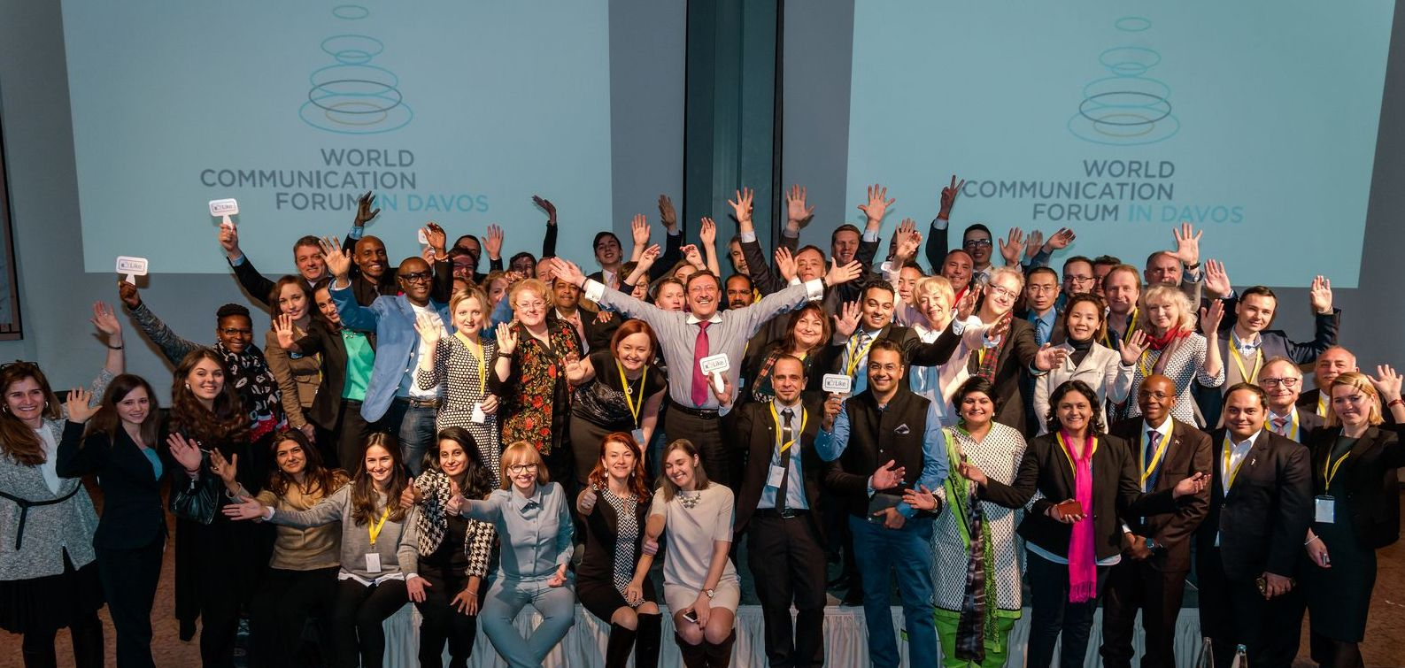
Moving to Geneva, the World Communication Forum has also changed its format. The 8th addition will last longer and will be far more intensive. Additionally, the Forum will be held in cooperation with various international organizations. Here is the preliminary agenda:
13 Mar’17, Geneva Motor Show: Branding & Design;
14 Mar’17, UN Headquarters: Global orgs & Government communications;
15 Mar’17, UN Headquarters: Global companies & Business Development;
16 Mar’17, CERN: Science, Innovation & Technology;
17 Mar’17, GLION Institute of Higher Education: Education in Communications;
Yanina Dubeykovskaya, Founder and Content Director of the World Communication Forum and President of the WCFA association, shared: “During the past 7 years, the Forum in Davos helped us shape a global community of communicators who view our profession as a mission – the mission to make this world more connected, more open, and more trusted. We believe that, especially today, communication is the key driver for the future development of the world, of humanity, and of each individual. We have created a new format for holding a business event and we have accepted representatives of more than 58 countries in our WCF family. Over 263 speakers have stepped-out in Davos during these 7 years. In the offline and online media, there have been 110 publications of the last edition – the WCF’2016. We launched the regional WCF format back in 2013 and we have already held over 15 regional forums in different countries. What is best of all is that we have made a lot of friends!”
Ms Dubeykovskaya added that the Forum has grown and is ready to move from a Global Village to a Global Capital. Geneva is the best place where, for 5 consecutive days, the participants will “touch globalism and feel global culture at their very fingertips.” The Forum aims to shape the global communication agenda and foresee new opportunities for communication’s impact on the future of humanity. Two days have become insufficient, so the organizers are launching a series of events under the brand WCF Geneva Week, focusing on different areas of communication: Global & Corporate Communication, Branding & Design, Science & Innovation Communication, and Education & Communication.
“Next year we move to Geneva for a week, to feel the Global Communication Touch!” – said Ms Dubeykovskaya. “I hurry to thank our partners: The Story (Poland), Don Valley (South Africa), GROU (Ukraine), Kaiser Communication (Germany), RADA (Egypt), JSP Communications (Nigeria), CROS (Russia), M3 Communications Group, Inc. (Bulgaria), Capital Communications (Hungary), Competence Communication (Italy).”
WCFDavos – 7 editions (2010-2016) – in figures:
• 42% agency managers • 32% CorpComm Heads • 11% university reps • 10% Gov reps • 5%
media • 7 years WCFDavos • 58 countries • 263 speakers • 202 presentations • 165+
consultancies • 115+ companies • 125+ partners • 19 Gov units • 20 international orgs • 22
educational institutions • 45 media partners • 65 panel discussions • 32 keynotes • 140 videos
• 28 personal + 7 corporate C4F awards • 13 case studies • 5 training classes • 12 regional
forums • 5 projects of the WCFA association
Follow us on:
Facebook: https://www.facebook.com/WorldCommForumDavos
Twitter: https://twitter.com/WorldCommForum
YouTube: https://www.youtube.com/user/forumdavoscom
Linkedin: https://www.linkedin.com/groups/2252687
www.forumdavos.com
www.c4fdavosaward.com

For more details, please contact:
Valentina Atanasova, Project Manager, +359 884435044
Aleksandra Antokhina, PR Manager, +49 176 4183 6565

