Winners of the Communication for Future Awards 2017

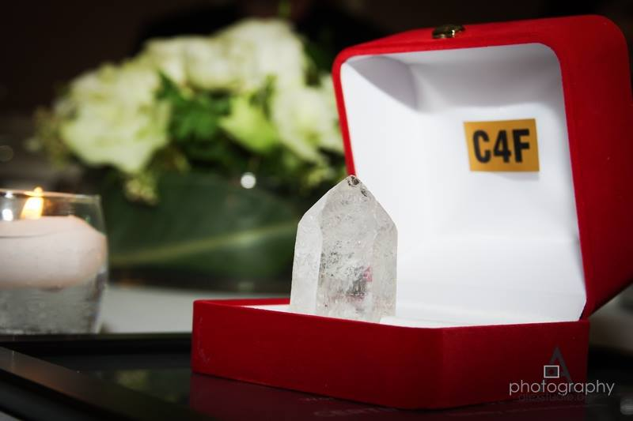
The C4F Awards 2017 was held on March 14, at Beau Rivage Hotel, in Geneva, Switzerland. The award recognizes highly professional and globally remarkable individual communicators and/or organizations with a creative approach and unique vision of the future of the communications industry worldwide. The prestigious C4F Awards was launched in 2011 and this is its 7th edition. There are 23 nomination categories for the Awards under three divisions: Personal, Corporate and Start-Ups.

Chairmen of the jury: Mr. Alfred Koblinger, CEO of BBDO, Austria, is the Chairman for Personal Categories and Ms. Rana Nejem, Founding Director of YARNU, Jordan, is the Chairman for the Corporate Categories. Here is the link to the Juries of the C4F Awards: http://www.c4fdavosaward.com/Jury
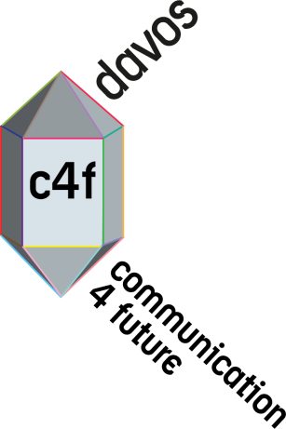
The organizers received 86 applications altogether, in all 23 categories. Among the nominees there are representatives from 30 countries on 5 continents. Companies and individuals, who represent the best of the cases, were announced as winners at the Gala ceremony on 14 March.

We are pleased to announce the Winners of the C4F Awards 2017:

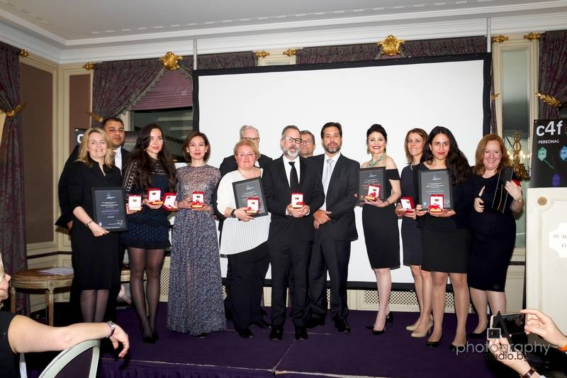

PERSONAL AWARDS
Grand Davos Award
Fran Bidderman, CEO and Strategista of Advantages Inc (USA)
David Gallagher, President Omnicon PR Group (UK)
Titan of the Future
Dr. Kara Alaimo, Asst Professor of Public Relations, Hofstra University (USA)
Relations of the Future
Catherine Hernandez-Blades, Senior VP, Corporate Comms Aflac (USA)
Evangelist of the Future
Adebola Williams, Founding Partner Red Media, (Nigeria)
Eduardo Vieira, Founder Ideal Group (Brazil)
Talent of the Future
Assel Kozhakova, Founder Red Point Khazakhstan LLP, (Khazakhstan)
Leader of the Future
Ganesh AC, Founder ACG Consultancy (India) and
Eduardo Vieira, Founder Ideal Group (Brazil)

STARTUP AWARDS
Idea of the Future: Deerak Solutions (India)
Technology of the Future: ACG Consulting (India)

CORPORATE AWARDS
Education of the Future: CROS, Russia, & KETCHUM - SVIZERRA, Italy
City of the Future: Amazing Villach, Austria
Trust of the Future: Pro Zorro, Ukraine
Pro Bono of the Future: Spring PR, Armenia
Community of the Future: Sound PR, Italy
Reputation of the Future: SPN Communications, Russia
Communications of the Future: KETCHUM - ESTRA, Italy
Creative of the Future: TCS, Europe
Anti Crisis of the Future: KETCHUM - SVIZERRA, Italy
Value of the Future: KETCHUM - PRADA, Italy
Employee Communications of the Future: SAP, Germany
Branding of the Future: SPN Communications, Russia

Yanina Dubeykovskaya, Founding Director of C4F Awards: "Congratulations to all the winners! At the Gala we reviewed interesting showcases and greeted extremely talented professionals from 30 different countries. It was a great feeling of cross-cultural communication, when the best practices of each country were shared across the table. I am sure the C4F Awards 2018 is going to be much bigger and more encouraging for the communication professionals all over the globe."

For questions, please, contact:
Yanina Dubeykovskaya, C4F Awards Director: +41 762 413 224; yana@forumdavos.com
Sukruti Narayanan, Global Manager of C4F Awards: +91 771 881 5357
WhatsApp: +91 97910 73007;
c4f@forumdavos.com

