Communication for Future Awards 2017 – shortlist is determined!

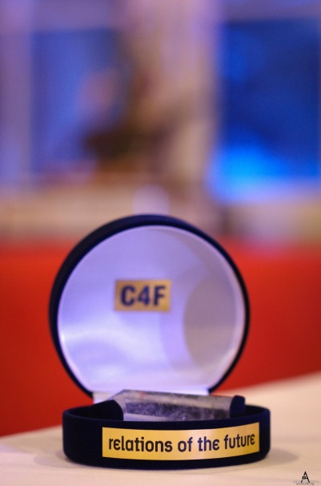
The International Jury Board of C4F Awards 2017 consisting of Communication Stalwarts from 20 different countries announced the shortlist of nominees 2017.

The C4F Awards 2017 will be held on March 14 in Geneva, Switzerland. The award recognizes highly professional and globally remarkable individual communicators and/or organizations with a creative approach and unique vision of the future of communications. The prestigious C4F Awards were launched in 2010 and this is their 8th edition. There are 23 nomination categories for the Awards under three divisions: Personal, Corporate and Start-Ups.

Mr. Alfred Koblinger, CEO of BBDO, Austria, is the Chairman for Personal Categories and Ms. Rana Nejem, Founding Director of YARNU, Jordan, is the Chairman for the Corporate Categories. Here is the link to the Jury boards of the C4F Awards:
http://www.c4fdavosaward.com/Jury
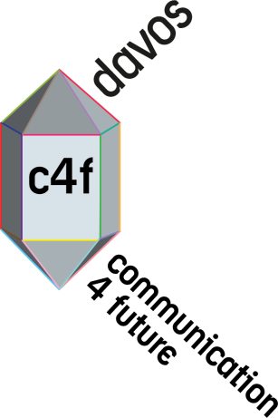
Organizers received applications in all 23 categories. Among the nominees, there are representatives from 30 countries and 5 continents. Companies and individuals who represent the best of the cases have now been shortlisted.
These participants have been selected and go into the final round of evaluation by the jury board who will determine the winners.
We are pleased to announce the shortlist of the C4F Davos Award 2017:

Short-listed candidates in Personal Categories:

- Fran Bidderman, CEO and Strategista of Advantages Inc (New York, USA)
- David Gallagher, President Omnicon PR Group (UK)
- Eduardo Vieira, Founder Ideal Group (Brazil)
- CK Kumaravel, Founder Naturals Salon (India)
- Catherine Blades, Senior VP, Corporate Comms Aflac (USA)
- Flavio Oliveira, Manager Public and Media Relations (Netherlands)
- Adebola Williams, Founding Partner Red Media, (Nigeria)
- Dr. Kara Alaimo, Asst Professor of Public Relations, Hofstra University (USA)
- Alexandra Cousteau, Founder Blue Legacy International, (USA)
- Assel Kozhakova, Founder Red Point Khazakhstan LLP, (Khazakhstan)
- Ana Braskamp, Manager Corporate Comms Yahoo (USA)
- Ganesh AC, Digital and Media Consultant, (India)
- Antokhina Aleksandra, Berndt+Partner Communication Manager, (Russia)

Short-listed candidates in Corporate Categories:
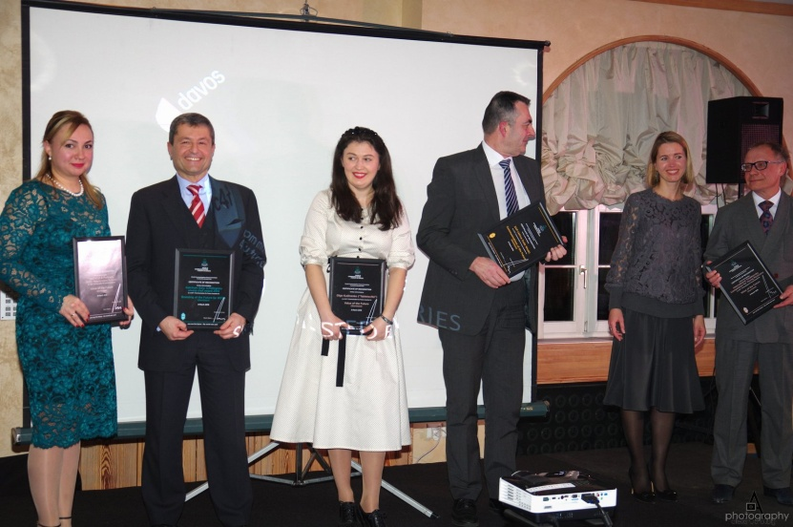
- "Gurov PR", Russia
- "CROS", Russia
- "Ketchum - SVIZERRA", Italy
- "Amazing Villach", Austria
- "City of LODZ", Poland
- "Ketchum - Philips CSR", Italy
- "Pro Zorro", Ukraine
- "P&G",Ukraine
- "Spring PR", Armenia
- "TCS", Europe
- "Zagran", Russia
- "Sound PR", Italy
- "International Center Creative Technologies of Consulting", Russia
- "SPN Communications", Russia
- "Ketchum -ESTRA", Italy
- "SAP", Germany
- "Competence Communication-ZTE", Italy
-" Ketchum - PRADA", Italy
- "Indian Oil", India
- "Deerak Solutions", India

The Winners will be announced at the Gala Awarding Ceremony held in the Hotel Beau Rivage on the 14th March 2017: http://www.beau-rivage.ch

Yanina Dubeykovskaya, Founding Director of C4F Awards, shared:
"We are happy to receive applications from 22 different countries this year. So many talented people and companies work in communications to make this World more trustful, connected and open. We congratulate all the participants of the shortlist. The winners of the nominations will be announced on March 14 in Geneva, at the C4F Davos Awards Gala Ceremony. Good luck to all selected in the shortlist participants, see you in Geneva!"

People who wish to attend this event can register in the link below:
http://www.forumdavos.com/registration

For questions, please, contact:
Yanina Dubeykovskaya, C4F Awards Director:
Tel: + 41 762 413 224; yana@forumdavos.com
Sukruti Narayanan, Global Manager of C4F Awards:
Tel: + 91 771 881 5357, WhatsApp: +91 97910 73007; c4f@forumdavos.com

