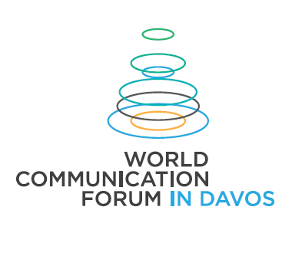**WORLD COMMUNICATION FORUM AROUND THE WORLD IN 2016  
TWO SUMMER COURSES AND FOUR REGIONAL AUTUMN EDITIONS**

This autumn, the **World Communication Forum** will again circle the globe in its consecutive regional format, with **four separate editions** in the respective countries, chronologically: **Ukraine, Poland, Malaysia, and Turkey**. The regional forums will be preceded by **two special sessions** in August and early September: an intensive educational course – for young managers, final-year students or MBA graduates, and an adventurous mountain-trekking challenge – for all brave communicators!

WCF’s key task is to create a global professional community with valuable expertise in the field of communications and strengthen its influence on the formation of the Global Development Agenda. Therefore, in Aug-Nov’2016, the whole WCF family worldwide and all young specialists or dedicated communicators, PR experts, and corporate communication managers who wish to keep up with the latest tendencies of the profession or simply want to challenge their own potential, are welcome to join the upcoming special thematic or regional WCF sessions listed below!

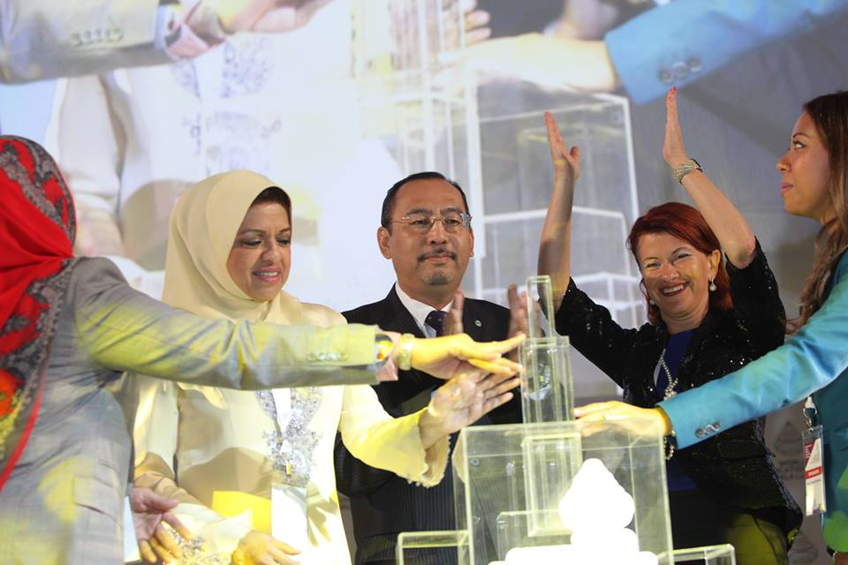**Opening of the Regional WCF in Kuala Lumpur, Malaysia’2015:** Dato’ Sri Shahrizat Abdul Jalil, Chief of Pergerakan Wanita UMNO, YB Dato' Jailani Bin Johari, Deputy Minister of Communications & Multimedia, Yanina Dubeykovskaya, Initiator and General Director of WCF and President of WCFA, Nurul Shamsuri, Regional Director of WCF in Kuala Lumpur.

**Yanina Dubeykovskaya**, WCF’s initiator and General Director, proudly shares: “The WCF has now long gone **beyond the frame of a single annual event** – it has expanded far beyond Davos, too… We have already held Regional WCFs in a number of key cities across Europe and Asia, bringing our lively discussion-based format, offering a modern approach and fresh solutions to the most important problems defined by the host country, and fostering further development and progressive changes in 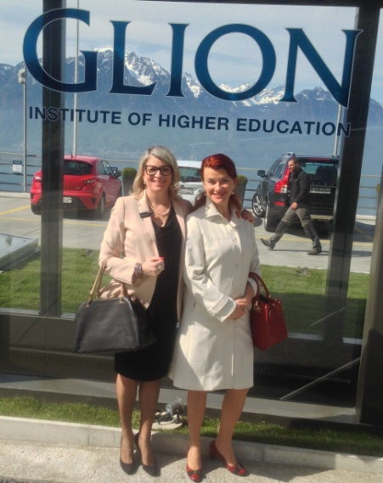the national professional community and the respective local or regional market. We bring our leading global expertise with a spirit of unity and cross-cultural globalism that naturally permeates the WCF – it has been embraced by all the participants who have so far come to join us from 58 countries altogether! WCF itself arrives in countries where it is eagerly expected, and where the local talent & professionalism gets fully engaged by the WCF-ambassadors, following our mission and sharing our dream: to make our world more open, more connected, and a better place to live in!”

**Major Partners** with whose kind support the **First WCF** **editions** will be held in Poland and Turkey: The City of Lodz (<https://www.youtube.com/watch?v=BqziuS9n0dk&feature=youtu.be>) and Istanbul University (<http://www.istanbul.edu.tr/en/>).**The** **Key Partner** of the **First Educational WCF Communication Camp** is the GLION Institute of Higher Education (<http://www.glion.edu/>). The upcoming WCF editions in 2016 – with leading Global Communication experts as speakers, are listed as follows:

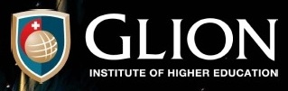● WCF | ComCamp, 14-21 Aug’16 – Geneva & Glion sur Monteux, Switzerland, [more info >>](http://www.forumdavos.com/regional/13)  
**Educational program for young managers and communication specialists!  
Officially supported by the WCFA association and the GLION Institute of Higher Education!**(7 sessions/master classes, hiking in the Alps, visits at the UN HQ and companies, hotel included)  
Book Online: [http://wcfcomcamp-2016.evenium.net](http://wcfcomcamp-2016.evenium.net/)

● WCF | Everest, 4-17 Sept’16, [more info >>](http://www.forumdavos.com/regional/20)  
**Challenging adventure for brave communicators who seek to conquer new heights!**(4 sessions/discussions, accommodation and meals included)   
Book Online: [http://early-bird-wcf-everest-2016.evenium.net](http://early-bird-wcf-everest-2016.evenium.net/)

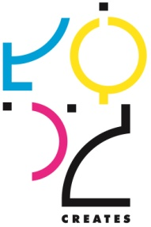 ● WCFDavos | Kyiv, 19-20 Sept’16, [more info >>](http://www.forumdavos.com/regional/17)  
**Focus: Win-win strategies as an alternative to conflict in business, politics and society!**(9 panel discussions and a regional edition of the prestigious C4F Awards)  
Book Online: <http://forumdavos2016.ticketforevent.com/>

● WCFDavos | Łódź, 10-11 Oct’16, [more info >>](http://www.forumdavos.com/regional/18)   
**Focus: Innovations and Human-Centered Design!  
Officially supported by the City of Lodz as a Key Partner!**(For Innovation Officers, CEOs or City Mayors interested in Technology and Design)  
Book Online: <http://www.davoslodz.com/registration>

● WCFDavos | Kuala Lumpur, 25-26 Oct’16, [more info >>](http://www.forumdavos.com/regional/19)

● WCFDavos | Istanbul, 3-4 Nov’16, [more info >>](http://www.forumdavos.com/regional/16)  
**Focus: Crises VS Chances – Country, Company, Personal Reputation!  
Officially supported by the Istanbul University – one of the leading universities of the world!**(7 panels discussions, 3 training sessions, gala dinner)

WCF had started expanding right after its 3rd main annual Davos edition in 2013 – followed by two separate sessions: • Moscow’13 (Glocality) • Prague’13 (Comms 3.0). Since then, each of the annual Davos summits was preceded or followed by either a regional or a thematic forum: • Moscow’14 (Leadership) • Barcelona’14 (Visual Comms) • Kiev’14 (Challenges & Chances: Business, Society, State) • CERN-Geneva’15 (Comms for Scientific Breakthrough) • Moscow’15 (Comms Lab) • Kiev’15 (New Comms: Gov, Biz, Media, Community) • Kuala Lumpur’15 (Comms World: Changes, Challenges, Chances) • Kazan’15 (Global Tourism: new Comms) • Friedrichshafen’16 (Influential Comms for Techno-&-Science Innovations). The last thematic session held in March’2016 was titled “Zeppelin View” and took place in the hub of the Zeppelins – the city of Friedrichshafen, Germany, discussing the impact of Influential Communications for Global Technological & Scientific Development. It has now become the solid ground for setting a special format for future development and expansion of the WCF, focused specifically on science-oriented communications and their role for successful integration and progressive synergy between science, innovative research, business, and society.

*WCF is an annual global summit uniting the communication professionals worldwide – for an open dialogue that shapes the Global Communication Agenda. It can be preceded or followed by Thematic or Regional Forum editions focused on specific aspects of the industry, viewing the national-level reality, and discussing local or regional market perspectives. Initiated in 2010 by an International Coordinating Committee, the WCF has so far united acknowledged professionals from 58 countries worldwide. The main two-day conference – held so far in Davos, Switzerland – covers the latest trends and future tendencies in the global communications industry.*

Follow **#WCFDavos** in the social media:

* Official website: http://www.forumdavos.com
* Facebook: http://www.facebook.com/WorldCommForumDavos
* Twitter: http://www.twitter.com/WorldCommForum
* YouTube: http://www.youtube.com/forumdavoscom

Contact:  
Yanina Dubeykovskaya, WCFDavos Content Director, President of the WCFA  
+41 76 241 3224, [yana@forumdavos.com](mailto:yana@forumdavos.com)  
Valentina Atanasova, WCFDavos Project Manager, Strategic Communications & Partnerships, PR, Web-content  
+359 88 44 50 44, [partners@forumdavos.com](mailto:partners@forumdavos.com)