Global Communication Leaders united in aProgram Board for WCFDavos’2017
Today, 15 April, the new WCF Committee was officially announced – the Program Board in charge of the preparations for the next, 8th edition of the annual World Communication Forum in Davos.
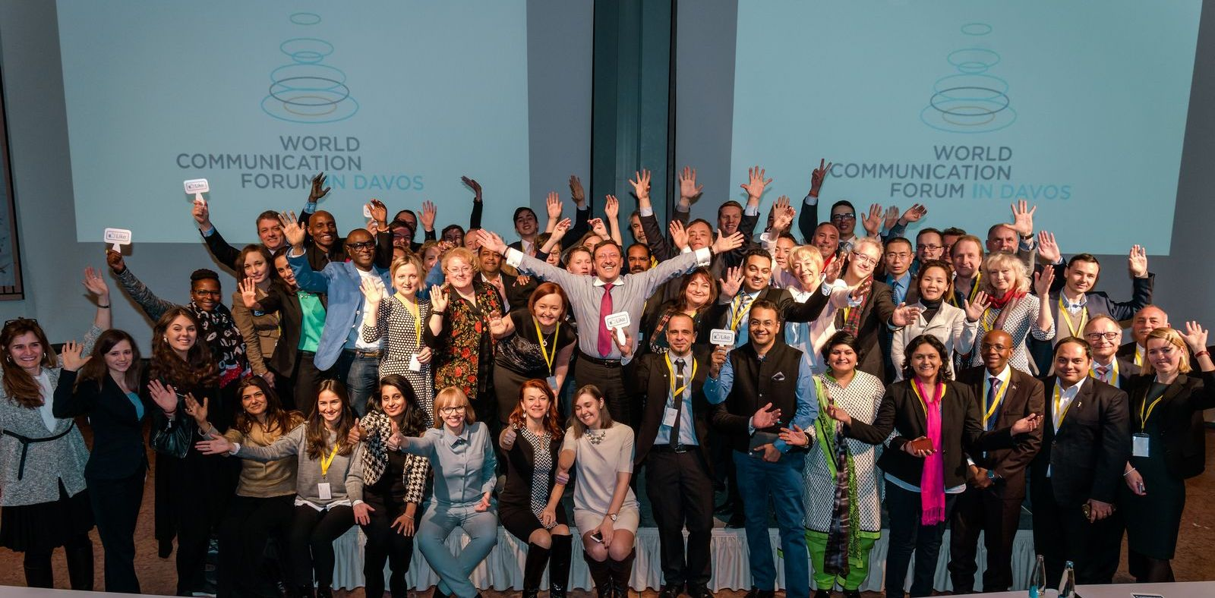
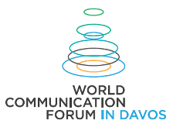
Announcement of the Board is the first step towards the organization of the next WCF forum. The event will take place on 9-10 March, 2017, in Switzerland, again at the Davos Congress Centre, a traditional meeting place for an annual survey and marking the trends of the global communication industry worldwide. The goal of the forum is to strengthen the impact of communications both as a business branch and as a professional community that fosters the global development of the world.
The high-level expertise of the 36 Committee members includes public affairs, country reputation, intra-governmental and global corporate communication, social and digital media insight, crisis management, cross-cultural interaction, branding, design, integrated marketing, and more. They represent the national communication industries and professional communities of 24 countries on 4 continents. Among the Committee members of WCF’s Program Board for 2017 are:
- Alfred Koblinger, CEO of BBDO Holding (Austria)
- Prof. Dr. Ali Murat Vural, Executive Board Member, Bersay Communications (Turkey)
- Donald Liphoko, Director General, Government Comms & Information System (South Africa)
- Dymitr Romanowski, Co-founder of The Story, Design & Innovation (Poland)
- Eva Snijders, Storyteller. Coach. Change Agent (Spain)
- Faith Muthambi, Minister of Communications of the Republic of South Africa
- Gabor Hegyi, Founding Managing Director of Capital Communications (Hungary)
- Guntram Kaiser, Chief Executive Officer of KaiserCommunication GmbH (Germany)
- Gianni Catalfamo, Web 2.0 evangelist, Founder of cc:catalfamo (Italy)
- Irina Bakhtina, VP Global Sustainable Biz Comms Capability & Training, Unilever (Russia)
- Iryna Zolotarevych, Head of the PR&GR Practice at AGAMA Communications (Ukraine)
- Jamie Vernon Ph.D., Editor-in-Chief at American Scientist, Director of Science Communications & Publications at Sigma Xi (USA)
- Jon-Hans Coetzer, Executive Dean, Glion Institute of Higher Education (Switzerland)
- Kara Alaimo, Ph.D., Assistant Professor of Public Relations, Hofstra University (USA)
- Lorenzo Brufani, Competence Communication - Owner and General Manager (Italy)
- Maxim Behar, ICCO President, Chairman of Hill+Knowlton Strategies in Prague, CEO & Chairman of the Board of M3 Communications Group, Inc. (Bulgaria)
- Mustapha Khalfi, Minister of Communications and Government Spokesperson of Morocco
- Nurul Ashiqin Shamsuri, Program Director, Information and Communication Secretariat at Wanita UMNO, and Head of Program at UCSI University (Malaysia)
- Paul Holmes, Founder and CEO of The Holmes Report and the SABRE awards (UK)
- Philip Osagie, Global Strategist of JSP Communications & African PR expert (Nigeria)
- Philippe Borremans, Director Strategy at PR Media - Morocco (Belgium)
- Rana Nejem, Founding Director of YARNU (Jordan)
- Sabitha Natraj, Chief Manager Corporate Communications, Indian Oil Corporation Ltd (India)
- Saurabh Kumar Uboweja, Founder, CEO & Director Brand Strategy at Brands of Desire (India)
- Sean Gardner, Co-Founder of the Huffington Post "Twitter Powerhouses Series" (USA)
- Sergey Zverev, Founder and President of CROS PR & Public Affairs (Russia)
- Sherwet Kafafy, Marketing and Communication Director at TAQA Arabia (Egypt)
- Scott Fahlman, Research Professor, Carnegie Mellon University (USA)
- Solly Moeng, Managing Director, DonValley Brand, Marketing & Comms (South Africa)
- Srdjana Janosevic, Chief Press Secretary at the President's Office, Republic of Seychelles
- Stuart Bruce, Digital Corporate Communications, Online PR trainer and consultant (UK)
- Tanuja Kehar, Vice President, Corporate Communications at Unitech (India)
- Tatevik Pirumyan, Executive Director of APRA - the Armenian Public Relations Association
- Xu Wejdong, Vice Secretary General, China International Public Relations Association
- Yogesh Joshi, President of ABCI - the Association of Business Communicators of India
- Zhao Dali, Executive VP & Secretary General, China International Public Relations Association
Yanina Dubeykovskaya, member of the Committee in her capacity as WCFDavos Founder & Content Director as well as President of the WCFA association, shared: “WCFDavos, both as a forum and as a global community, is developing only through the human beings it unites. For 7 years, we have been able to involve representatives of about 60 countries and transform the event into the most influential and most appreciated diversity-of-expertise platform in the world. The WCF Committee acting as the Program Board in 2017 includes leaders of the global professional community who, as key drivers of the Forum, provide a unique agenda content and intensify its impact worldwide.”
The function of the WCF Committee as a Program Board is to outline strategic key points for the conceptual format of WCF’s 8 edition, announce a draft agenda, steer the preparation phases, make resolutions on due partnerships, suggest or approve topics and applications by speakers, and monitor all the marketing and implementation throughout the year, taking also into account the schedule for due upcoming regional forum sessions till the end of 2016. The WCF Committee’s first action as a Program Board will be to approve the draft agenda for the World Communication Forum in 2017 and announce it on the official website.
WCF Committee & Program Board for 2017: http://www.forumdavos.com/committee
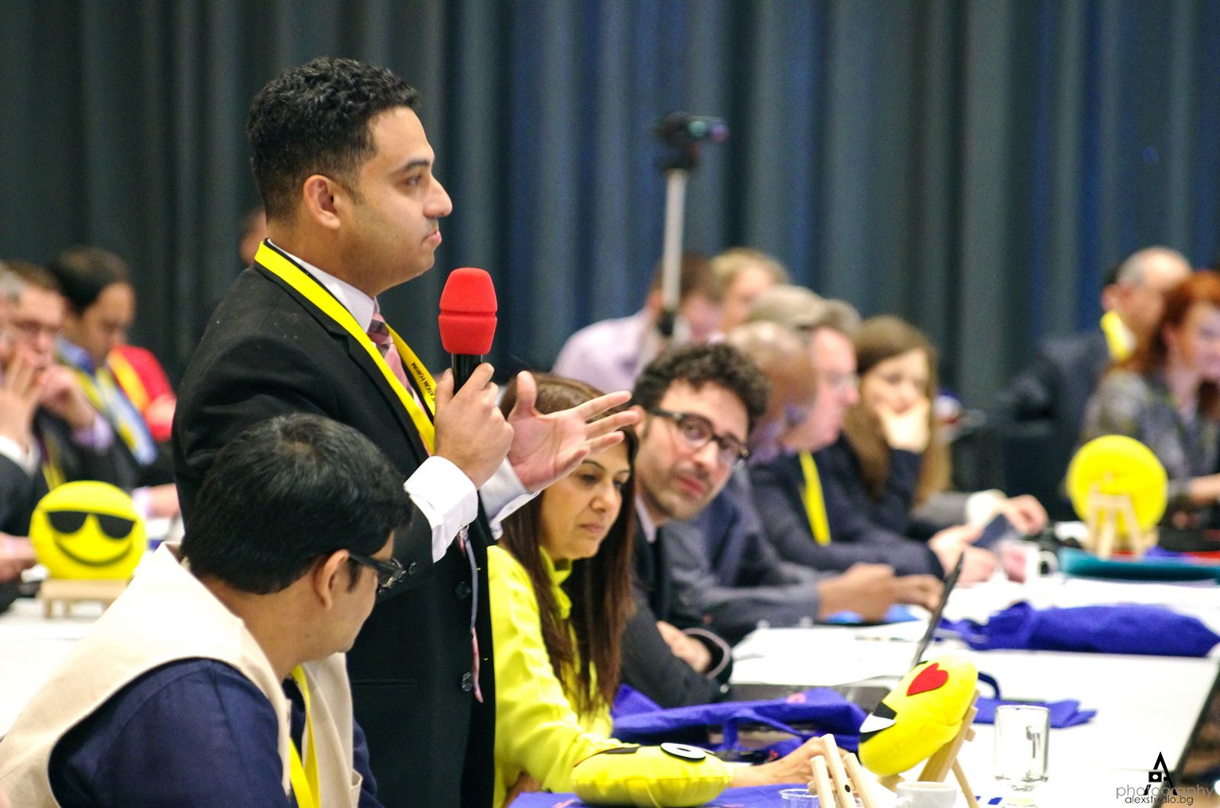
WCF is an annual global event held at the Davos Congress Centre in Switzerland. Initiated by an International Coordinating Committee in 2010, it has united a great number of acknowledged professionals from 58 countries worldwide. Since its third annual edition in Davos, WCF has started expanding its global professional community with regional sessions held in some of the largest cultural centers and business capitals across Europe and Asia. The two-day conference covers the latest trendy areas and issues and outlines future tendencies in the global communications industry.
Follow #WCFDavos in the social media:
- Official website: http://www.forumdavos.com
- Facebook: http://www.facebook.com/WorldCommForumDavos
- Twitter: http://www.twitter.com/WorldCommForum
- YouTube: http://www.youtube.com/forumdavoscom
Contact:
Yanina Dubeykovskaya, WCFDavos Founder and Content Director, President of the WCFA
+41 76 241 3224, yana@forumdavos.com
Valentina Atanasova, WCFDavos Project Manager, Communications & Partnerships
+359 88 44 50 44, partners@forumdavos.com

