C4F Davos Awards Winners 2016 have been announced!
On 8 of March, 2016, the C4F (Communication for the Future) Davos Award Gala Ceremony took place for the 6th time, as a part of the seventh annual World Communication Forum in Davos. The C4F Davos Awards recognize remarkable individual communicators and companies with a creative professional approach and unique vision of the future of communications.
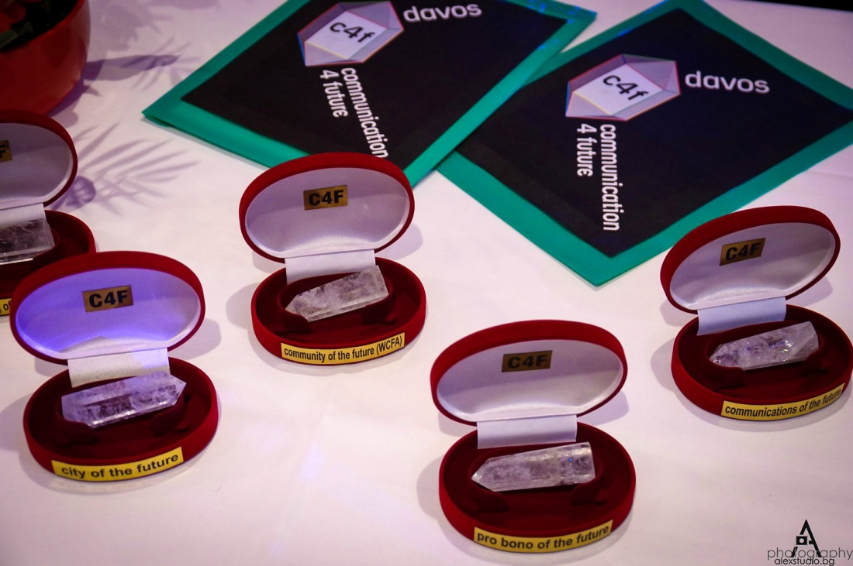
Personal Awards are to be given to individuals with a strong professional influence on the global improvement of communication in its broad sense and also with a truly effective contribution in fostering new trends for the development of the communications industry worldwide.

This year, the jury determined the best and awarded personal awards to the following nominees:
• Olga Kudinenko "Tabletochki" fund, Relation of the Future (Ukraine)
• Natalia Gromadskikh, Leader of the Future (Belarus)
• Maxim Yakover, Idea of ​​the Future, (Ukraine)
The Corporate Awards are to be given to companies which set the standards for effectiveness and professionalism within the global communication industry and demonstrate creativity in the realization of their communication strategies and campaigns.
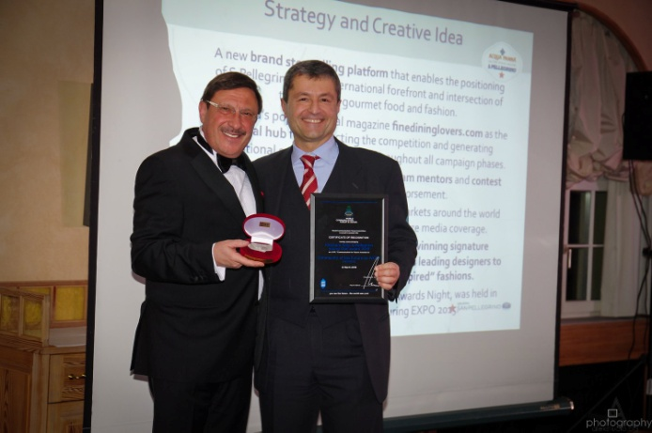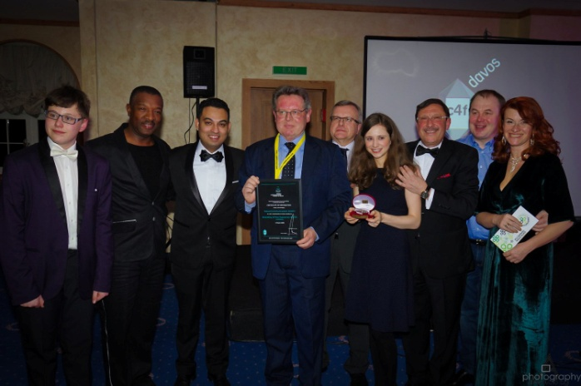
Following the results of the jury’s voting, winners among the corporate nominations are:
• SAP, "Africa Code Week", Education of the Future (South Africa);
• VTB Arena Park, City of the future (Russia);
• APRA, "Together we can", Pro Bono of the Future (Armenia);
• Ketchum Italy, "S.Pellegrino young chef award 2015", Community of the Future, (Italy);
• Ketchum Italy, "S.Pellegrino young chef award 2015", Communications of the Future, (Italy);
• Coordination Committee for the Events of Armenian Genocide Centennial, "We are Armenians", Communications of the Future (Armenia);
• Kaiser Communication GmbH, Branding of the Future (Germany).
"We continue to implement our mission – forming the basic principles of the communications industry and supporting outstanding professionals. C4F Davos Awards annually recognize those who are able to offer effective and creative methods for the development of global communications. This year we have divided the nominations into 2 categories - personal and corporate. We received more than 20 cases worthy of a nomination. Evaluation of all applications was held in two stages. In the first stage the jury determined the candidates for each nomination. In the second stage the voting members of the jury evaluated the nominees based on five criteria: effectiveness, influence, trend, integration of solutions and social convenience. The nominees with the highest number of points were elected as winners," said Yanina Dubeykovskaya, C4F Davos Awards Director, WCFA association’s President.

