World Communication Forum holds a series of events intended for Global Influencers of Communication in March 2016

Communication professionals, CEOs, representatives of ministries, media and the biggest communication schools will participate in the World Communication Forum in Davos in March this year (www.forumdavos.com).

The focus of this year’s edition of the forum will be on the global communication agenda. WCF-Davos’2016 includes a number of various and presently relevant topics, among which:
- Country Branding
- Communications in the Arab world
- Education in Communications. How to be prepared for the future?
- Global Tourism industry in the age of Communications
The full content is available at: www.forumdavos.com/programme

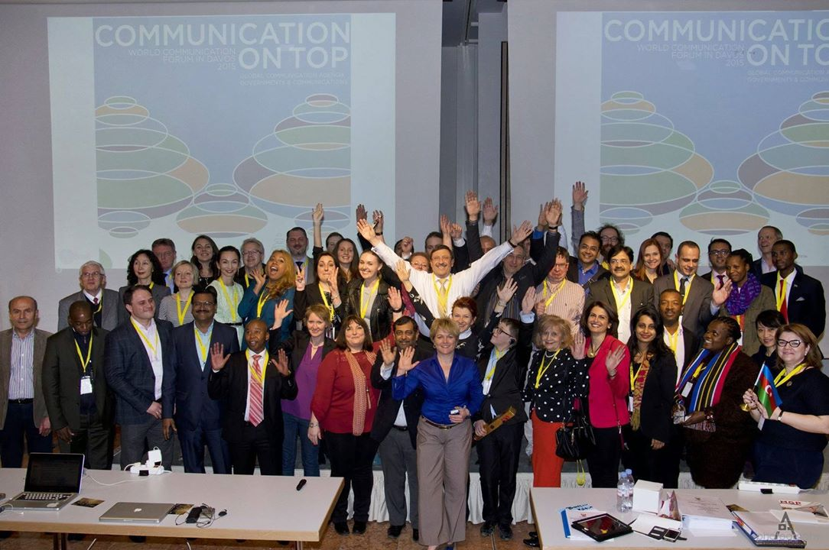

An international line-up of speakers and delegates will exchange expertise on the most important aspects of the current development of the communications industry and the newest influential trends that have a massive impact on society.
“Impressive event partners, diversity of speakers and participants, superb event brand and co-branding with the location of Davos – a great organization! We had a very profitable time!” – as stated by Paul Holmes, founder and CEO of the Holmes Report and SABRE awards, about one of the recent WCF editions (2014).

The seventh edition of the forum will host a series of events, among which:

WCFDavos | Zeppelin View Session
On March 7, in Friedrichshafen, Germany, with a focus on research, science and technology of communications >>> http://www.forumdavos.com/regional/14
WCFDavos | Zeppelin View topics are:
- Zeppelin Cases
- Issue management
- Flight technology (aeronautics; unmanned aircraft development – a single invention’s effect; ecosystem drones; the aircraft of the future)
- Step-outs of chief editors and journalists from leading scientific periodicals
The Zeppelin View Session is intended for science communicators, industry experts, PRs and marketers in the field of aircraft, flight and drones technologies, as well as journalists and editors covering scientific and technological breakthrough issues and innovations.

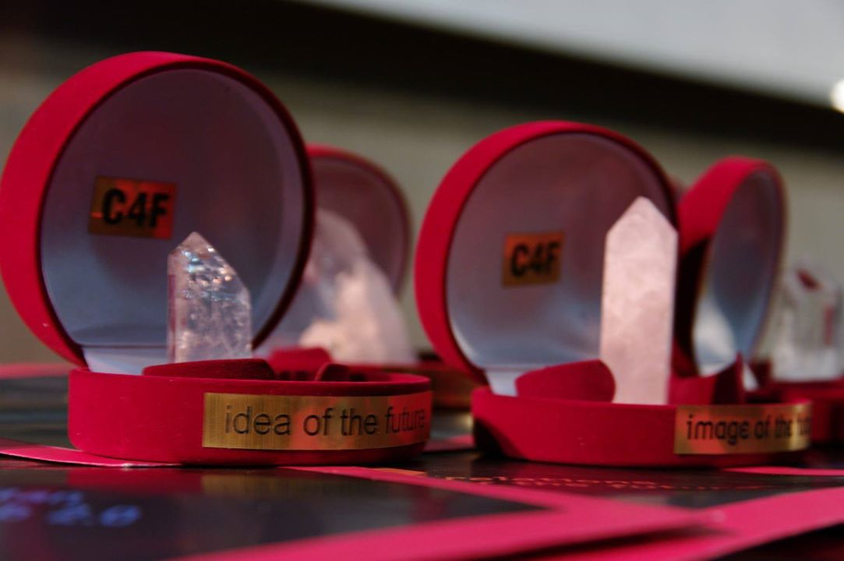
C4F Davos Awards
On March 8, in Davos, as a traditional part of the annual WCF, two international jury panels will acknowledge the brightest ideas in PR, media, branding and communications with the Communication 4 Future Award. Applicants can submit their corporate or personal nominations till 29 January, 2016 >>> www.c4fdavosaward.com/
Chairmen of the jury panels for personal and corporate C4F awards are, respectively:
Scott Fahlman, WCF-Davos Committee member, Research Professor at Carnegie Mellon University (USA), "Father" of the smiley emoticon
Maxim Behar, ICCO President, WCFDavos Committee co-Chair, Chairman of Hill+Knowlton Strategies (CZ), CEO & Chairman of the Board of M3 Communications Group, Inc. (BG)

WCF-Davos Global Education Program
On March 8 and 9, parallel with the main forum, a session will be held for the first time, focused on global education in communications. WCFDavos | GlobEdu is intended for students and young communication professionals. During the two-day training session, participants will be grouped into several teams of 5 students and a senior university representative as a leader, with a real case study being assigned to each team. At the end of the training, a jury will evaluate and acknowledge the most effective strategy for dealing with the assignments. Students and tutors can apply at >>> www.forumdavos.com/regional/15

Apart from the main summit in Davos, this year there will be five regional WCF sessions held in the following countries: Croatia, Ukraine, Malaysia, Turkey, and Poland.

Exclusive Partner-agencies of WCF-Davos’2016 are:
M3 Communications (Bulgaria) www.m3bg.com/
KaiserCommunication (Germany) www.kaisercommunication.net/en/
Capital Communications (Hungary) www.capital.hu/
CROS (Russia) http://www.cros.ru/eng/company/history/
Grou-AGAMA (Ukraine) www.grou.com.ua/
DonValley (South Africa) http://www.donvalley.co.za/
Cyber Gear (UAE) http://www.cyber-gear.com/index.php
Rada Research & PR (Egypt) http://www.rada.com.eg/
First House (Norway) http://firsthouse.no/english/
Competence (Italy) http://www.competencecommunication.com/en
The Story (Poland) http://www.story-digital.com/
JSP Communications (Nigeria) http://www.jspcommunications.com/v2/
Depot WPF (Russia) http://www.depotwpf.com/
JSP Communications http://www.jspcommunications.com/v2/
Armenian Public Relations Association (APRA) http://www.apra.am/
China International Public Relations Association (CIPRA) http://www.cipra.org.cn/
PR Hub http://www.prhub.it/en/
The Place Brand Observer http://placebrandobserver.com/
PR Newswire http://www.prnewswire.co.uk/
Sostav.ru http://www.sostav.ru/
Facemark http://www.facemark.az/
LifeInterMidia http://lifeintermidia.com.br/
Grupo 13 http://www.grupo13.com.co/
Real Leaders Magazine http://real-leaders.com/

The first edition of World Communication Forum in Davos was held in 2010. WCF-Davos is focused on communications and their key role in business, media, society, and politics. Each year the two-day forum covers important topics discussed by the global communication professionals’ community and outlines the newest tendencies within the communications industry.

Contact:
Maria Aladzhova, PR Assistant, World Communication Forum in Davos
PR | Media Relations | Social Media

Official WCF-Davos social media profiles:
Facebook: http://www.facebook.com/WorldCommForumDavos
Twitter: http://www.twitter.com/WorldCommForum
YouTube: http://www.youtube.com/forumdavoscom

