WCFDavos’16: diversity in an exciting new Communication World!
World Communication Forum in Davos, Switzerland, 7th edition, is in full preparation!
On 8-9 March, 2016, communication professionals from all over the world will again get together to discuss the key trends in the field of global communications.
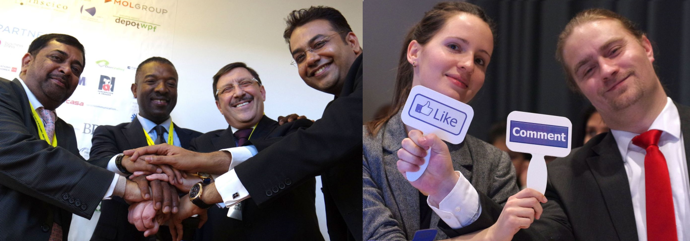
The programme provides a diversified content and publicity opportunities for experts with out-of-the-box vision for the future of the industry. The participants will find out how to add meaning, integrate interests and reach a growing influence in multinational brands, how to engage the globe with city storytelling, how to manage crisis periods on the social media, and much more.
WCFDavos will again discuss some controversial topics:
- Communications in the Arab world.
- From digital evolution to robot revolution – humanity, communications, ethics.
- Quantity or Quality? What is your social media top priority?
- Revolutionizing Communications – seeing them a mission, rather than as a service!
- Tourism: new customers’ behavior and new communication services.
Among the speakers and moderators of the plenary panels are leading experts, such as:
Mustapha Khalfi, Minister of Communications and Spokesperson of the Government of Morocco, Scott Fahlman, Research Professor at Carnegie Mellon University, also known as “Father” of the smiley emoticon, Tanuja Kehar, Vice President Corporate Communications at Unitech in India, Solly Moeng, Managing Director of Don Valley in Soth Africa, Kate Thompson-Duwe, Managing Director of Amplicon Group in South Africa, Sean Gardner, co-Founder of the pioneering Huffington Post "Twitter Powerhouses Series", Don Anderson, Chairman and co-Founder of the Asia Content Marketing Association and Regional Managing Director of We Are Social in Singapore, Saurabh Uboweja, Founder, CEO & Director Brand Strategy at Brands of Desire.
Traditionally, WCFDavos holds the Communications for Future (C4F) Davos Award. However, this time it offers up to 23 categories for recognition of remarkable creativity and unique vision of the future of communications, in two major groups of awards: Personal (individual communicators with a strong influence on global communications) and Corporate (companies setting the standards for effectiveness & professionalism).
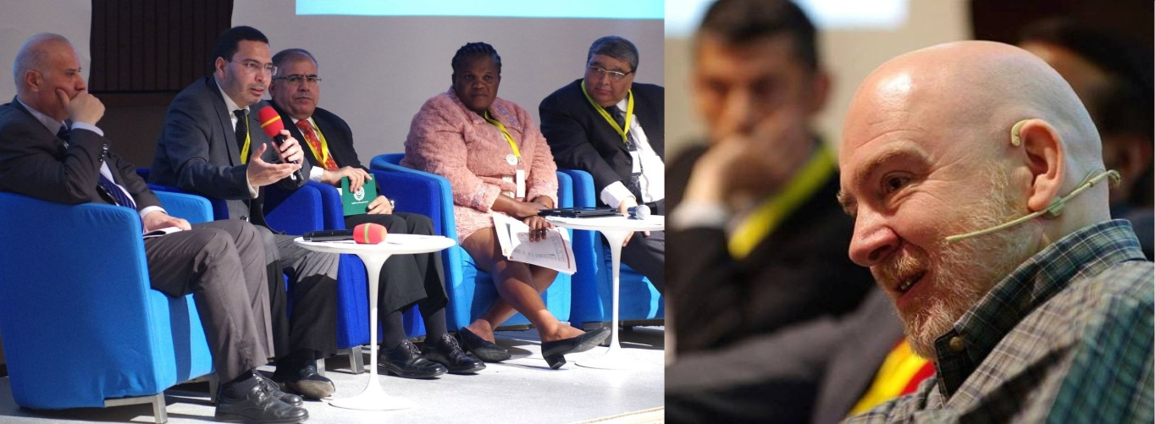
Mustapha Khalfi, Minister of Communications of Morocco:
“I have no doubt that the World Communication Forum is assured of its place in the history as a platform where new solutions for an exciting new world are being shaped”.
Paul Holmes, the PR industry guru worldwide:
“No idea how they did it, but in just a few years the organizers have created the most lively, engaging and influential event in the industry. This forum is an absolute phenomenon!”
WCFDavos 2016 is supported by exclusive partner agencies from all over the world: M3 Communications (Bulgaria), Kaiser Communication (Germany), Capital Communications (Hungary), CROS (Russia), Grou-AGAMA (Ukraine), Don Valley (South Africa), SPEM Communications (Slovenia), Manifesto Communications (Turkey), Cyber Gear (UAE), RADA Research & PR (Egypt), First House (Norway).
WCF is an annual global event held at the Davos Congress Centre in Switzerland. Initiated by an International Coordinating Committee in 2010, it has united a great number of acknowledged professionals from 55 countries worldwide. Since its third annual edition in Davos, WCF has started expanding its global professional community with regional sessions held in some of the largest cultural centers and business capitals across Europe and Asia. The two-day conference covers the latest trendy areas and issues and outlines future tendencies in the global communications industry.
For more information: www.forumdavos.com

Facebook: http://www.facebook.com/WorldCommForumDavos

Twitter: http://www.twitter.com/WorldCommForum

YouTube: http://www.youtube.com/forumdavoscom
Contact:
Valentina Atanasova, Project Manager of the World Communication Forum in Davos
Comms with Speakers & Committee, Partnerships, Website content, SM, PR
Mobile: (+359) 884435044, Skype: ataval.bg

