34 states worldwide shape Global Communications Agenda at WCFDavos 2015
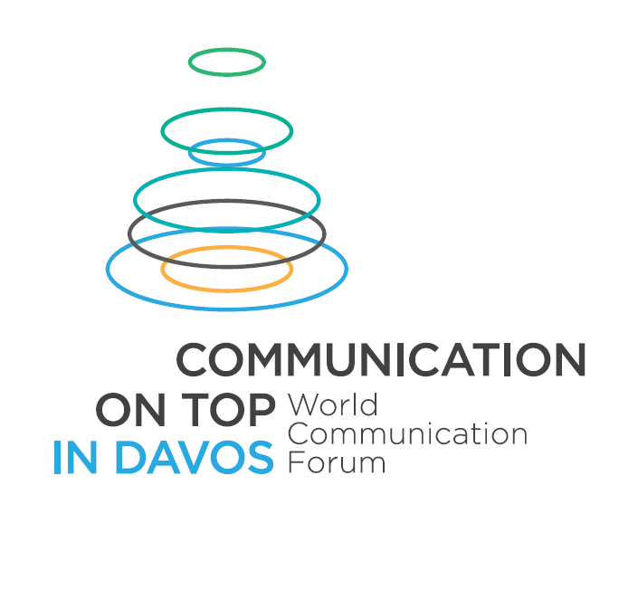

On March 10-11, the sixth edition of the World Forum “Communication on Top” in Davos welcomed delegates from 5 continents at the Davos Congress Centre in Switzerland.

The main focus was on priorities and challenges of the global communication agenda in 2015, government communications, public diplomacy, communications and leadership, cross-cultural and global communications, and innovative education.

Mustapha Khalfi, the Minister of Communications of Morocco, and Faith Muthambi, the Minister of Communications of South Africa, as well as official representatives of the Ministry of Information in Lebanon and the Foreign Ministries of Djibouti, Kazakhstan, Hungary, the Czech Republic, the Slovak Republic, and Spain attended WCFDavos 2015.

Renowned leaders of elite consultancies also joined the summit this year and took part as speakers in the first day. Colin Byrne, the CEO of Weber Shandwick for UK & EMEA, shared:
“I think the Forum is terrific and bringing an important new dimension to our discussions as a global industry.”
China and South Korea’s top agencies contributed to the agenda in the face of Hong (Holly) Zheng, President of Bluefocus International and Chair of the Business Management Committee at Bluefocus Communication Group, and Kim Kyong-Hae, CEO and President of Communications Korea.

The global corporate business was represented by owners and leading communication officers of several large enterprises: Luis Ramos, Head of Communications at ThyssenKrupp Elevator (Germany), Dr. Raviraj Ahirrao, Founder of Vasturaviraj Group (India), Rich Kylberg, Vice President Communications and Global Marketing at Arrow Electronics (USA).
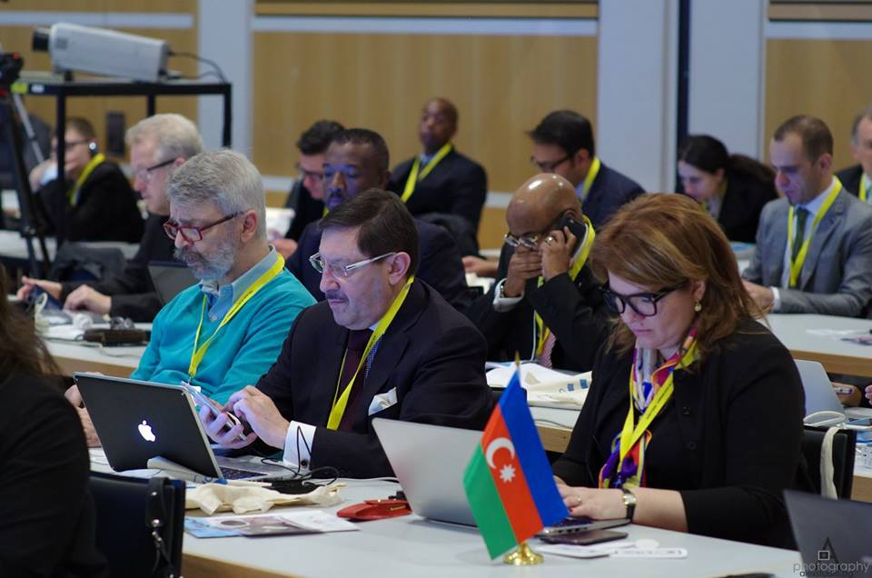

WCFDavos also welcomed the leaders of the three largest professional associations from China, India and the Middle East – Zhao Dali, Executive Vice President & Secretary General of China International Public Relations Association, Yogesh Joshi, Co-Chair of WCFDavos Committee, President of ABCI (India) , and Dr. Refat Alfaouri, Director General of the Arab Administrative Development Organization (Egypt, Middle East and North Africa). Bharat Patel, the head of one of the largest media in India – Sandhya Prakash Group, took part in the opening panel.

Two more highlights of Day 1 were the panel on Communications in Asia, with emphasis on the specific features, and the panel on Communications & Leadership or: how to position globally your company as #1. The speakers were leading communicators from Asia, Europe, and Africa.

The accent of Day 2 was on the “Universities, Science, Industry partnership” panel, supported by Russian Venture Company and the Institute for Science & Innovation Communication. Prof. Alexander Gerber, Founder & Scientific Director of INSCICO, shared a research- learning approach in teaching comms, while RVC’s Deputy CEO & Director of Project Management Evgeny Kuznetsov talked about ecosystem management as a key driver for the development of universities and companies:
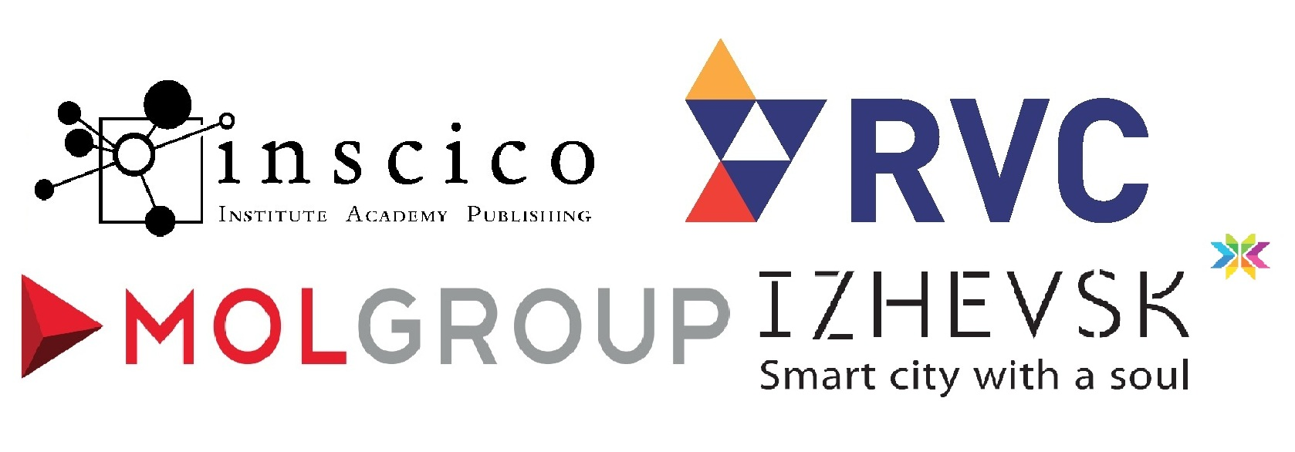
"The only thing that makes sense is the spirit of innovation within a community. You should encourage it to appear and help it develop. It's about people and culture – there are features of the system that you can actually change to ease the advent of innovative culture. Of course, cultural changes have to grow up naturally, yet you can tip the system towards change, and for that you have to start from the top and go down. This is what we do. So, the process stops being ‘project management’ and becomes ‘ecosystem management’".

The message of the #WCFDavos summit was reflected in the special keynote by Rich Kylberg focusing on today’s heroes: innovation and communication! He introduced ‘communivation’ as a term, highlighting the huge importance of communications as a key driver of global changes and a possibility for positive influence on the development of the world.
The conclusions of the summit will be announced in the World Communication Review which is being launched as a project in April this year, so – stay in tune!

World Communication Forum in Davos 2015 is supported by: Russian Venture Company, INSCICO, MOL Group, the city of Izhevsk, CROS, M3 Communications, KaiserCommunication, H+K Portugal, SPEM Communications, Canela PR, Pleon Talan, Communications Korea, Capital Communications, DonValley, Cyber Gear, Business Press, Manifesto Communications, First House, Cap & Cime PR, RADA Research & PR, GrupoCASA, Sciolli Comunicadores, Smartcom Corp, Percepcion & Imagen, Evenium.net, Depot WPF, Ochsner Consulting, PROI Worldwide, IABC EMENA, CIPRA, ABCI, ARADO, ASSOREL, LatAmPR Network, BAPRA, APRA, RPRA, RBCA, MPRS, BPRA, Marketing mreza, Todo Mundo, LifeInterMidia, Real Leaders Magazine, PR Report, Grupo 13, PR Newswire, Sostav.ru, PRnoticias.com, Korea Economic Daily, KOREAPR.review, Facemark, and Kongress Hotel Davos.
Presentations
http://www.forumdavos.com/presentations/2015
Albums
https://picasaweb.google.com/107126070606639475341/WCFDavos2015
https://www.facebook.com/media/set/?set=a.794731170595724.1073741868.100275280041320
https://www.facebook.com/media/set/?set=a.795177770551064.1073741869.100275280041320
https://www.facebook.com/media/set/?set=a.795266300542211.1073741870.100275280041320
First Reviews
https://sonofgeektalk.wordpress.com/2015/03/13/what-is-wcf/
http://stuartbruce.biz/2015/03/international-pr-thought-leader-videos-from-the-davos-world-communication-forum.html

