Winners of 2015 C4F Davos Awards Announced
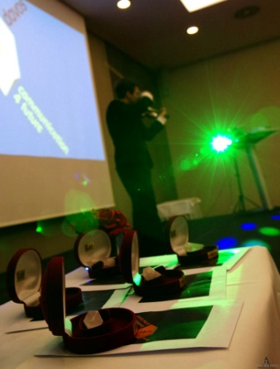
Now in its fourth year, Communication for Future Davos Award recognized the world’s most influential and forward-thinking communicators from across the globe during the annual World Communication Forum Davos (WFC Davos) held in Davos on March 10-11. Overall, there were 5 prizes granted during the awards ceremony, including the Grand Davos Award.
First launched in 2011, Communication for Future Awards has since then grown to become one of the world’s most sought-after personal prizes within the industry, recognizing top performers across a range of communications disciplines, such as visual communications, media relations, reputation management, CSR, branding, education, and more. Receiving the award in the previous years were many of the industry’s bellwethers like Paul Holmes, Maxim Behar, Gianni Catalfamo, James Gillies, Anne Villemoes, and many others.
Overall, there were 25 outstanding PR personalities shortlisted for this year’s award, who were then voted for by the respected jury panel made up of the previous winners of C4F Davos Award and leaders of the communication market: Anne Villemoes, Diane McEachern, Iryna Zolotarevych, Jason Ng, Juan Carlos Belloso, Liz Strauss Maria Schicht, Maxim Behar, Scott Fahlman, Uday Salunkhe, and Yanina Dubeykovskaya. For more details on this year’s jury, please follow the link.
Following a rigid selection process, the jury named 5 persons to receive this year’s C4F awards in the respective categories:
Idea of the Future – Saurabh Kumar Uboweja
Relations of the Future – Nurul Ashiqin Shamsuri
City of the Future – Marc Puig i Guardia
Titan of the Future – Dr. Volker Stoltz
Grand Davos Award - Zhao Dali
“Today, communications are all about being global, and I’m happy that people we now have on our winners’ list are the people representing an international community of communications professionals capable of moving the industry forward on a truly global scale. I would like to congratulate the winners with this well-deserved recognition, as well as thank all of the judges for their hard work and commitment,” comments Irina Zolotarevych, C4F Davos Awards Director, WCFDavos Committee member, and PR&GR services director at AGAMA Communications Group (Ukraine).
Yanina Dubeykovskaya, Chair of WCFDavos Coordination Committee shares: “WCFDavos has always sought for the ways to promote individual effort within the communications industry, supporting professionals who spearhead innovation and whose vision defines industry’s future and drives global change. C4F is definitely a grand step in that direction, helping us single out and recognize opinion leaders to help us build global communications agenda as part of the World Communication Forum.”
For more information about C4F Award, please refer to:
C4F Davos Awards Director Irina Zolotarevych (c4faward@gmail.com)
Official website: http://c4fdavosaward.com/

