World Communication Forum shapes the Global Communications Agenda
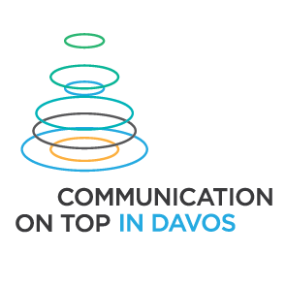
On March 10-11, in Davos, communications experts from 24 countries across 5 continents will speak at the sixth edition of the World Communication Forum. A day earlier, on March 9, a special session dedicated to communicating scientific breakthrough will take place in CERN, Geneva.

Among the most engaging topics in the WCFDavos agenda are: Diplomacy 2.0., Tourism and Branding, Communications and Leadership, Communications in Asia, Cross-cultural VS Global, Employee Communications, Storytelling, Competitive Education in Communications, and more: http://www.forumdavos.com/programme

The conclusions of WCF summit 2015 will be summoned in a World Communication Review after the forum. The review will also include articles by key speakers of the event and describe the main trends of the communications industry for 2015. The priorities will be defined during a discussion during the Forum that will pinpoint the opinion of the global professional community, provided via Facebook or in comments via the Twitter hashtag #WCFGCA.

Partners of WCFDavos 2015 are the Russian Venture Company, the Hungarian oil and gas company MOL Group, and INSCICO, an extramural research institution, providing applied and contract research in the field of science and innovation communication.
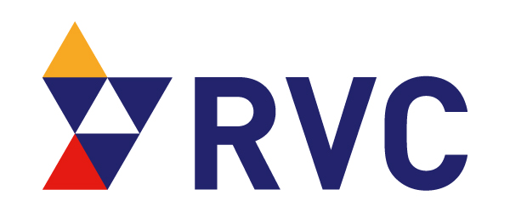

Exclusive partner-agencies of WCF in Davos for 2015:
M3 Communications, CROS Public Relations and Public Affairs, KaiserCommunication, Hill+Knowlton Portugal, SPEM Communications, Canela PR, Pleon Talan, Communications Korea, Capital Communications, DonValley, Cyber Gear, Business Press, Manifesto Communications, First House, Cap & Cime PR, RADA Research & PR, GrupoCASA, Sciolli Comunicadores, Smartcom Communication Integral, and Percepcion & Imagen. Official Partners are: Evenium.net, Depot WPF, Ochsner Consulting, PROI Worldwide, IABC EMENA, CIPRA, ARADO, ASSOREL, LatAmPR Network, APRA, BAPRA, ABCI, RPRA, RBCA, MPRS.
___________________________________________
World Communication Forum, Davos is a global event that aims to bridge the gap and connect key markets worldwide. Over the last five years WCFDavos has been addressing the ongoing issues and trends in the public relations industry worldwide, attaining the contribution of over 130 senior-level communicators as speakers and registering participants from over 44 countries worldwide. In 2014, in Switzerland, WCF was registered as a non-profit organization.
Facebook: http://www.facebook.com/WorldCommForumDavos
Twitter: http://www.twitter.com/WorldCommForum
YouTube: http://www.youtube.com/forumdavoscom

