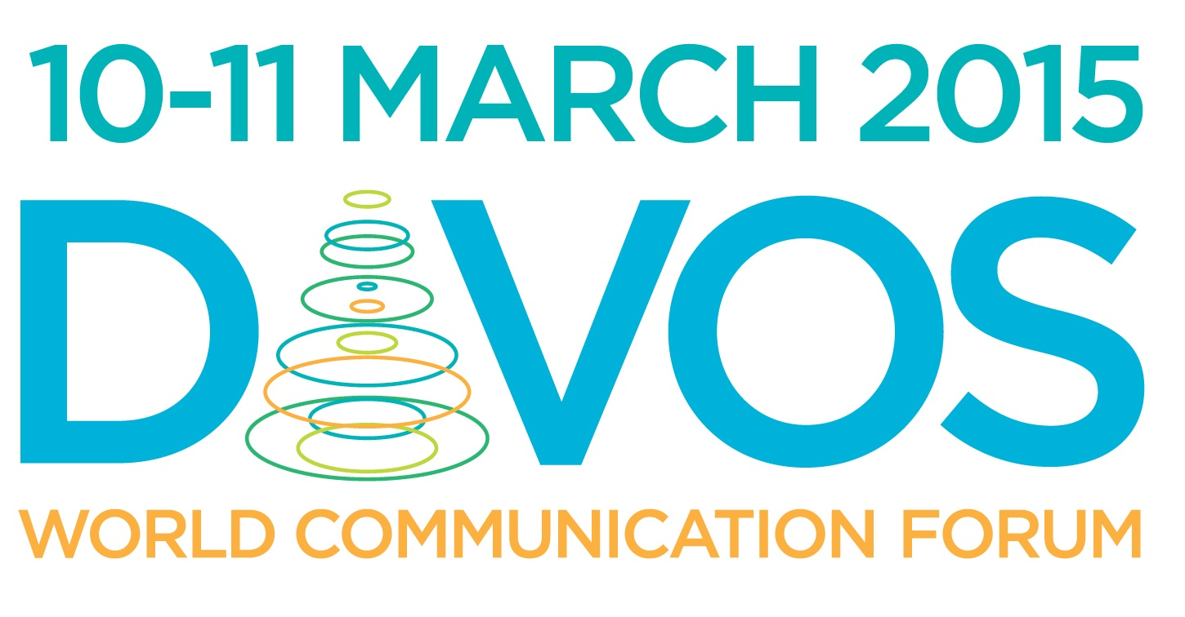
World Communication Forum in Davos 2015:
Exploring New Behaviour, Values, Business

On March 10-11, 2015, during the sixth World Communication Forum in Davos, senior-level communicators from five continents will discuss the features of the new global communication agenda. Like every past year since 2010, the Davos Congress Centre will be traditionally hosting the event.

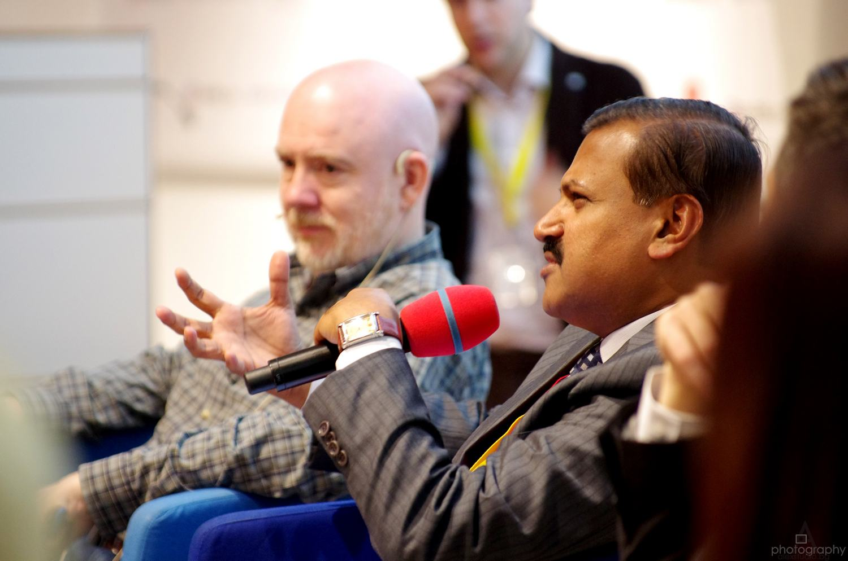
Among the invited participants in the summit, are ministers of communications, CEOs and directors of leading PR agencies, media executives, and scientists. The main topics of WCF-Davos’2015 are:
- Global Communications Agenda 2015.
- Diplomacy 2.0.
- Government & communications - development & regulations.
- Country and place branding. How to engage the globe? Communications in Tourism.
- Comms & leadership. How can communications help your company be #1?
- Communications in Asia – specific features.
- Story-telling and story-sharing… or story-selling, and how ethical (if ethical at all)?
- Visual communications.
- What will be the future Internet of Things?
- Communications for a better future. The Sharism Philosophy.
- Relations of the future: Ownership. State. Trust.
- Employee Communications.
- What influences trust in a brand: Communications VS Customer Experience?
- PR/Media/Communication in Education.
- Communications in science and education.
- Communications in Sports.
- Person/Media/Brand - to be or not to be?
- Insurance. Communications of expectations.
- CSR campaigns - to make a better world or to provide a business solution?
- The real life-story of a top leader in the Communications industry.
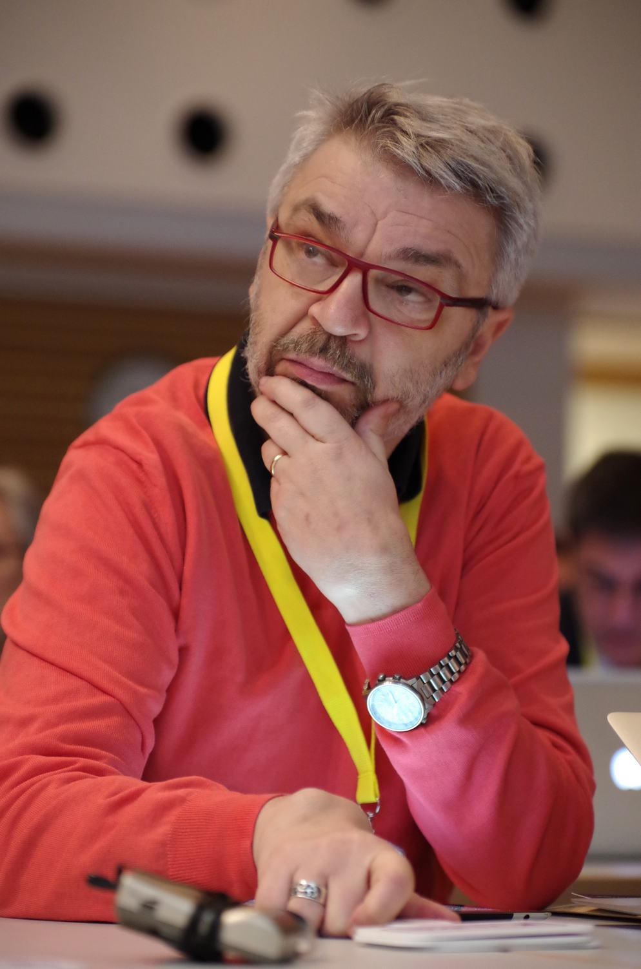
“The World Communication Forum has graduated into a staple for those who want to expand the scope of their professional network. Not many places where you can meet and interact with top communication experts from 5 continents, at a time where the success in our profession critically depends on the ability to function and connect globally”, says Gianni Catalfamo, Co-Chair of the WCFDavos Committee.

The sixth World Communication Forum in Davos is supported by exclusive partner-agencies from 14 countries in Europe, Africa, Asia and the Middle East:
Cyber Gear LLC (United Arab Emirates), Communications Korea (South Korea), Pleon Talan (Ukraine), Manifesto Communications Group (Turkey), Canela PR (Spain), DonValley (South Africa), SPEM Communications (Slovenia), CROS Public Relations & Public Affairs (Russia), Business Press (Italy), Capital Communications (Hungary), KaiserCommunication GmbH (Germany), M3 Communications (Bulgaria), and First House (Norway).
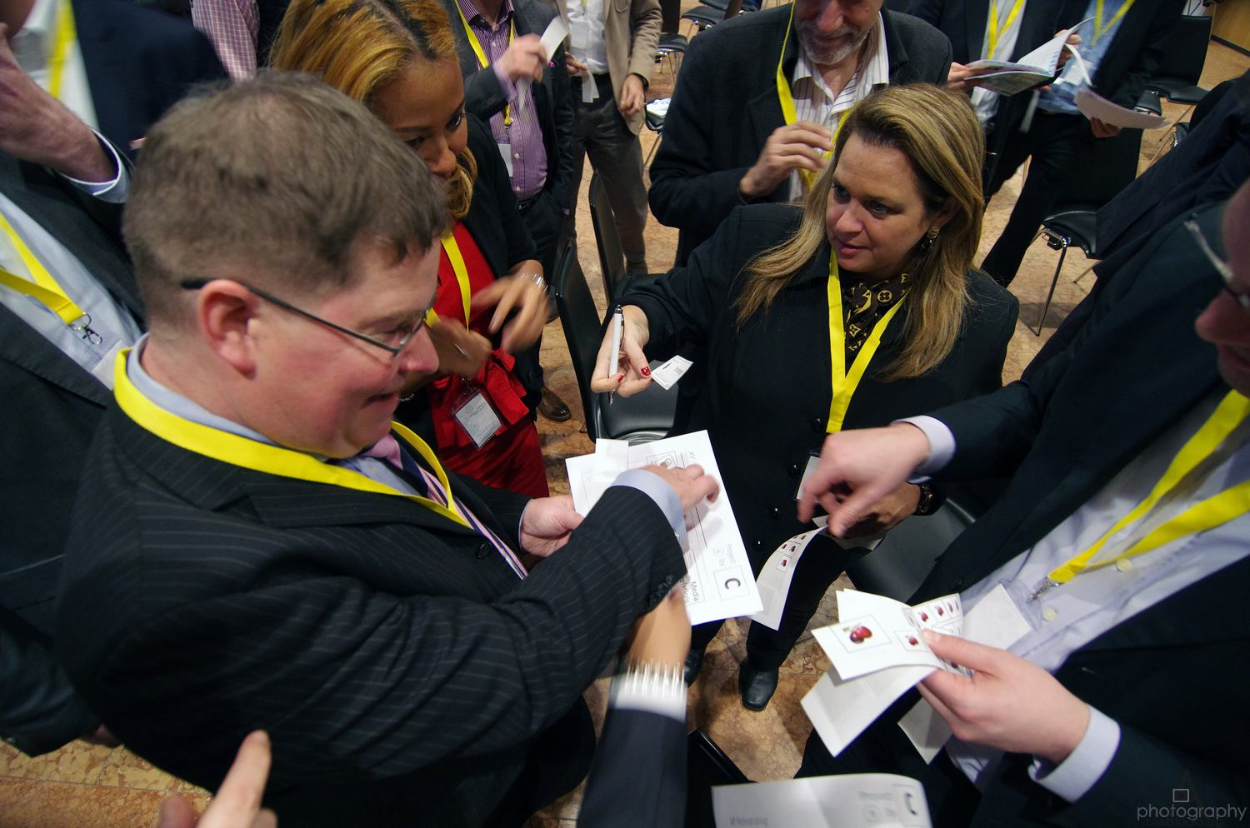
World Communication Forum in Davos is an annual global event focused on the future development of communications, their role in business, society and politics. Over the last five years WCFDavos has been addressing the ongoing issues and trends in the public relations industry worldwide, attaining the contribution of over 130 senior-level communicators as speakers and registering participants from over 44 countries worldwide.

Facebook: http://www.facebook.com/WorldCommForumDavos
Twitter: http://www.twitter.com/WorldCommForum
YouTube: http://www.youtube.com/forumdavoscom
For details on registration: http://www.forumdavos.com/registration

