WCF in Davos concludes partnership with CIPRA

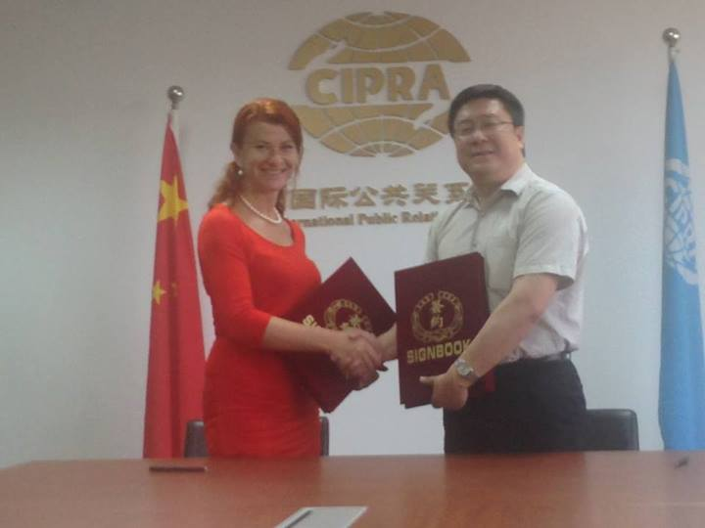
A valuable partnership agreement between the World Communication Forum in Davos and theChina International Public Relations Association was signed during the 2014 Big Data Forum held in Beijing on May 25, at the annual 2014 China International Public Relations Congress. Both parties were represented respectively by Yanina Dubeykovskaya, co-Chair of the International WCFDavos Committee, and Zhao Dali, Executive Director and Secretary General of the CIPRA. The newly blossomed partnership brought WCFDavos once step closer to accomplishing its mission: bridging the gap between the key markets worldwide.

China International Public Relations Association (CIPRA), set up in April 1991 as a corporate body and head-quartered in Beijing, is a national organization aimed at international cooperation in the field of public relations. In 2007, CIPRA obtained the Special Consultative Status of ECOSOC. Today teh organization unites over 200 members. The vision of CIPRA is to let the world know China and to let China orient itself to the world. One of the key missions of the association is to develop the process of professionalization, standardization and internationalization of the PR industry in China, as well as to support Chinese PR and communication agencies interested in opportunities abroad. Mr. Zhao Dali joined the WCFDavos International Committee in the spring of 2014, after attending the regional session of the forum held in Moscow. His professional experience includes working in the Department of Asian Affairs of China’s Ministry of Foreign Affairs. He has been in his current position since 2010. Mr. Li Daoyu, former Deputy Director-General of the department of International Organizations and Conferences of the Foreign Ministry of China,s the elected President of CIPRA.

Yanina Dubeykovskaya shared: "We highly appreciate this step, since China is one of the fastest growing market within the industry, and we are pleased to be able to offer a global platform for the development of the Chinese communication business abroad. We are eager to welcome the Chinese delegation of PR professionals at the 6th edition of the World Communication Forum in Davos."

China became the 3rd biggest PR market in the world in 2012.
So far WCFDavos has united top representatives of 44 countries and accomplished seuccessful partnerships with over 15 key international orgabizations within the industry, such us ICCO, IABC-EMEA, AMEC, IAB-Europe, PROI-Worldwide, PRCA (UK), ABCI (India), PRISA (South Africa), RPRA (Russia), ASSOREL (Italy), PROPR (Mexico), BPRA (Switzerland), HUOJ (Croatia), DSOJ (Serbia), LRVS (Lithuania), ZOJ and PRSS (Slovenia), BAPRA (Bulgaria), MPRS (Hungary), APRA (Armenia), APRA and KoPR (Czeck Rep), IPR (Ghana), and more.
WCF is an annual event held in Davos Congress Centre, Switzerland. Initiated by an International Coordinating Committee in 2010, it has united acknowledged professionals from 44 countries worldwide. The forum has been supported by key associations including: ICCO, PRCA, IAB-Europe, IABC-EMEA, Association of Business Communicators of India (ABCI), Russian PR Association (RPRA), PR Consultants Association UK (PRCA), Association of PR Agencies in Switzerland (BPRA), Italian Association of PR Agencies (ASSOREL), Mexican Association of Public Relations (PROPR), Public Relations Institute of Southern Africa (PRISA), etc.

