Dr. Jesus Del Hoyo Arjona is the winner of the First Regional C4F Davos Award
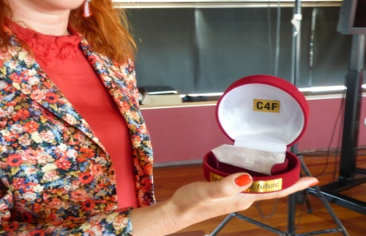
The prestigious C4F Davos Award launched its first Regional "Image of the Future" nominations last week, during the World Communication Forum session in Barcelona. The award aims to acknowledge outstanding communicators with creative approach and innovative vision for the future of communications. The particular category was not accidentally chosen – it is in full synergy with the focus of the Barcelona forum dedicated to Visual Communications. As visualization has become the language of the future, the nominees are well-known professionals who create stunning images in their field.
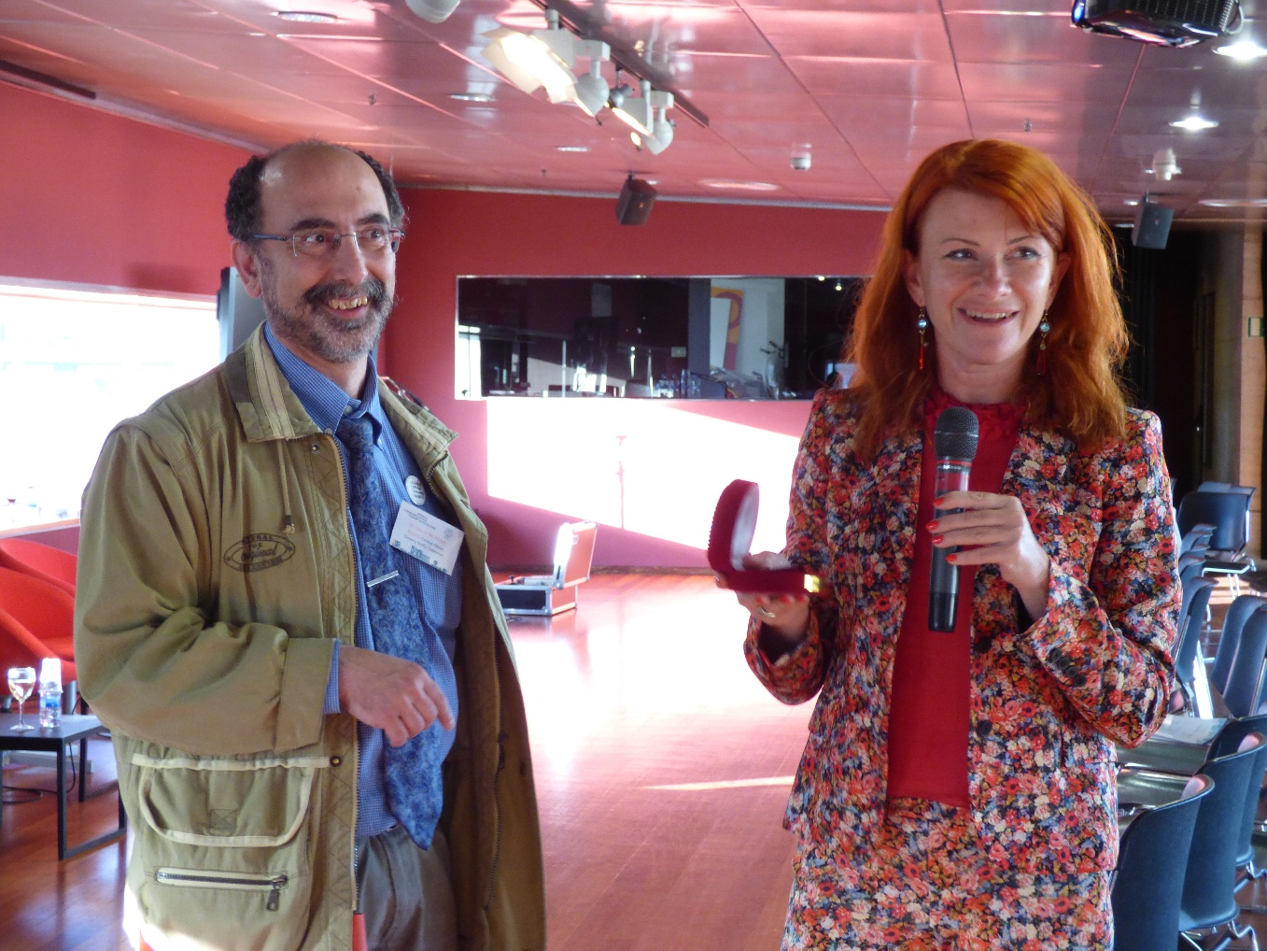
The online voting was held by the forum speakers in an absolutely confidential way, as per due criteria for the category and upon the voter’s personal view as an expert. Each had to select three nominees, rating them first, second, and third in place. The experts readily gave their vote:
Congratulations to Dr. Jesus Del Hoyo Arjona, Dean of Collegi Oficial del Disseny Gràfic de Catalunya, who won with more than half of the votes!
Yanina Dubeykovksya, co-Chair of the International WCF Committee, rendered the first Regional "Image of the Future" to Dr. Arjona.
Dr. Arjona has 30 years of experience in graphic design. He has dedicated his career to research in corporate identity, information design, typography and visual parameterization. During the regional session of WCFDavos in Barcelona, Dr. Jesus Del Hoyo Arjona rendered a presentation on "Necessary ingredients of communication in XXI century: the role of graphic design."

C4F Davos Awards are the first of their kind. They are rendered to challenging visionaries and communication professionals with key achievements in the development of the communications industry. The award is presented in 7 categories: Titan of the Future, Image of the Future, Media of the Future, Relations of the Future, Idea of the Future, Grand Davos Award and Tolerance for the sake of the Future initiated by the International Oleksandr Feldman Foundation in 2014. The C4F Davos Awards Ceremony was held for the first time in 2011, during the annual edition of the World Communication Forum in Davos. To see the C4F Davos Awards Winners from previous years, please visit: http://www.forumdavos.com/awards
WCFDavos Official profiles:
Facebook: http://www.facebook.com/WorldCommForumDavos
Twitter: http://www.twitter.com/WorldCommForum
YouTube: http://www.youtube.com/forumdavoscom

