New Committee and Co-Chairs of WCFDavos 2015 Announced
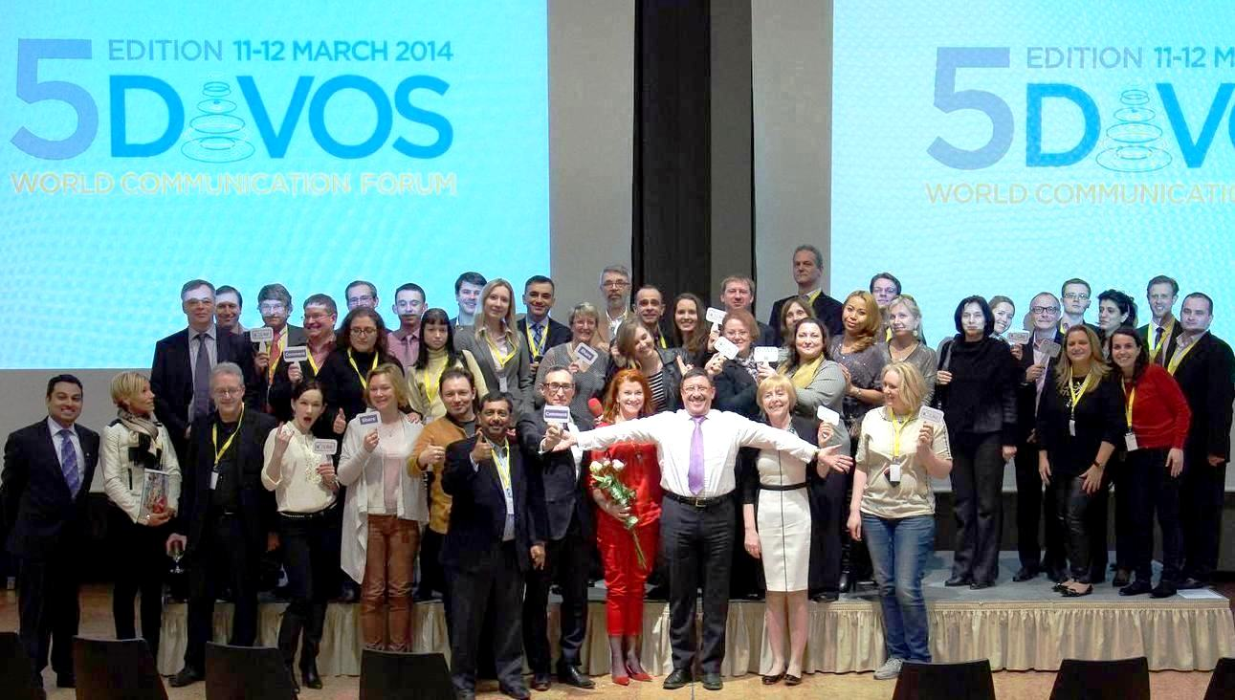
After the latest success of the fifth annual edition of the World Communication Forum in Davos, the due elections of an International Coordinating Board and co-Chairs for WCFDavos 2015 have recently been held. The new committee comprises of 26 well-known communications professionals, representing 18 countries across 4 continents. Together they provide a truly global and efficient perspective of today’s communications industry. The duties of the Board include promoting the WCFDavos’s global communications community and developing the forum itself, defying key topics of the agenda, recommending speakers, and nominating candidates for the prestigious C4F Davos Awards.

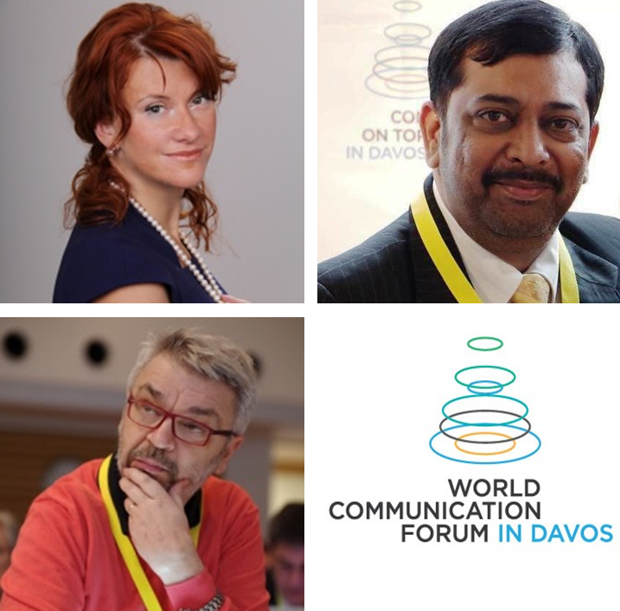
The elections of new co-Chairs have been held online, via a completely anonymous voting of the 26 members. Congratulations to the newly-elected co-Chairs of WCFDavos 2015: Yanina Dubeykovskaya, Gianni Catalfamo, and Yogesh Joshi!
Here is what the three Co-Chairs shared regarding their plans for the next year’s event:

“The several priorities for WCFDavos 2015 are further development and improvement of the forum, including a larger number of closed-doors sessions in the agenda, increasing the number of annual WCFDavos regional sessions, and concluding key partnerships with influential Public Relations agencies from around 20 countries, with possibilities for a long-term cooperation. We believe that today communication is the driving force that can change not only business, but also people, society, and the world”, said Yanina Dubeykovksya.

“I think one of the most unique features of the WCF is its authentic, bottoms-up international nature. It is about people who like to debate the grand issues in marketing and communication on a true peer-to-peer fashion, bridging across cultures, languages, backgrounds. As a co-Chair, I intend to work to further extend the footprint of the WCF, Asia beckons! :-D”, shared Gianni Catalfamo.

“I would desire more participation from the Asian sub-continent in WCF's convention next year. As a leader of the Communication Industry of Asia, the biggest continent where the future is, I would like to create a platform for the young talent coming up from our region, as well as for the voice of bright communication professionals across Asia. As a co-Chair, I would try to get legends of the Communication Industry on the WCF platform in 2015 and I would like to share Best Practices coming from the Asian Communication Industry”, added the third co-Chair, Yogesh Joshi.

Here is the full list of the WCFDavos Board members for 2015:
Yanina Dubeykovskaya, WCF Board co-Chair, CEO of Тоp Communications GmbH (Austria)
Yogesh Joshi, WCF Board co-Chair, President of ABCI (India)
Gianni Catalfamo, WCF Board co-Chair, Chairman of Pleon in Italy
Andre Manning, Global Head of public relations and public affairs, Booking.com (Netherlands)
Andreas Hugi, President of BPRA, the Association of PR Agencies in Switzerland
Christian Dougoud, EMEA Customer Success Consultant at Linkedin (UK)
Dr. Gabor Hegyi, Founding Managing Director of Capital Communications (Hungary)
Dymitr Romanowski, Co-founder and CEO of The Story digital branding agency (Poland)
Iryna Zolotarevych, Managing Director of PR agency Pleon Talan (Ukraine)
James Gillies, Head of the Communications Group at CERN (Switzerland)
Lars Hilse, Founder & CEO of Web Strategy & E-Business Consultants (Germany)
Dr. Leandro Herrero, CEO of Chalfont Project Ltd., Partner of Viral Change Global LLP (UK)
Lorena Carreño Díaz, VP of the Mexican Communication & Marketing Industry Confederation
Maxim Behar, Chair of H+K Strategies (CZ), CEO and Chair of M3 Communications (BG)
Prof. Dr. Marc Langendorf, Deputy Head of Corporate Comms at Siemens AG (Germany)
Natalia Belenko, Founder of TOP Communication GmbH (Russia)
Nurul Ashiqin Shamsuri, Director of Lubri Oil Corporation (M) SB (Malaysia)
Paul Holmes, Founder and CEO of The Holmes Report and the SABRE awards (UK and USA)
Rui Martins, Corporate Communications and Public Affairs Director at Dianova Portugal
Stuart Bruce, Digital Corporate Communications, Online PR trainer & consultant (UK)
Sergey Zverev, Founder and President of CROS PR & Public Affairs (Russia)
Scott E. Fahlman, Research Professor, Carnegie Mellon University (USA)
Svetlana Kananykhina, CEO of Event Life Communication, WCF Event Director (Russia)
Valery Levchenko, Head of Comms, Moscow Institute of Physics and Technology (Russia)
Zhao Dali, Executive VP & Secretary General, China International Public Relations Association
__________________________________________________
World Communication Forum in Davos was initiated in 2010 by the International Coordinating Committee. In the last five years more than 150 speakers from nearly 44 countries, representing no less than 85 partners, over 100 consultancies, and more than 85 companies, have attended the event, while around 15 truly large international organizations have supported the forum.

World Communication Forum’s Official Website: http://forumdavos.com/
Facebook: http://www.facebook.com/WorldCommForumDavos
Twitter: http://www.twitter.com/WorldCommForum
YouTube: http://www.youtube.com/forumdavoscom

For details on registration: http://www.forumdavos.com/registration

