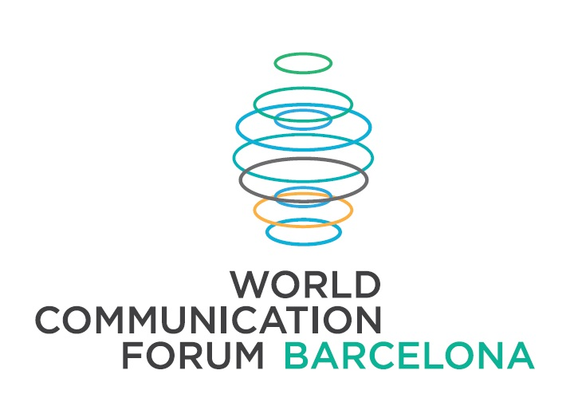
World Communication Forum visits Barcelona
A special regional session of the Davos World Communication Forum dedicated to Visual communications will take place On May 23 in Centro de Cultura Contemporanea de Barcelona.
The choice of topics and location is not random – Barcelona is known as one of the world’s design capitals, and the city itself is a bright example of a visual attraction. Top European experts in design, marketing, PR and related subjects will get together to discuss current trends, exchange best practices and display the most remarkable and innovative cases.

Main topics of the Forum are:
- The future language: image or text?
- Necessary ingredients of future visual communications.
- Visual storytelling: simplifying complex stories.
- Emotional image of the city.
- Visual social media – involvement and creativity.
- Design of life – design as a lifestyle.
- Emerging technologies for visual communications.
Among the speakers of the Forum are top-rated professionals with global influence:
- Alfred Koblinger, CEO KPK BBDO (Austria)
- Maxim Behar, WCFDavos Committee co-Chair, Chairman of H+K Strategies (Czech Republic),
CEO & Board Chairman of M3 Communications (Bulgaria)
- Alberto Tognazzi, Professor of Instituto Europeo de Diseno (Spain)
- Dr. Jesús Del Hoyo Arjona, Professor of Collegi Oficial del Disseny Gràfic de Catalunya (Spain)
- Jorge Lopez, VP Southern Europe, Lewis PR (Spain)
- Eva Snijders, Founding Partner, Visual Chemistry (Spain)
- Catarina Vasconcelos, Managing Director, LPM Communicacao (Portugal)
- Teresa Figueira, General Manager for Lisboa, H+K strategies (Portugal)
- Elizaveta Panfilova, Managing Director, Salvador D (Russia)
- Ekaterina Lavrova, PR director, Depot WPF branding (Russia)
- Ignacio Navarro Delgado, Founder of “Augmented Reality, Barcelona”
and others.
Full agenda is available on the WCFDavos official website: http://www.forumdavos.com/regional/5
Online registration: http://wcfdavos-barcelona.evenium.net/
Last year the forum started to hold regional sessions, which already took place in Moscow and Prague and the next one is scheduled for September in Kyiv. Barcelona visual communication session is also planned to be held annually and is expected to become one of the brightest European events for visual communications.
Official partners of the Barcelona session are: Salvador D creative lab, The European Packaging Design Association (EDPA), The Official Graphic Design Association of Catalonia, The Russian Brand Consultancies Association, Istituto Europeo di Design in Barcelona, Lewis PR in Spain, Canela PR in Spain, Augmented Reality Barcelona, Hill+Knolwton Strategies in Portugal, and LPM Communicacao in Portugal, and others. For more information: http://www.forumdavos.com/regional_partners/5
To follow the WCFDavos|Barcelona session via its social media profiles, join #WCFDavos on Twitter or the specially created Facebook event: https://www.facebook.com/events/210935075757163/
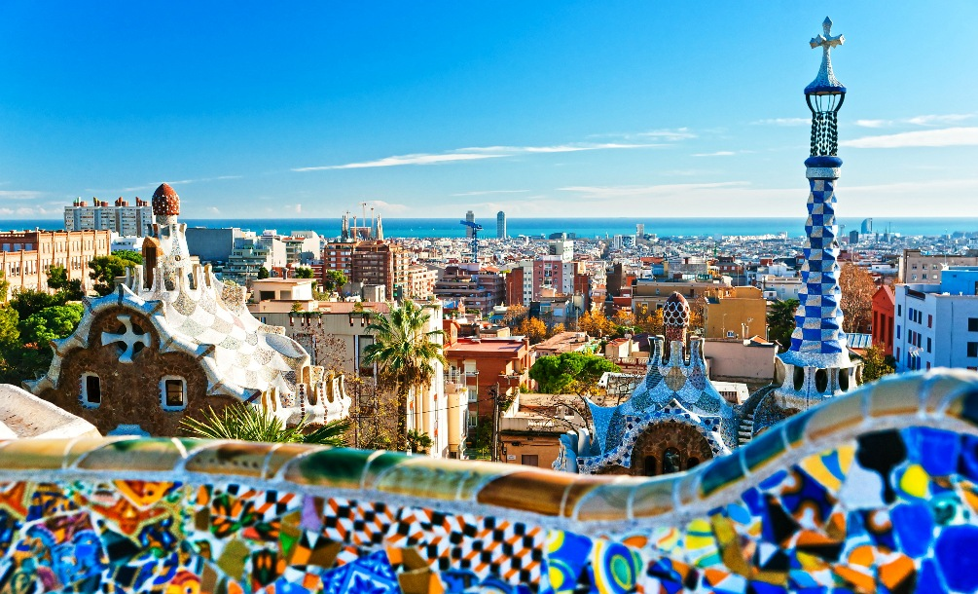
World Communication Forum, Davos is a global event that aims to bridge the gap and connect key markets worldwide. Initiated in 2010 by an international coordination committee, it has gained the support of numerous international partner associations and organizations from 40 countries across 5 continents: IAB Europe, The Holmes Report, the International Communications Consultancy Organisation (ICCO), the Public Relations Consultants Association in UK (PRCA), the Association of PR Agencies in Switzerland (BPRA), the Italian Association of Public Relations Agencies (ASSOREL), the Trans-Arabian Creative Communications (TRACCS), the Mexican Association of Public Relations, the Russian Public Relations Association (RPRA), the Armenian Public Relations Association (APRA), the Association of Business Communicators of India (ABCI), the Bulgarian Association of PR Agencies (BAPRA), the Brazilian Association of Communication Agencies (ABRACOM), and more.
Facebook: http://www.facebook.com/WorldCommForumDavos
Twitter: http://www.twitter.com/WorldCommForum
YouTube: http://www.youtube.com/forumdavoscom
Contacts:
Barcelona – Ekaterina Belyakova: +34 667 281 006 , barcelona@forumdavos.com
Moscow – Elizaveta Panfilova: +7 (903) 786 70 13, lika@salvador-d.ru
Organizing partner of WCFDavos – Barcelona: SALVADOR D creative lab. www.salvador-d.ru
Official media relations partner: Lewis PR
Official social media relations partner: Canela PR

